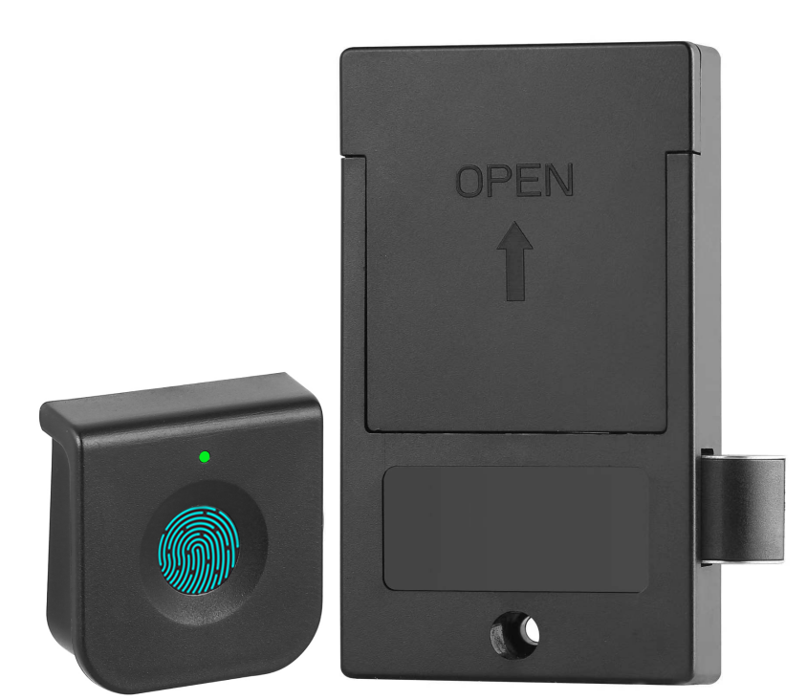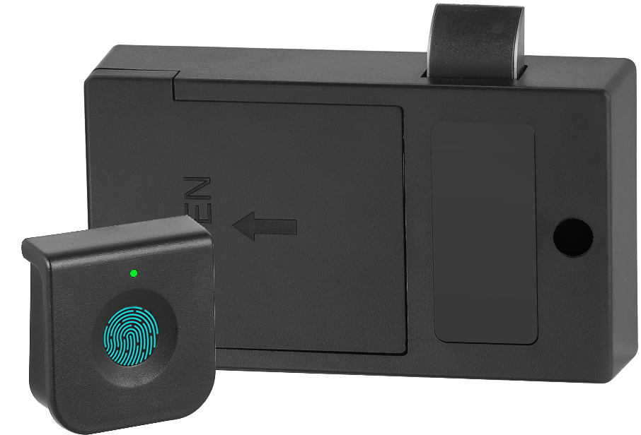

Features:
- Replace the traditional lock directly;
- Unlocked by fingerprint(s)；
- Low battery prompt;
- USB for emergency unlocking;
- ABS material

Technical Parameters
Power supply | 3 x AA alkaline batteries
Static current | ≤20µA
Dynamic current | ≤200mA
Working temperature | -15 ～ +55℃
Working humidity | 20 ～ 95%RH
Alarm voltage | 3.7±0.2V
Fingerprint capacity | 20 pcs
FP | 500DPI
FRR | ≤0.01%
FAR | ≤0.00004%
Door thickness | ≥ 10.00mm
Dimension
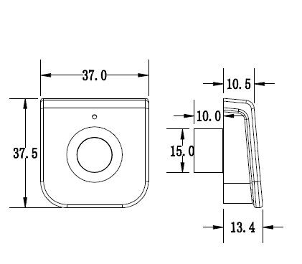
Powered by 3 pcs AA alkaline batteries, and the batteries last at least 13600 times operation;

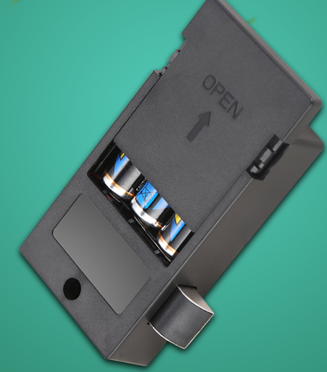

In case the batteries are exhausted and it is locked, use the USB key to insert into the USB port to unlock.

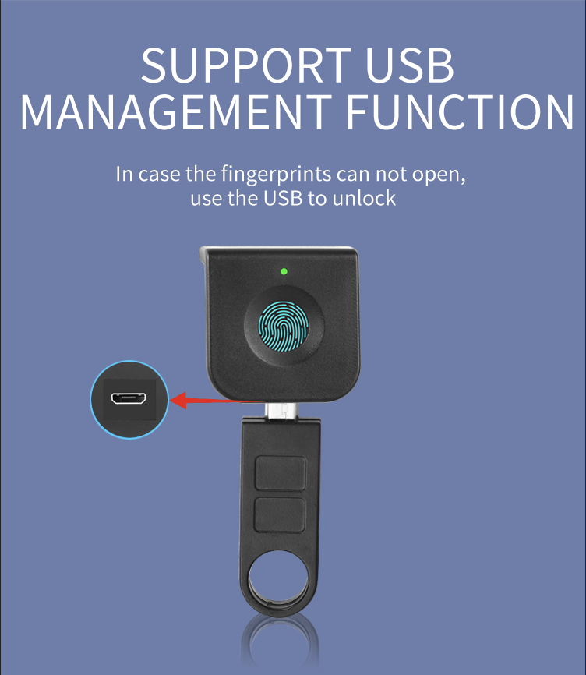

Application:

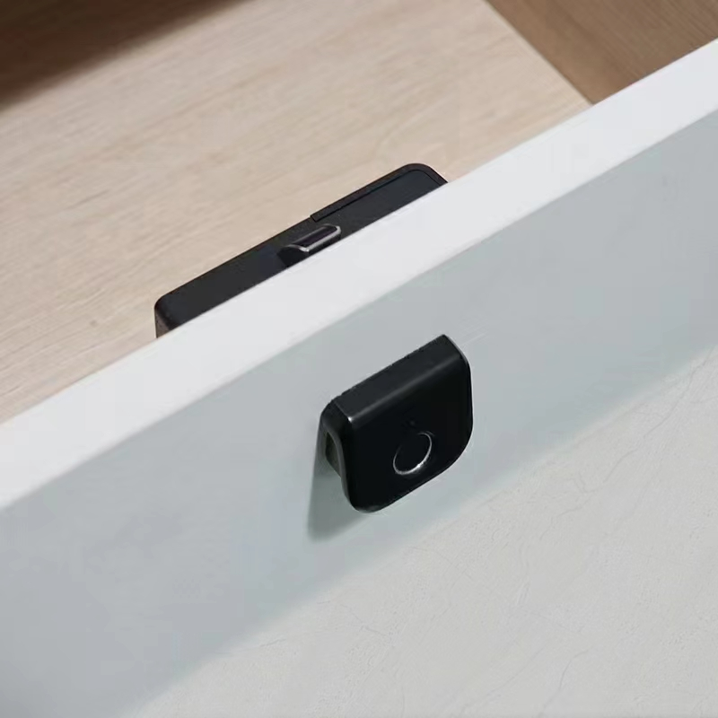

Pacgage:
1 pc/ box; Box size: 100mm x 55mm x 50mm;

