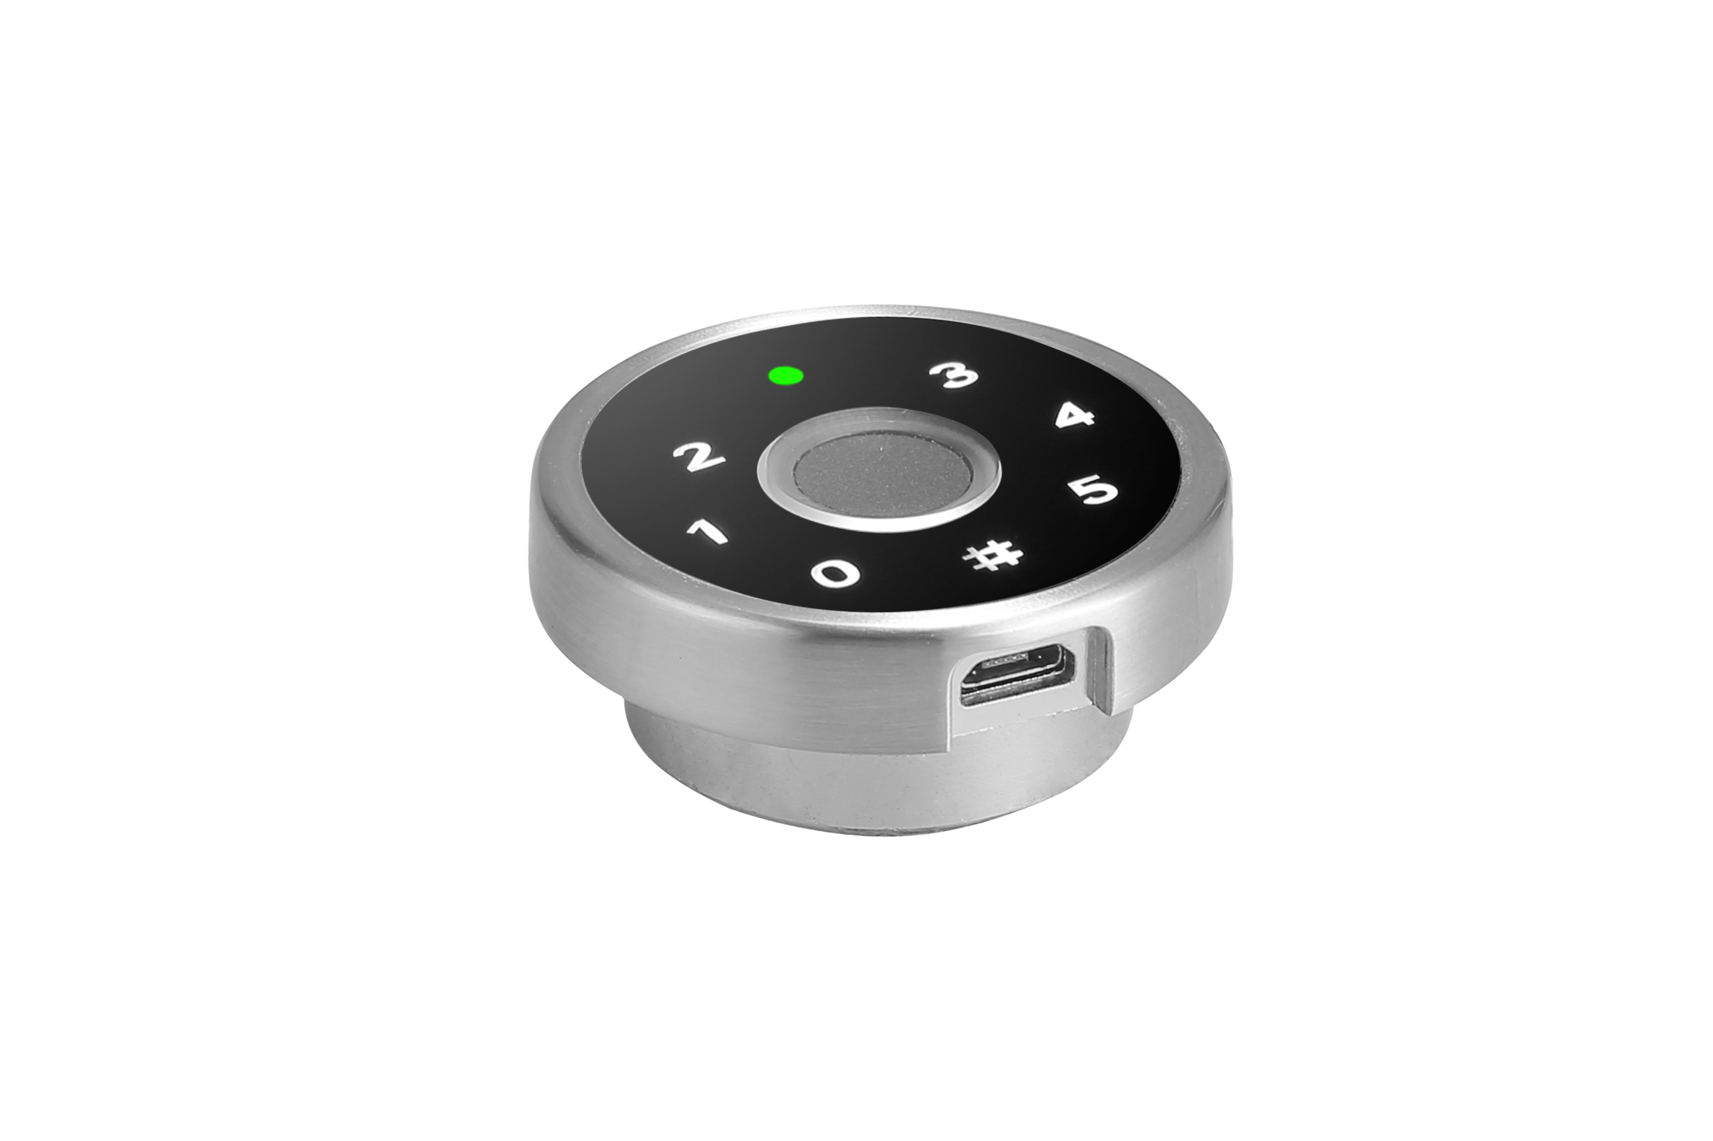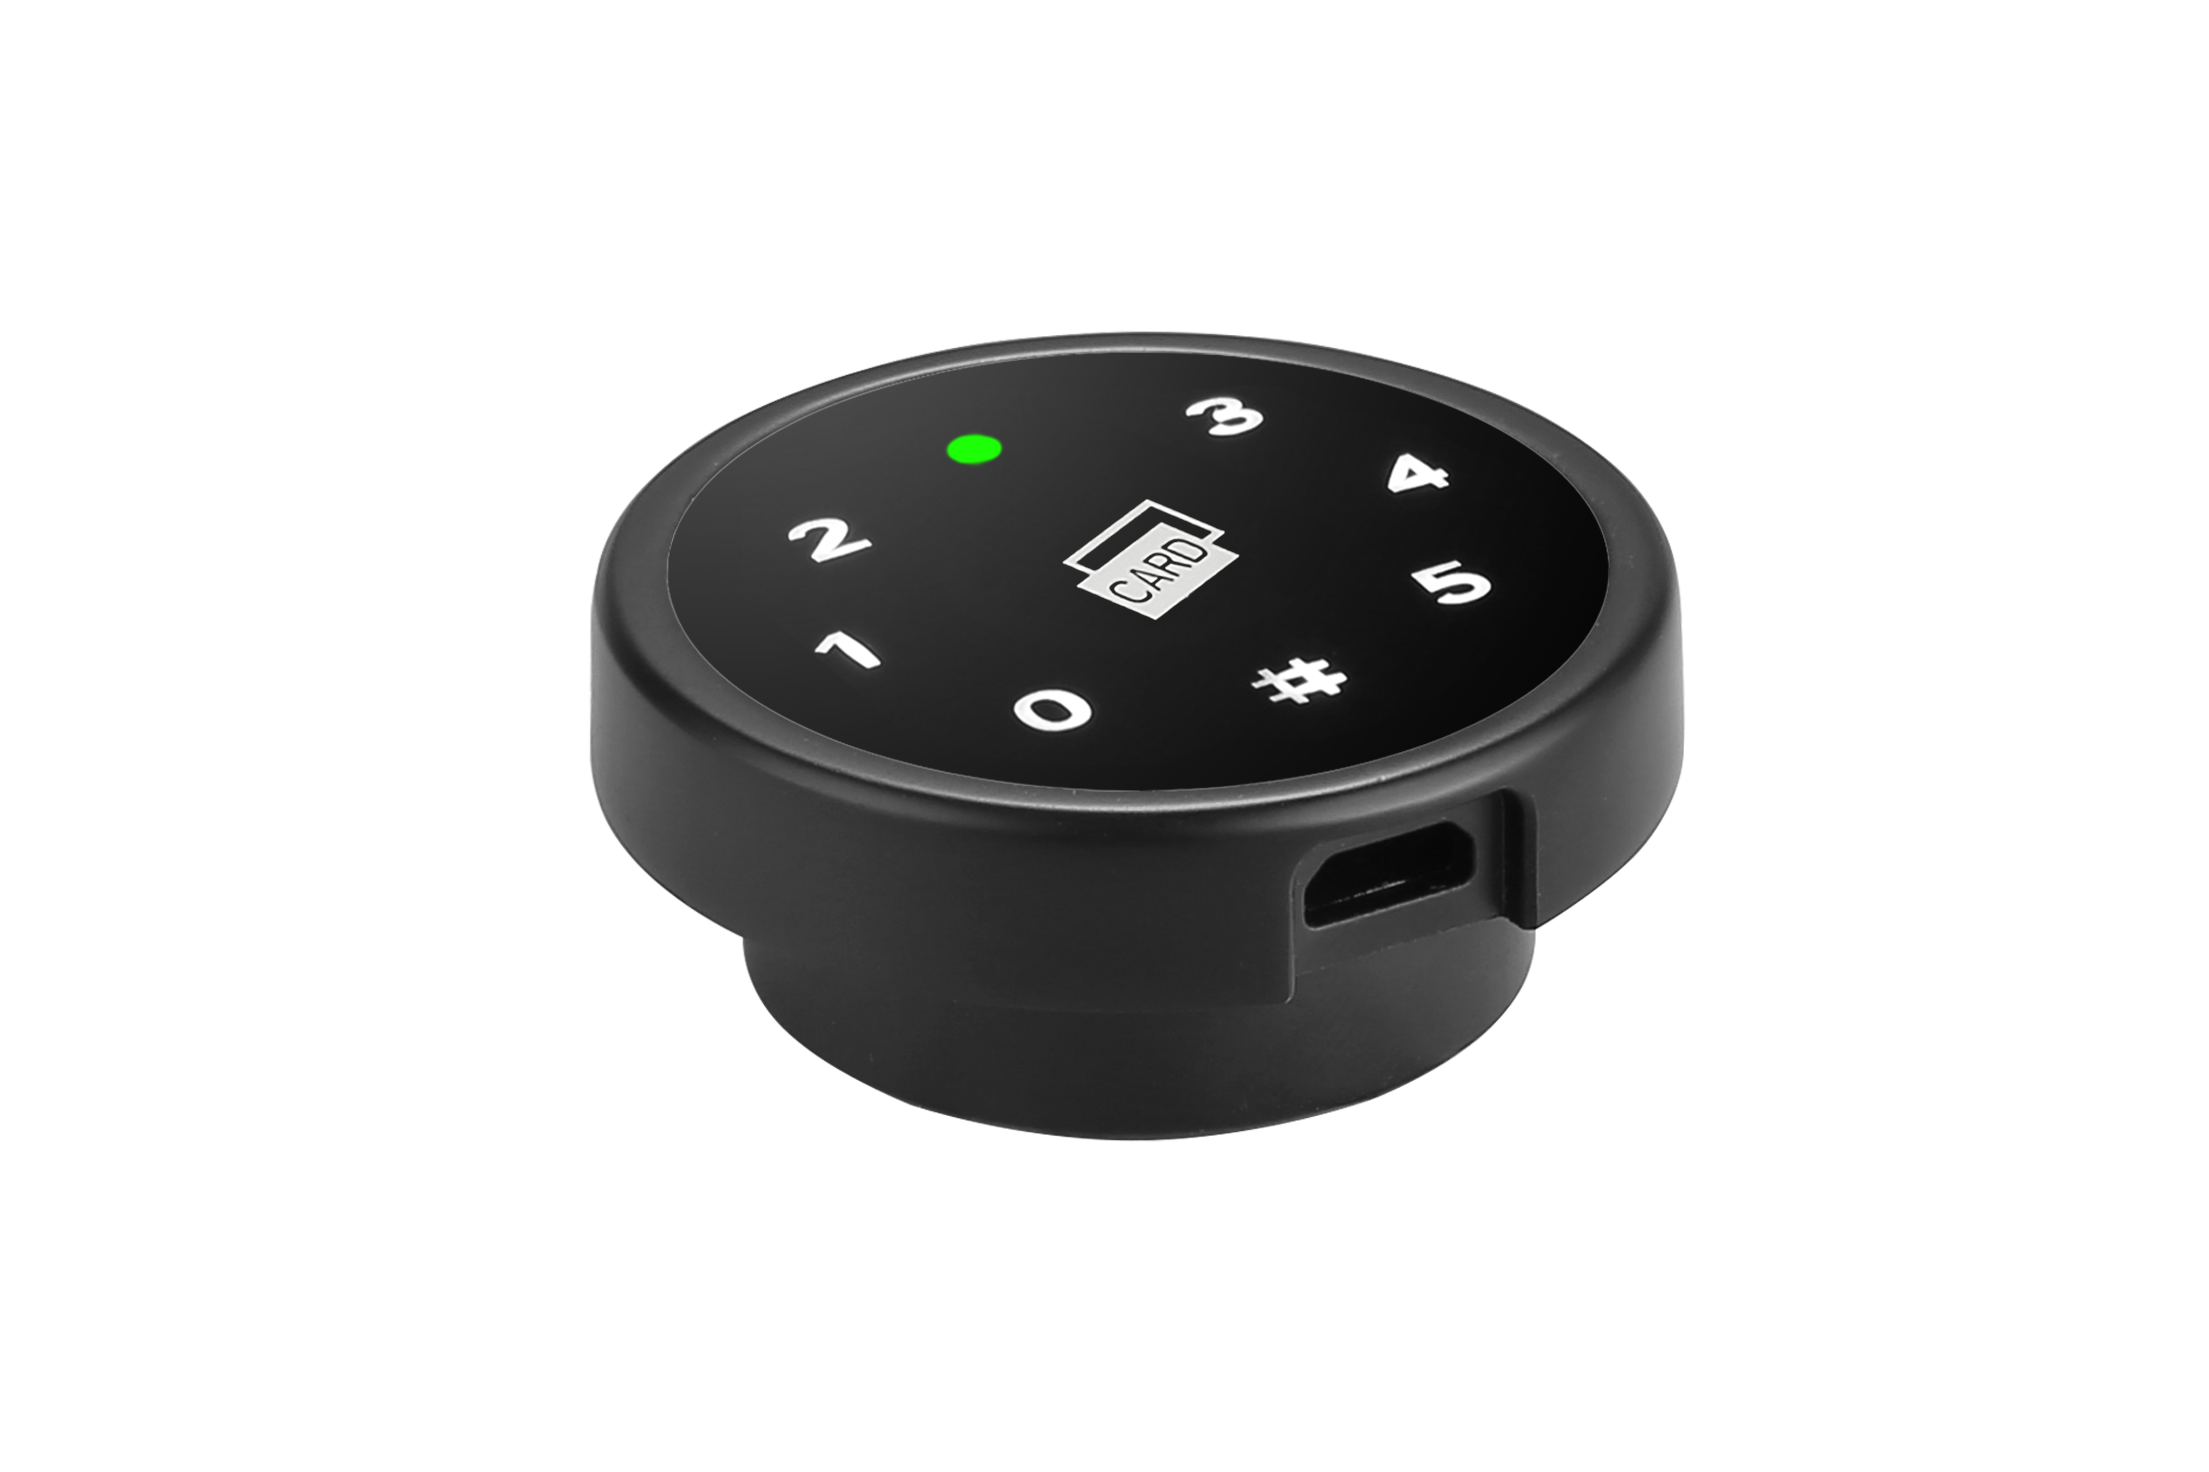
F680 KD680

Features:
- Secure control by level-management；
- Unlock by: Fingerprint/Password/Card;
- Tuya app is available;
- Indicator blinks while in locked status;
- Wrong password or Illegal card or non-registered fingerprint alarm;
- Low battery alarm;
- Anti-picked (prized) alarm;
- External power back up;
- Zinc alloy material;

Technical Parameters
Power supply | 3 x AA alkaline batteries
Static current | ≤20µA
Dynamic current | ≤200mA
Working temperature | -15 ～ +55℃
Working humidity | 20 ～ 95%RH
Alarm voltage | 3.7±0.2V
Fingerprint capacity | 40 pcs
Card capacity | 3 Master & 5 Users
FP | 500DPI
FRR | ≤0.01%
FAR | ≤0.00004%
Door thickness | ≥ 11.00mm
Dimension
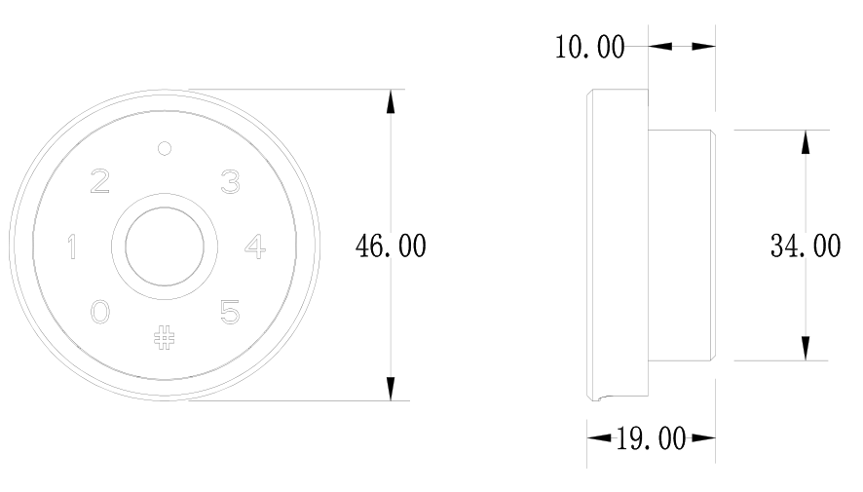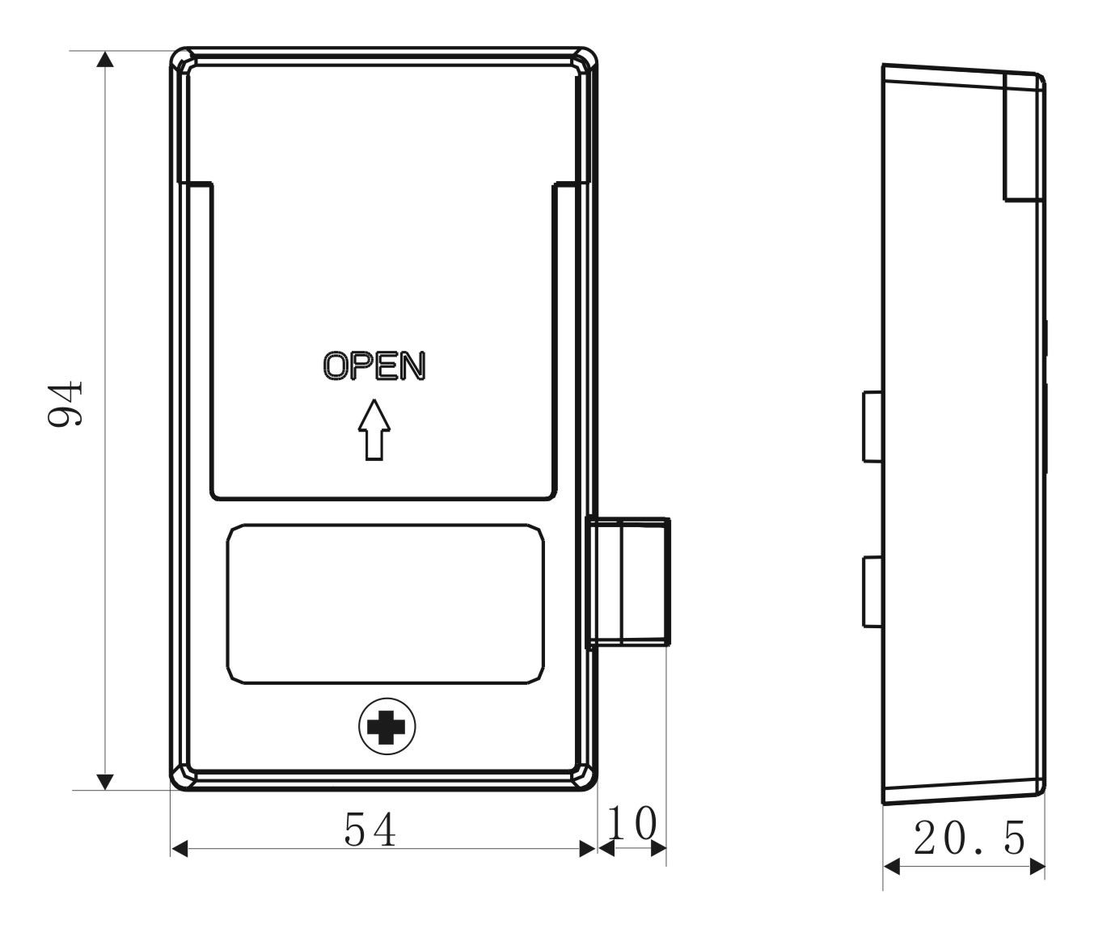
Power Source:
Powered by 3 AA alkaline batteries and low battery consumption; 3pcs last at least 12 months

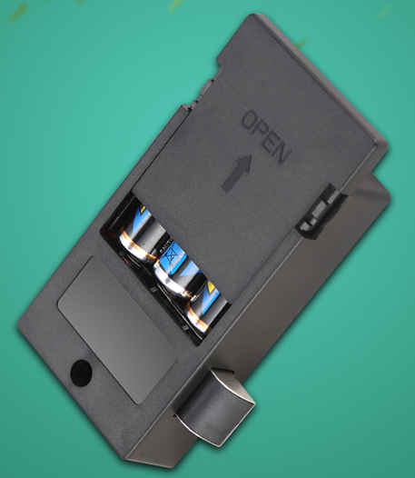
Latch mechanism: 300,000 life times (motor life times:450,000 times);
Tensile strength of the latch part against pulling force:1600N

Emergency Unlocking
In case the batteries are exhausted and it is locked, use the mobile phone charger to insert into the USB port to unlock.

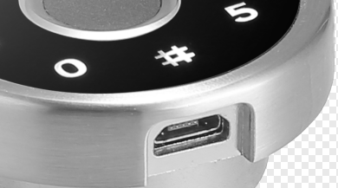

Rear Panels for options:

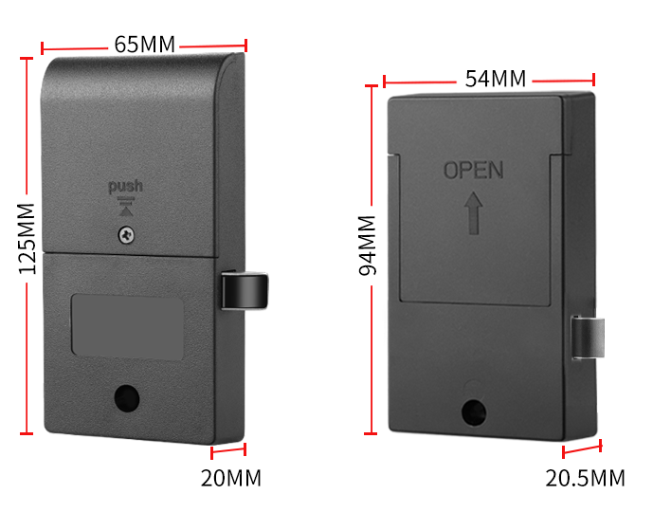
Remarks:
Slim big rear panel is suitable for big or middle-sized cabinet or locker use while mini rear panel is better for smaller cabinet or box use!!!

Standard Package for project:
2pcs/inner box
Carton size: 450mm x 295mm x 245mm
60 pcs/ctn ( 10.50kg)
Single Package for private use:
1pc/each box
Carton size: 450mm x 295mm x 245mm
36 pcs/ctn ( 8kg)

Applications:

