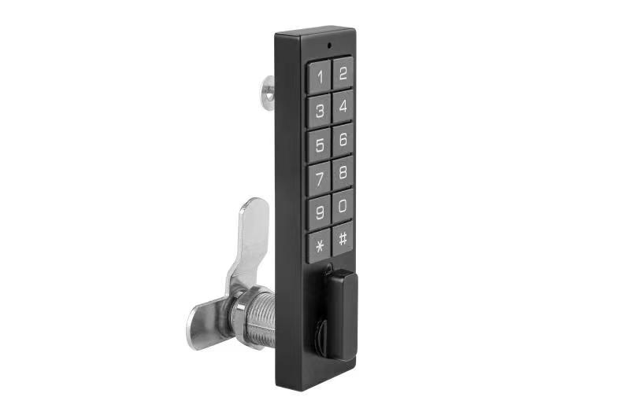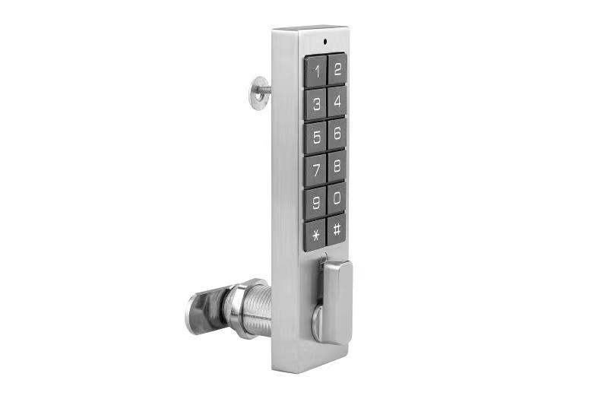
Features:
- Built-in button battery and rechargeable;
- Public or Private mode for options;
- Keypad with backlight for easy distinction;
- Indicator blinks while in locked status;
- Wrong password alarm;
- RED light blinks when the battery voltage is low;
- USB port for battery rechargeable;
- Suitable for any metal or wooden cabinet/drawer;
- Zinc alloy material.

Technical Parameters
Power supply | built-in lithium battery and rechargeable  (3.7V 200MAH)
Battery life | Last at least 2 years; average 20～50 operations every days
Working voltage | DC2.3 ～ 3.3V
Static current | ≤20µA
Dynamic current | ≤200mA
Working temperature | -15 ～ +55℃
Working humidity | 20 ～ 95%RH
Alarm voltage | When the voltage is low, there will be warning when opening
Door thickness | 0.5～12mm(metal) /16 ～ 22mm(wood)

Dimension
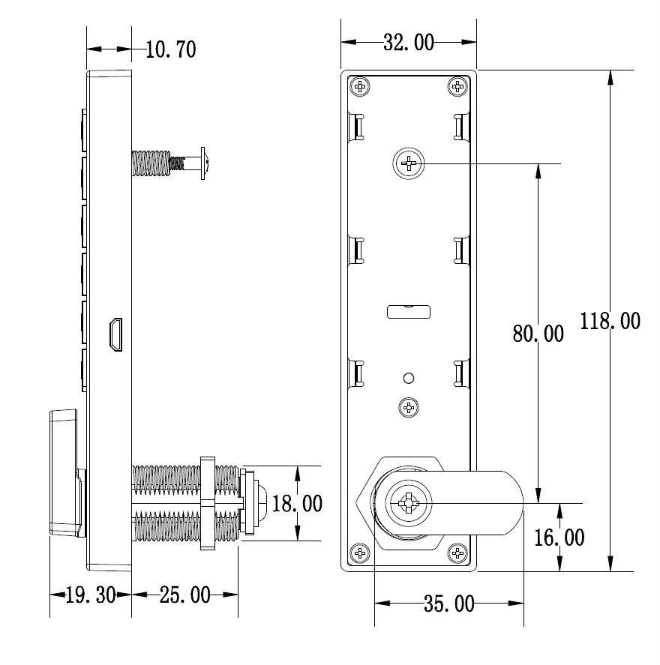

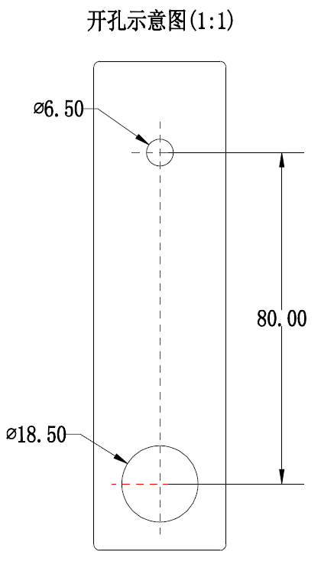

Powered by built-in lithium battery and last for at least 24 months.

In case the batteries are exhausted and it is locked, use a USB charger
to insert into the USB port to charge it at one time and the lock can be used again for a very long time.

Package:
2pcs/inner box
Carton size: 450mm x 295mm x 245mm
36 pcs/ctn (7.80kg)
72 pcs/ctn (14.30kg)

