**F(M)008B Smart Door Lock with App**

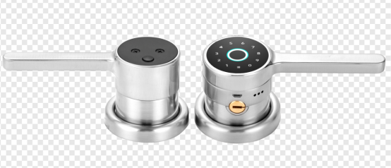 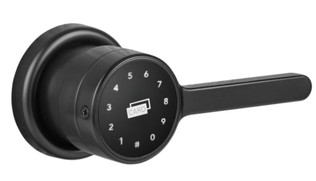

F008B M008B

■ **Product Description**

F(M)008B is a tilted-structure design with appearance patent.

The lock adopts buletooth（TTLOCK）or WiFi (Tuya) as the main control, supports low power consumption blue tooth(BLE4.0), manage the lock(fingerprint, passcode. IC card, e-key) and (remote-WiFi) access through App.

The lock supports firmware update, and software functions can be expanded through firmware update.

The lock is suitable for and widely used in commercial office, residential, government departments, army, banks, hospitals, etc.

**Installation Condition**

Door frame：≥ 110mm;

Door thickness: 30 ～ 65mm;

**Features**

* Tilted structure design for better view and convenient operation;
* **Replace traditional cylindrical knobset directly without any extra hole**;
* Multiple Unlock modes: Fingerprint/ password/M1 card /App;
* Wrong password or illegal card alarm;
* Low voltage alarm;
* Security password;
* Security locking by switch from inside;
* Up to 1000pcs access records can be queried for monitoring;
* Emergency power back-up(USB port);
* Mechanical key override;

**Technical Parameter**

**TT LOCK (Blue tooth) version**

|  |  |  |
| --- | --- | --- |
| Material | Zinc alloy | |
| Power supply | 4.5 ~ 6.5V（4 pcs AA alkaline batteries） | |
| Blue tooth standard | 4.1 BLE | |
| Support phone system | Android 4.3/IOS 7.0 above | |
| Alarm voltage | 4.8V ±0.2V | |
| Static current | ≤60µA | |
| Dynamic current | ≤200 mA | |
| Operating temperature | -20 ~ 70℃ | |
| Operating humidity | 20 ~ 93%RH | |
| Opening time | around 1.5 seconds | |
| FAR(False Acceptance Rate) | <0.001% | |
| FRR(False Reject Rate) | <1.0% | |
| Fingerprint capacity | 120pcs | |
| Mobile phone app | no limitation | |
| Card (Mifare1 card) capacity | 200 pcs | |
| Password capacity | APP send password | 150 pcs |
| Custom password | 150 pcs |

**Dimension**

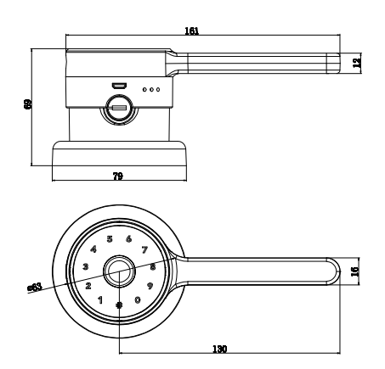 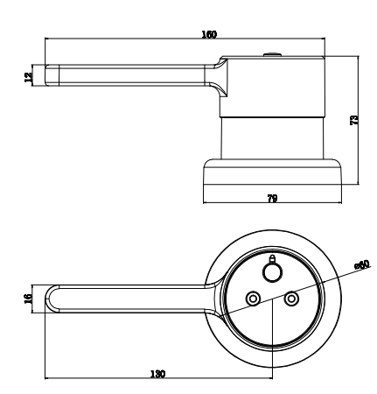

**Assembly Instruction**

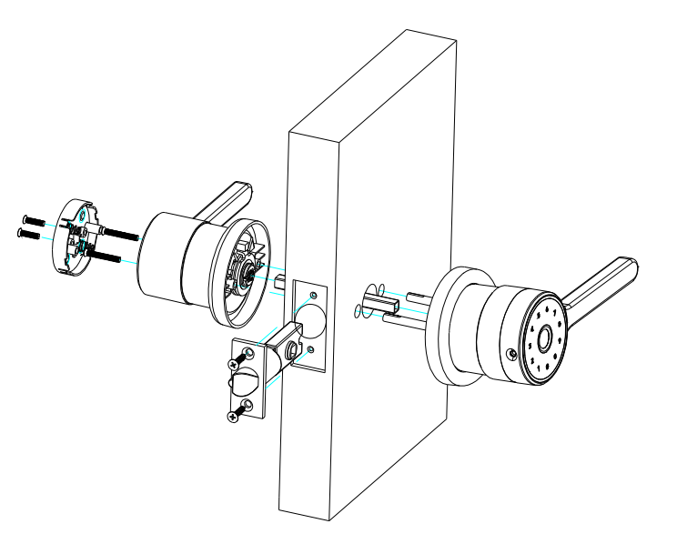

Package:

Inner box: 20.40 x 17.20 x 10.10cm 1.40kg/pc

Carton: 37 x 22x53cm 10pcs/ctn（15.00kg）

防水等级：IP

盐雾测试：拉丝镍 96个小时； 哑光黑 72个小时