**F(M)009 Smart Door Lock with App**

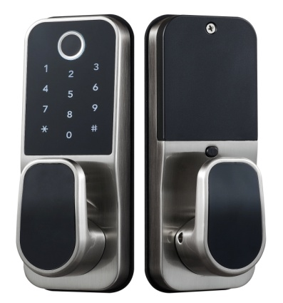 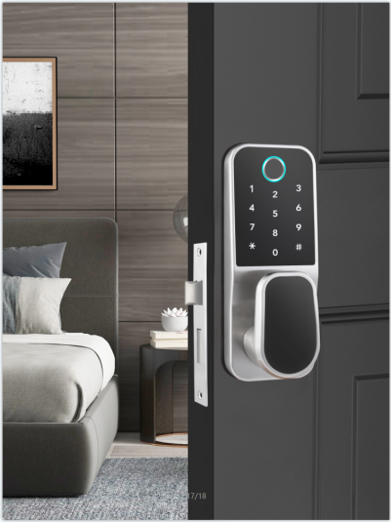 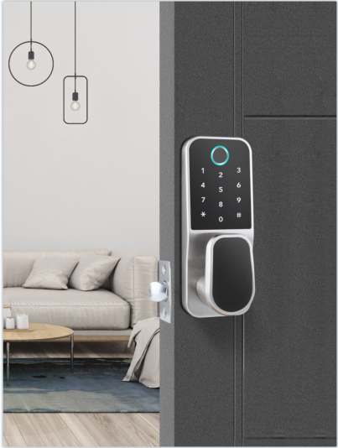

■ **Product Description**

F(M)009 is a tilted-structure design with appearance patent.

The lock adopts bluetooth（TTLOCK）as the main control, supports low power consumption blue tooth(BLE4.0), manage the lock(fingerprint, passcode. IC card, e-key) and (remote-WiFi) access through App.

The lock supports firmware update, and software functions can be expanded through firmware update.

The lock is suitable for and widely used in commercial office, residential, government departments, army, banks, hospitals, etc.

**Installation Condition**

Door frame：≥ 110mm;

Door thickness: 30 ～ 50mm;

Door thickness ≥ 50mm(cylinder pin will be longer);

Suit for push-inside door.

**Features**

* Inclined panel direction for better view and convenient operation;
* Zinc alloy material; strong and long-life lasting;
* Multi unlock modes: fingerprint/passcode/card/smart phone/key
* Passage mode and private mode convertible
* Secure-locking by button from inside enhances privacy and security
* Low voltage alarm;

(When the batteries are low, user put the finger on the reader or enter passcode or scan the card or click the icon on the phone to unlock the door, the lock voice prompts “Low battery, please change the batteries” and the keyboard back lights quickly blinks 1 second.)

* Wrong passcode/illegal card alarm;

(Any wrong passcode or illegal cards attempt 5 times; the keypad will be locked 5 minutes)

* Anti-peep passcode

(Any numbers can be added before or after the correct passcode to avoid the real code to be exposed in front of the strangers)

* Unlock records can be queried
* Emergency power back up by microUSB
* Mechanical key override

**Technical Parameter**

**TT LOCK (Blue tooth) version**

|  |  |  |
| --- | --- | --- |
| Material | Zinc alloy | |
| Power supply | 4.5 ~ 6.5V（4 pcs AA alkaline batteries） | |
| Blue tooth standard | 4.0 BLE (adopt Nordic 51822 blue tooth chip) | |
| Support phone system | Android 4.3/IOS 7.0 above | |
| Alarm voltage | 4.8V ±0.2V | |
| Static current | ≤60µA | |
| Dynamic current | ≤200 mA | |
| Operating temperature | -40 ~ 70℃ | |
| Operating humidity | 20 ~ 93%RH | |
| Opening time | around 1.5 seconds | |
| FAR(False Acceptance Rate) | <0.001% | |
| FRR(False Reject Rate) | <1.0% | |
| Fingerprint capacity | 200pcs | |
| Mobile phone app | no limitation | |
| Card (Mifare1 card) capacity | 100 pcs | |
| Password capacity | APP send password | no limitation |
| Custom password | 150 pcs |

**TUYA WIFI Version**

|  |  |  |
| --- | --- | --- |
| Power supply | 4.5 ~ 6.5V（4 pcs AA alkaline batteries） | |
| Support phone system | Android 4.3/IOS 7.0 above | |
| Alarm voltage | 4.8V ±0.2V | |
| Static current | ≤60µA | |
| Dynamic current | ≤200 mA | |
| Operating temperature | -40 ~ 70℃ | |
| Operating humidity | 20 ~ 93%RH | |
| Opening time | around 1.5 seconds | |
| FAR(False Acceptance Rate) | <0.001% | |
| FRR(False Reject Rate) | <1.0% | |
| Fingerprint capacity | 100pcs | |
| Mobile phone app | One administrator | |
| Card (Mifare1 card) capacity | 50 pcs | |
| Password capacity | APP send password | no limitation |
| Custom password | 10 pcs |

**Dimension**

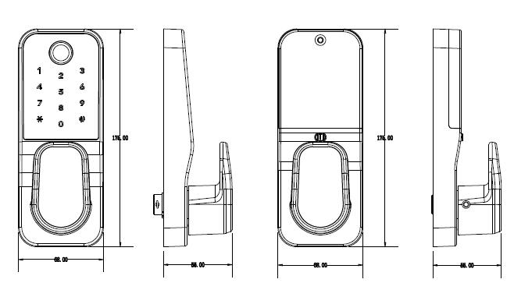

**Assembly Instruction**

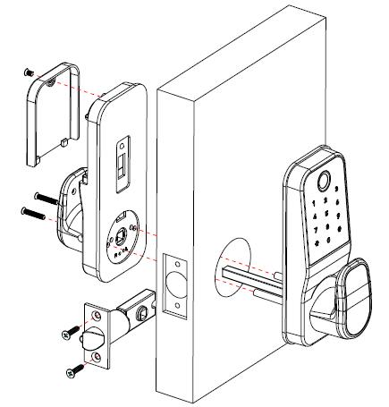

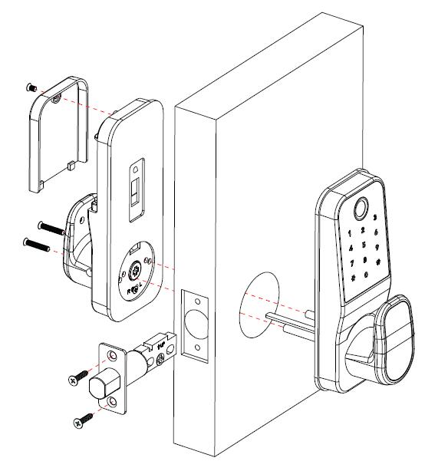

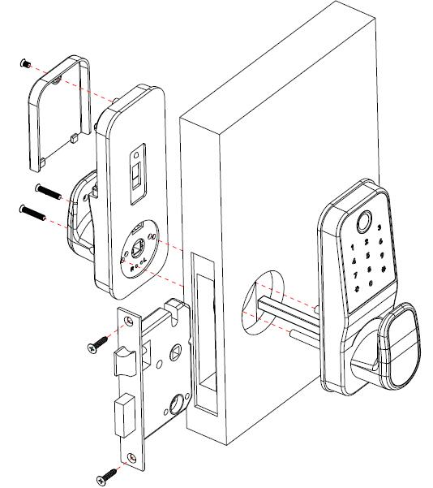

Package:

Inner box: 223 x 212x111mm /pc for latch/deadbolt（1.435 kg）

for mortise

Carton: 450 x 250x580mm 10pcs/ctn (15.35kg)

for latch/deadbolt

for mortise