**F010 Smart Door Lock with App**

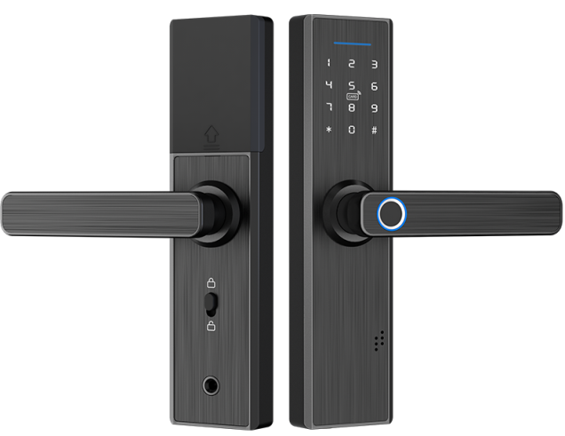 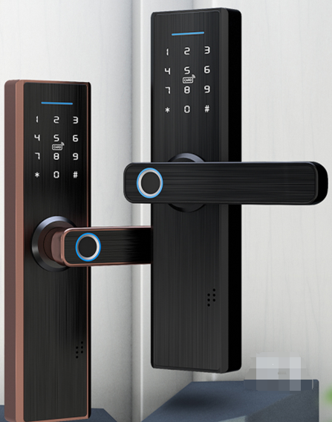

**F010**

**Installation Condition:**

* **Door Thickness:** 30 ～80mm;
* **Application:** Wood door, security door
* Different mortise: latchbolt:60/70mm or 7250 or 5050 optional.

**Features**

* Audio (and menu) guide facilitates set up and operation;
* Multiple Unlock modes: Fingerprint/ password/M1 card /mobile phone App;
* Auto-locking after close door;
* Security locking by lifting the front handle;
* Wrong password (or illegal card) alarm;
* Security password;
* Low voltage alarm;
* Security locking by switch from inside;
* Access records can be queried for monitoring;
* Emergency power back-up(USB port);
* Mechanical key override;

**Technical Parameter**

**TT LOCK (Blue tooth) version**

|  |  |  |
| --- | --- | --- |
| Material | Aluminum | |
| Power supply | 4.5 ~ 6.5V（4 pcs AA alkaline batteries） | |
| Blue tooth standard | 4.0 BLE (adopt Nordic 51822 blue tooth chip) | |
| Support phone system | Android 4.3/IOS 7.0 above | |
| Alarm voltage | 4.8V ±0.2V | |
| Static current | ≤60µA | |
| Dynamic current | ≤200 mA | |
| Operating temperature | -40 ~ 70℃ | |
| Operating humidity | 20 ~ 93%RH | |
| Opening time | around 1.5 seconds | |
| FAR(False Acceptance Rate) | <0.001% | |
| FRR(False Reject Rate) | <0.01% | |
| Fingerprint capacity | 200pcs | |
| Mobile phone app | no limitation | |
| Card (Mifare1 card) capacity | 100 pcs | |
| Password capacity | APP send password | no limitation |
| Custom password | 150 pcs |

**TUYA WIFI Version**

|  |  |  |
| --- | --- | --- |
| Power supply | 4.5 ~ 6.5V（4 pcs AA alkaline batteries） | |
| Support phone system | Android 4.3/IOS 7.0 above | |
| Alarm voltage | 4.8V ±0.2V | |
| Static current | ≤60µA | |
| Dynamic current | ≤200 mA | |
| Operating temperature | -40 ~ 70℃ | |
| Operating humidity | 20 ~ 93%RH | |
| Opening time | around 1.5 seconds | |
| FAR(False Acceptance Rate) | <0.001% | |
| FRR(False Reject Rate) | <0.01% | |
| Fingerprint capacity | 100pcs | |
| Mobile phone app | One administrator | |
| Card (Mifare1 card) capacity | 50 pcs | |
| Password capacity | APP send password | no limitation |
| Custom password | 10 pcs |

**Dimension**

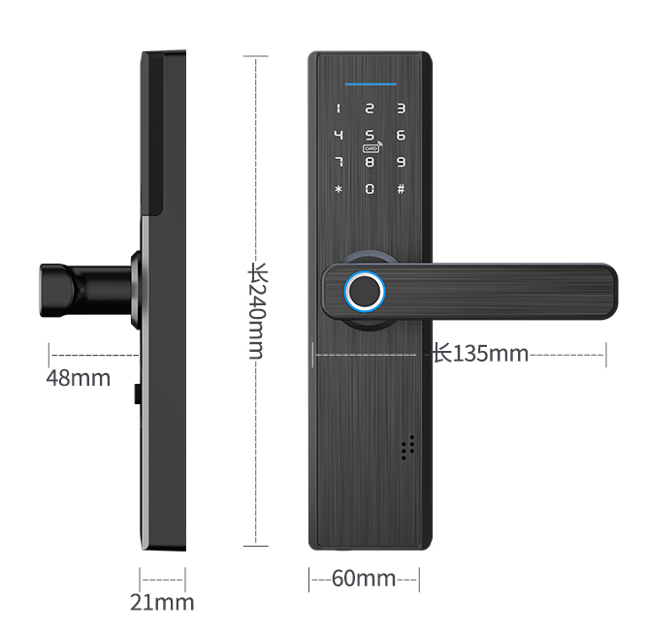

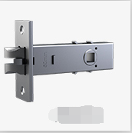 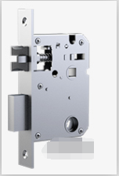

Package:

Inner box: 24 x 21.5x11.40cm 2.50kg/pc

Carton: 45 x 25x58cm 10pcs/ctn（26.00kg）