**F(M)009 Glass Door Lock**

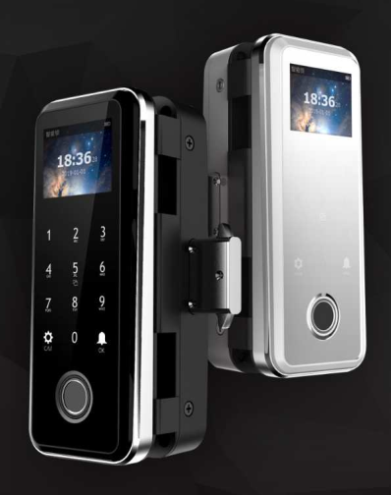 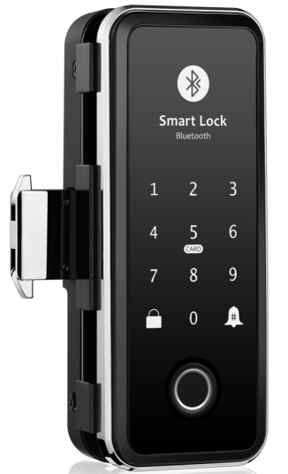

F009(traditional) F009(TTlock app)

**Installation Conditions**

Standard for double doors without frame

Application: wooden door/ Glass door/ aluminum door/

Glass door thickness: 8-12mm

**Features**

* Audio (and menu) guide facilitates set up and operation;
* Multiple Unlock modes: Fingerprint/ password/M1 card /remote controller;
* Wrong password (or illegal card) alarm;
* Low voltage alarm;
* Alarm for not locking properly;
* Passage mode;
* Security password;
* Access records up to 2000pcs;
* Emergency power back-up(USB port);

**Technical Parameter(Traditional)**

|  |  |
| --- | --- |
| Material | Aluminium +ABS |
| Power supply | 4.5 ~ 6.5V（4 pcs AA alkaline batteries） |
| Alarm voltage | 4.8V ±0.2V |
| Static current | ≤55µA |
| Dynamic current | ≤200 mA |
| Operating temperature | -25 ~ 65℃ |
| Operating humidity | 5 ~ 95%RH |
| Opening time | around 1.5 seconds |
| FAR(False Acceptance Rate) | <0.0001% |
| FRR(False Reject Rate) | <1.0% |