**F(M)007-0A Smart Door Lock with App**

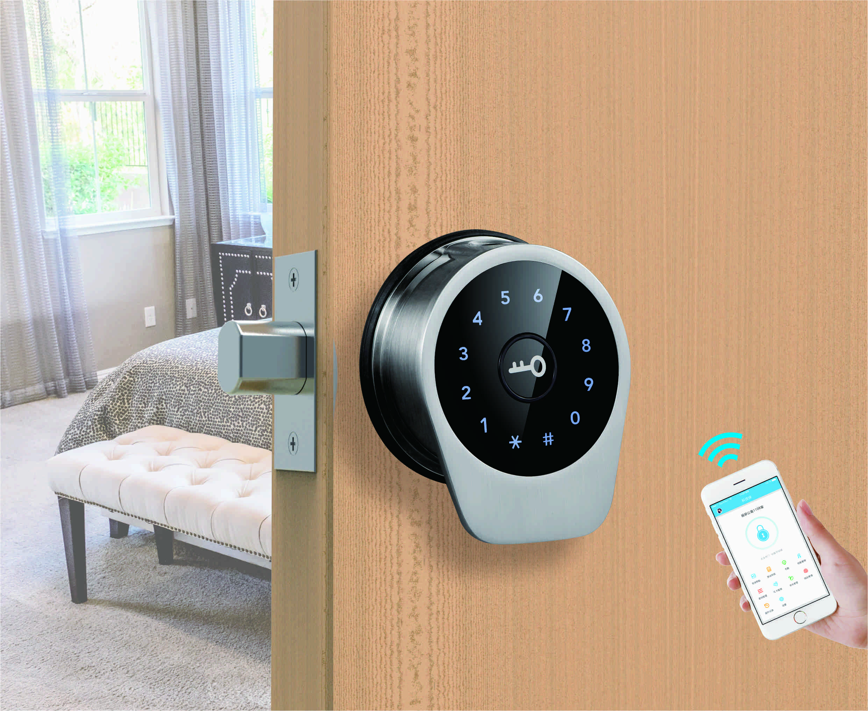

**F（M）007-0A**

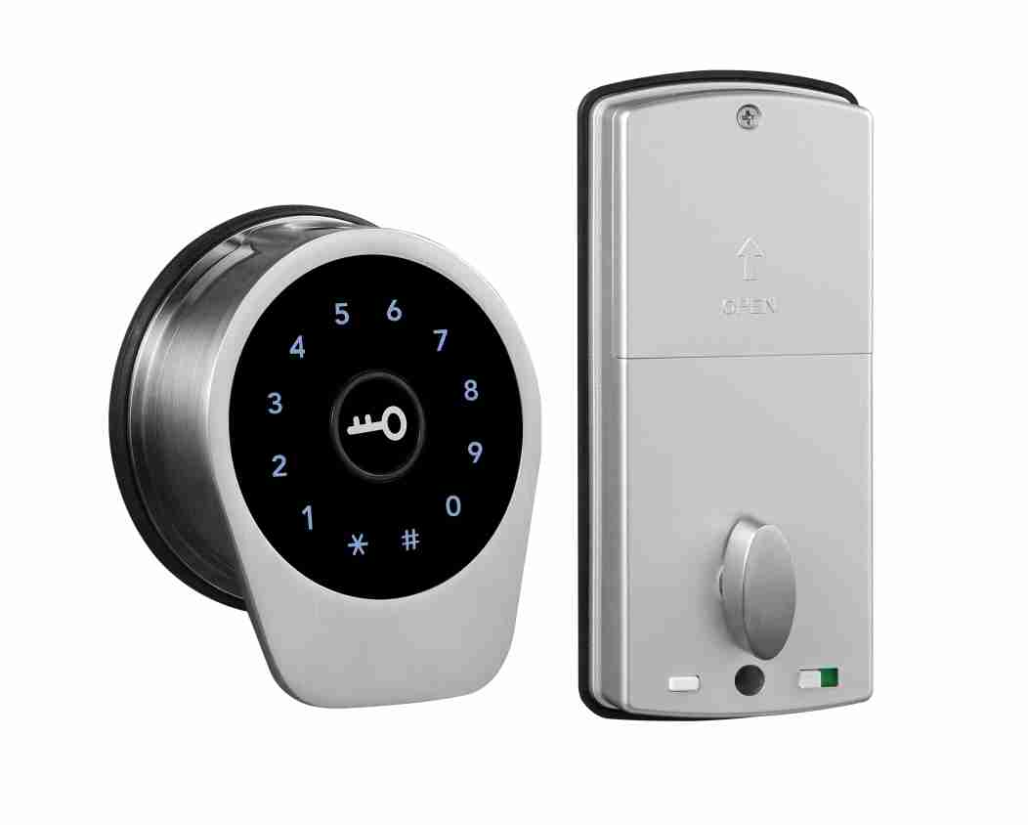 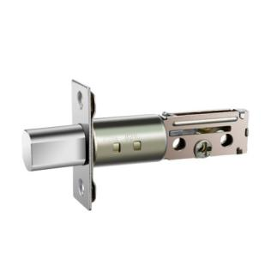

**F（M）007 Latch**

■ **Product Description**

F(M)007 is a tilted-structure design with appearance patent.

The lock adopts buletooth（TTLOCK）or WiFi (Tuya) as the main control, supports low power consumption blue tooth(BLE4.0), manage the lock(fingerprint, passcode. IC card, e-key) and (remote-WiFi) access through App.

The lock supports firmware update, and software functions can be expanded through firmware update.

The lock is suitable for and widely used in commercial office, residential, government departments, army, banks, hospitals, etc.

**Installation Condition**

Door frame：≥ 152mm;

Door thickness: 30 ～ 50mm;

Door thickness ≥ 50mm(cylinder pin will be longer);

Suit for push-inside door.

**Features**

* Tilted structure design for better view and convenient operation;
* Replace the cylindrical lock directly without adding any extra hole;
* Audio (and menu) guide facilitates set up and operation;
* Replace cylindrical lock directly without drilling hole of φ54mm diameter;
* Multiple Unlock modes: Fingerprint/mobile phone App /password/M1 card;
* Door-opening in distance;
* One-time password and timeliness password function available;
* Wrong password (or illegal card) alarm;
* Low voltage alarm;
* Pickproof alarm (optional);
* Security password;
* Security locking by switch from inside;
* Manual-locking or auto-locking available(auto-locking need to add magnetic device)
* Up to 1000pcs access records can be queried for monitoring;
* Emergency power back-up(USB port);
* Mechanical key override;

**Technical Parameter**

**TT LOCK (Blue tooth) version**

|  |  |  |
| --- | --- | --- |
| Power supply | 4.5 ~ 6.5V（4 pcs AA alkaline batteries） | |
| Blue tooth standard | 4.0 BLE (adopt Nordic 51822 blue tooth chip) | |
| Support phone system | Android 4.3/IOS 7.0 above | |
| Alarm voltage | 4.8V ±0.2V | |
| Static current | ≤60µA | |
| Dynamic current | ≤200 mA | |
| Operating temperature | -40 ~ 70℃ | |
| Operating humidity | 20 ~ 93%RH | |
| Opening time | around 1.5 seconds | |
| FAR(False Acceptance Rate) | <0.001% | |
| FRR(False Reject Rate) | <1.0% | |
| Fingerprint capacity | 200pcs | |
| Mobile phone app | no limitation | |
| Card (Mifare1 card) capacity | 100 pcs | |
| Password capacity | APP send password | no limitation |
| Custom password | 150 pcs |

**TUYA WIFI Version**

|  |  |  |
| --- | --- | --- |
| Power supply | 4.5 ~ 6.5V（4 pcs AA alkaline batteries） | |
| Support phone system | Android 4.3/IOS 7.0 above | |
| Alarm voltage | 4.8V ±0.2V | |
| Static current | ≤60µA | |
| Dynamic current | ≤200 mA | |
| Operating temperature | -40 ~ 70℃ | |
| Operating humidity | 20 ~ 93%RH | |
| Opening time | around 1.5 seconds | |
| FAR(False Acceptance Rate) | <0.001% | |
| FRR(False Reject Rate) | <1.0% | |
| Fingerprint capacity | 100pcs | |
| Mobile phone app | One administrator | |
| Card (Mifare1 card) capacity | 50 pcs | |
| Password capacity | APP send password | no limitation |
| Custom password | 10 pcs |

**Dimension**

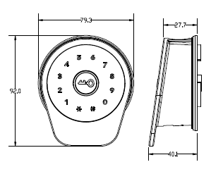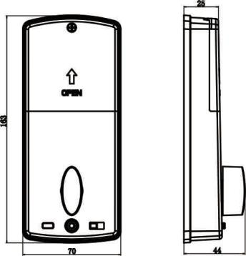

**Assembly Instruction**

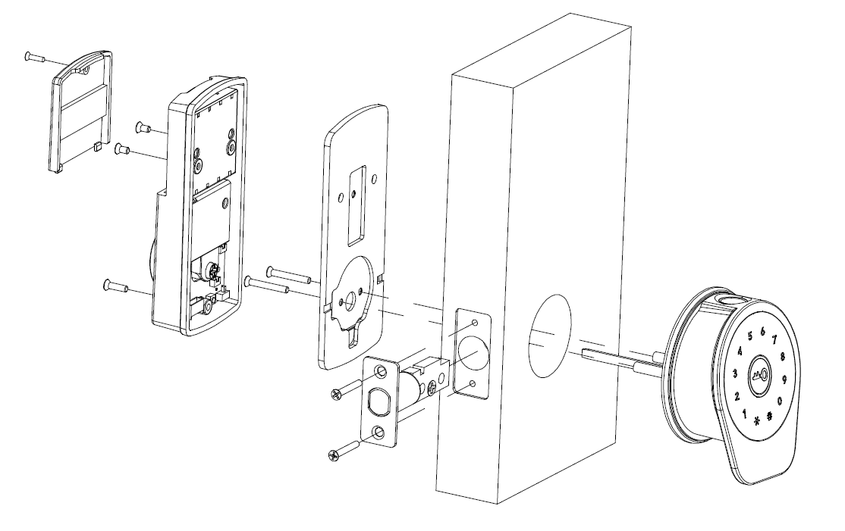

Package:

Inner box: 24 x 21.5x11.40cm 1.15kg/pc (for ABS rear panel)

1.435/pc (for metal rear panel)

Carton: 45 x 25x58cm 10pcs/ctn（12.50kg）for ABS rear panel

(15.35kg) for metal rear panel