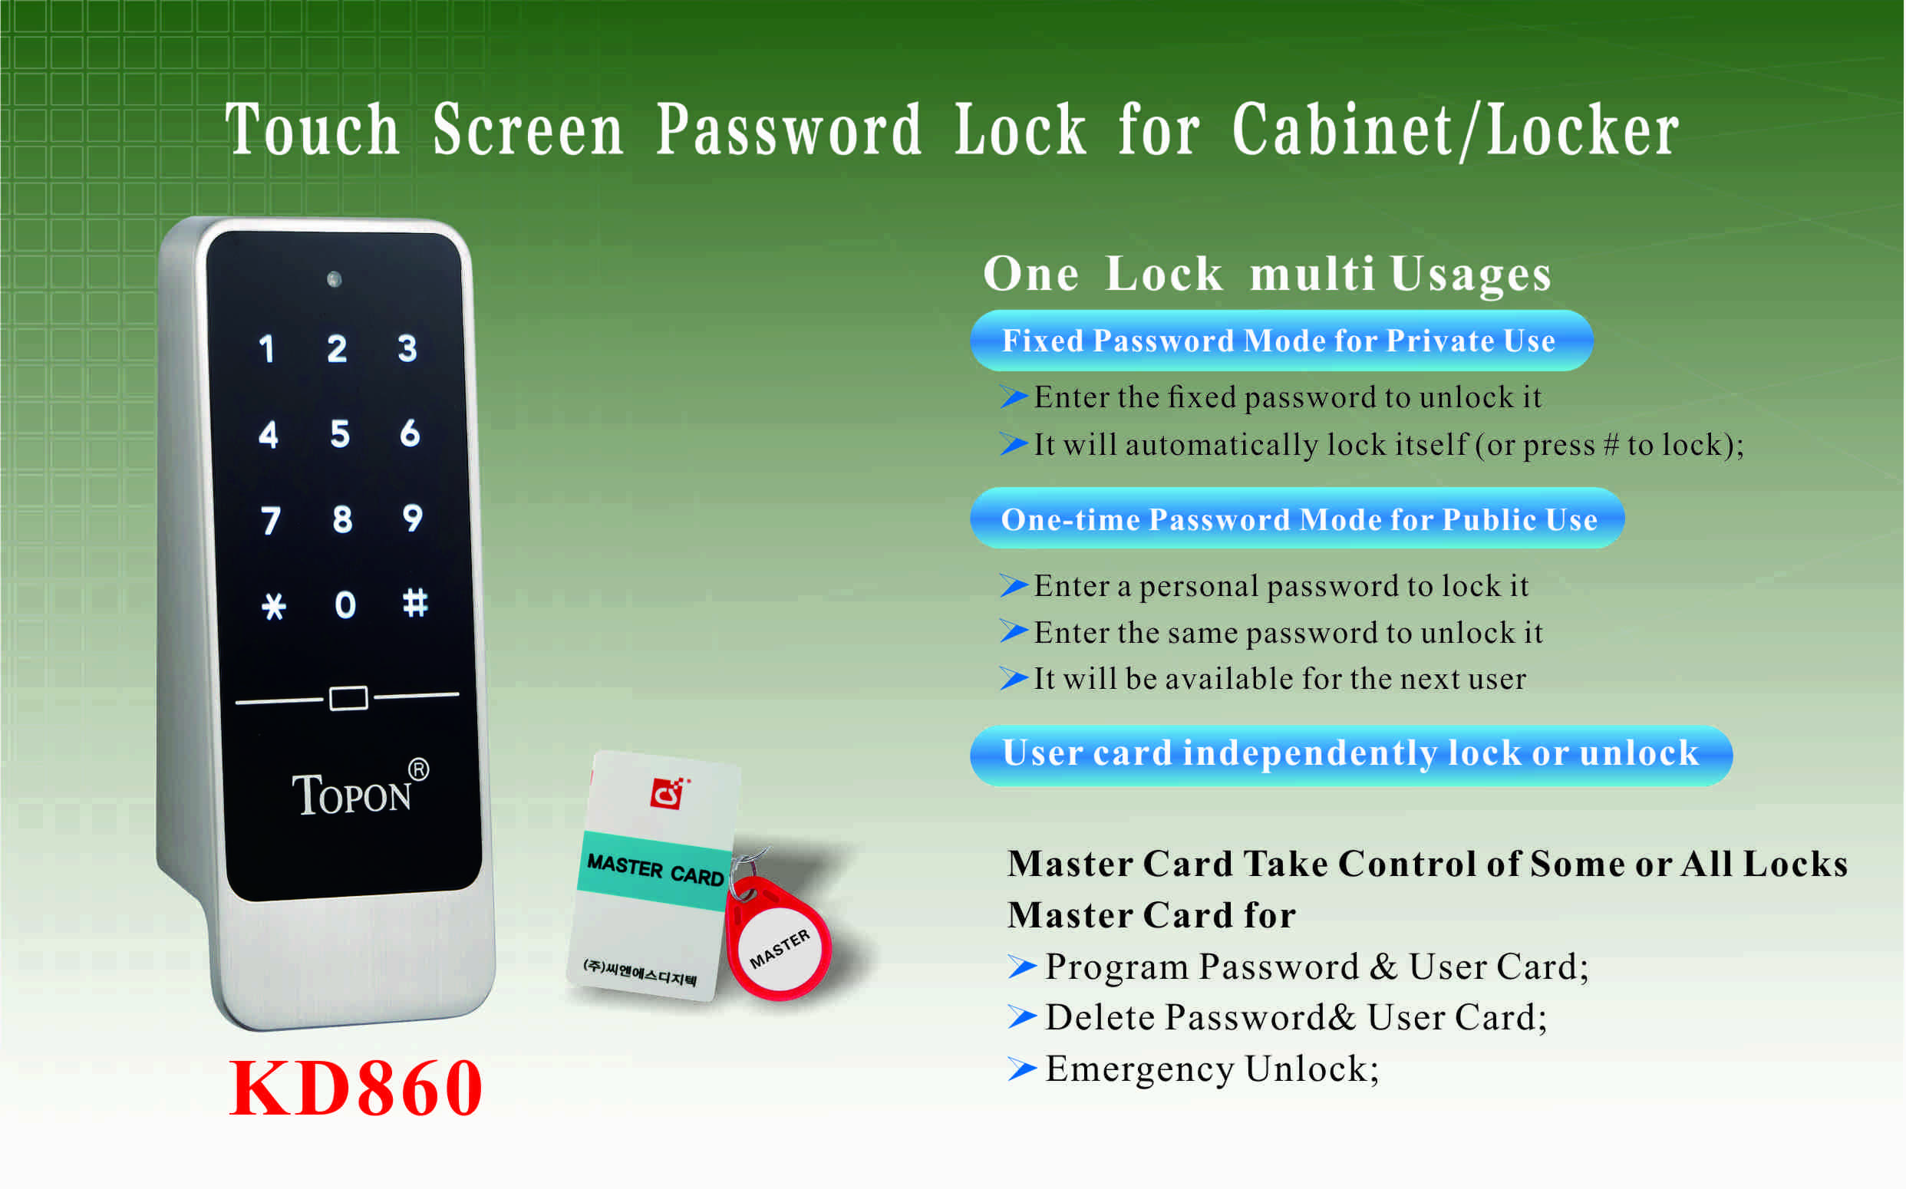

Features:
- Secure control by level management;
- Keyboard with backlight for easy distinction;
- Indicator blinks while in locked status（suitable for public cabinet）;
- Wrong code or illegal card alarm;
- Low battery alarm;
- Anti-picked (prized) alarm;
- External power back up(USB port);
- Zinc alloy material.

Technical Parameters
Power supply | 3 x AA alkaline batteries  DC3.6Ｖ～ DC4.8V
Battery life | 12 months around
Card type | EM card (125KHz)
Static current | ≤20µA
Dynamic current | ≤200mA
Working temperature | -15 ～ +55℃
Working humidity | 20 ～ 95%RH
Alarm voltage | 3.7±0.2V
Door thickness | 13 ～ 22mm

Dimension
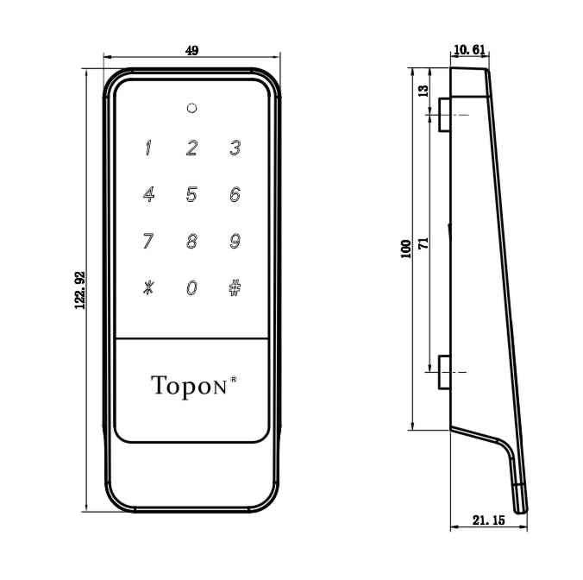

Powered by 3 AA alkaline batteries and batteries last at least 12 months.
Latch mechanism: 300,000 life times (motor life times:450,000 times);
Tensile strength of the latch part against pulling force:1600N
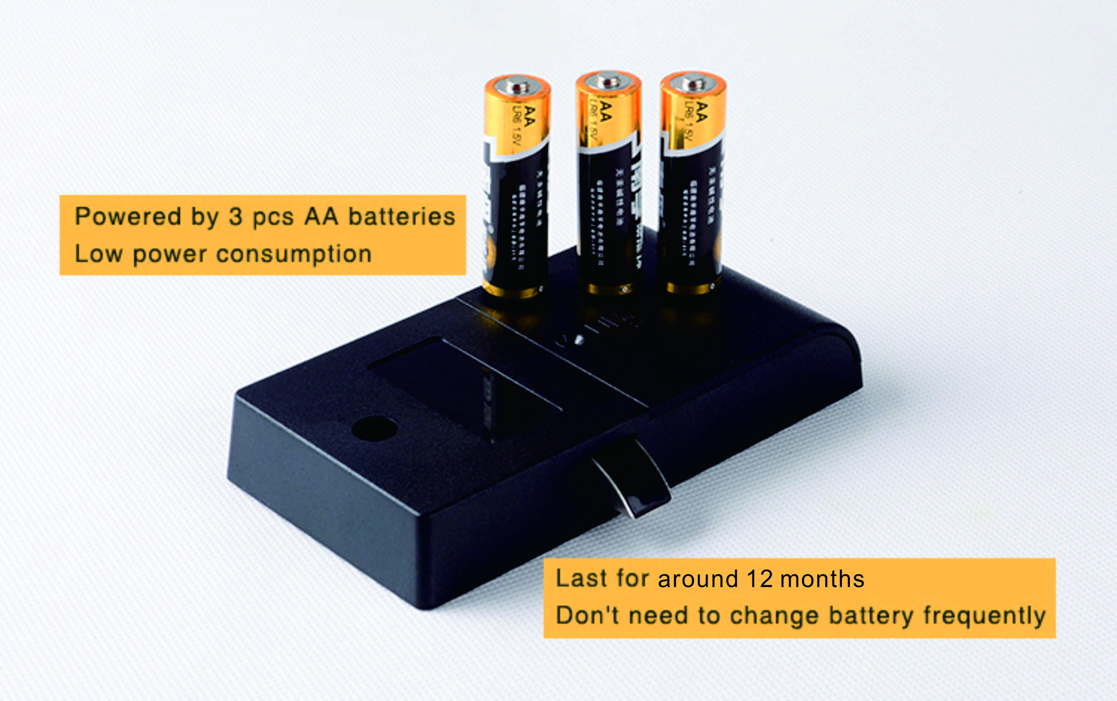
Emergency Unlocking
In case the batteries are exhausted and it is locked, use the mobile phone
charger to insert the USB port at the bottom of the front panel to unlock.

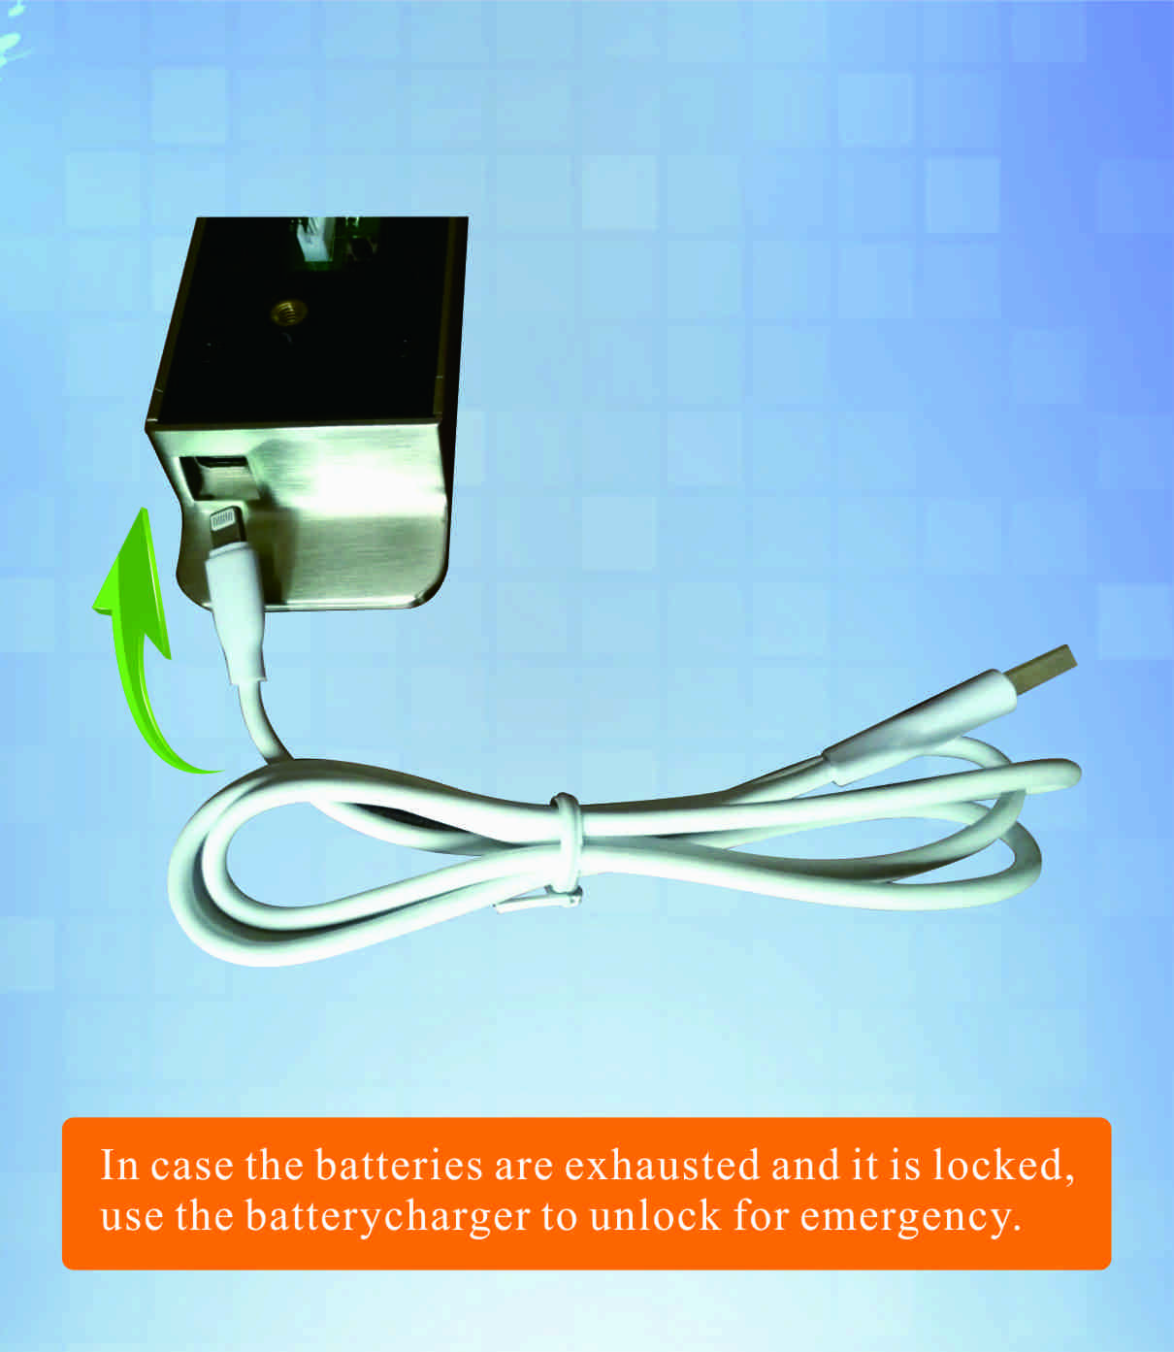
Package:
2pcs/inner box
Carton size: 430mm x 260mm x 250mm
40 pcs/ctn ( 9.3kg)

FAQ
Q: Can this password locker lock be used for public?
A:Yes, you can use it to public, use guest code to close it, then same code to open it.
Q: Is master card available for the digital locker lock?
A:It is available, it will be provided master card to open the lock for emergency.
Q: If user forgot password, how to open the locker?
A:Use master card to unlock it.

Q: What can we do if the power is exhausted.
A:There is a consecutive 8 sounds as alarm from the locks when the battery is low and open by code or card, and please replace the batteries after sound alarm.
If the batteries are dead in the locker lock, use external power to open it and change batteries.

