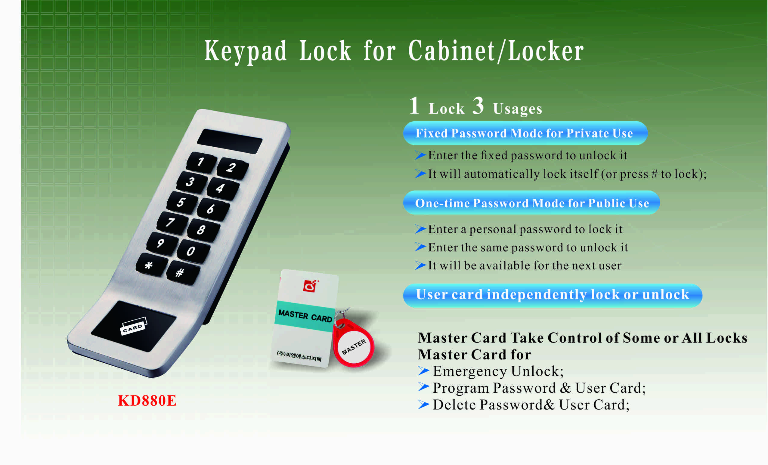

Features:
- Secure control by level management;
- Keypad with backlight for easy distinction;
- Indicator blinks while in locked status;
- Wrong code or illegal card alarm;
- Low battery alarm;
- Anti-picked (prized) alarm;
- External power back up;
- Stainless steel material.

Technical Parameters
Power supply | 3 x AA alkaline batteries
Battery life | 12～15 months
Static current | ≤20µA
Dynamic current | ≤200mA
Working temperature | -15 ～ +55℃
Working humidity | 20 ～ 95%RH
Alarm voltage | 3.7±0.2V
Door thickness | ≥ 1mm

Dimension

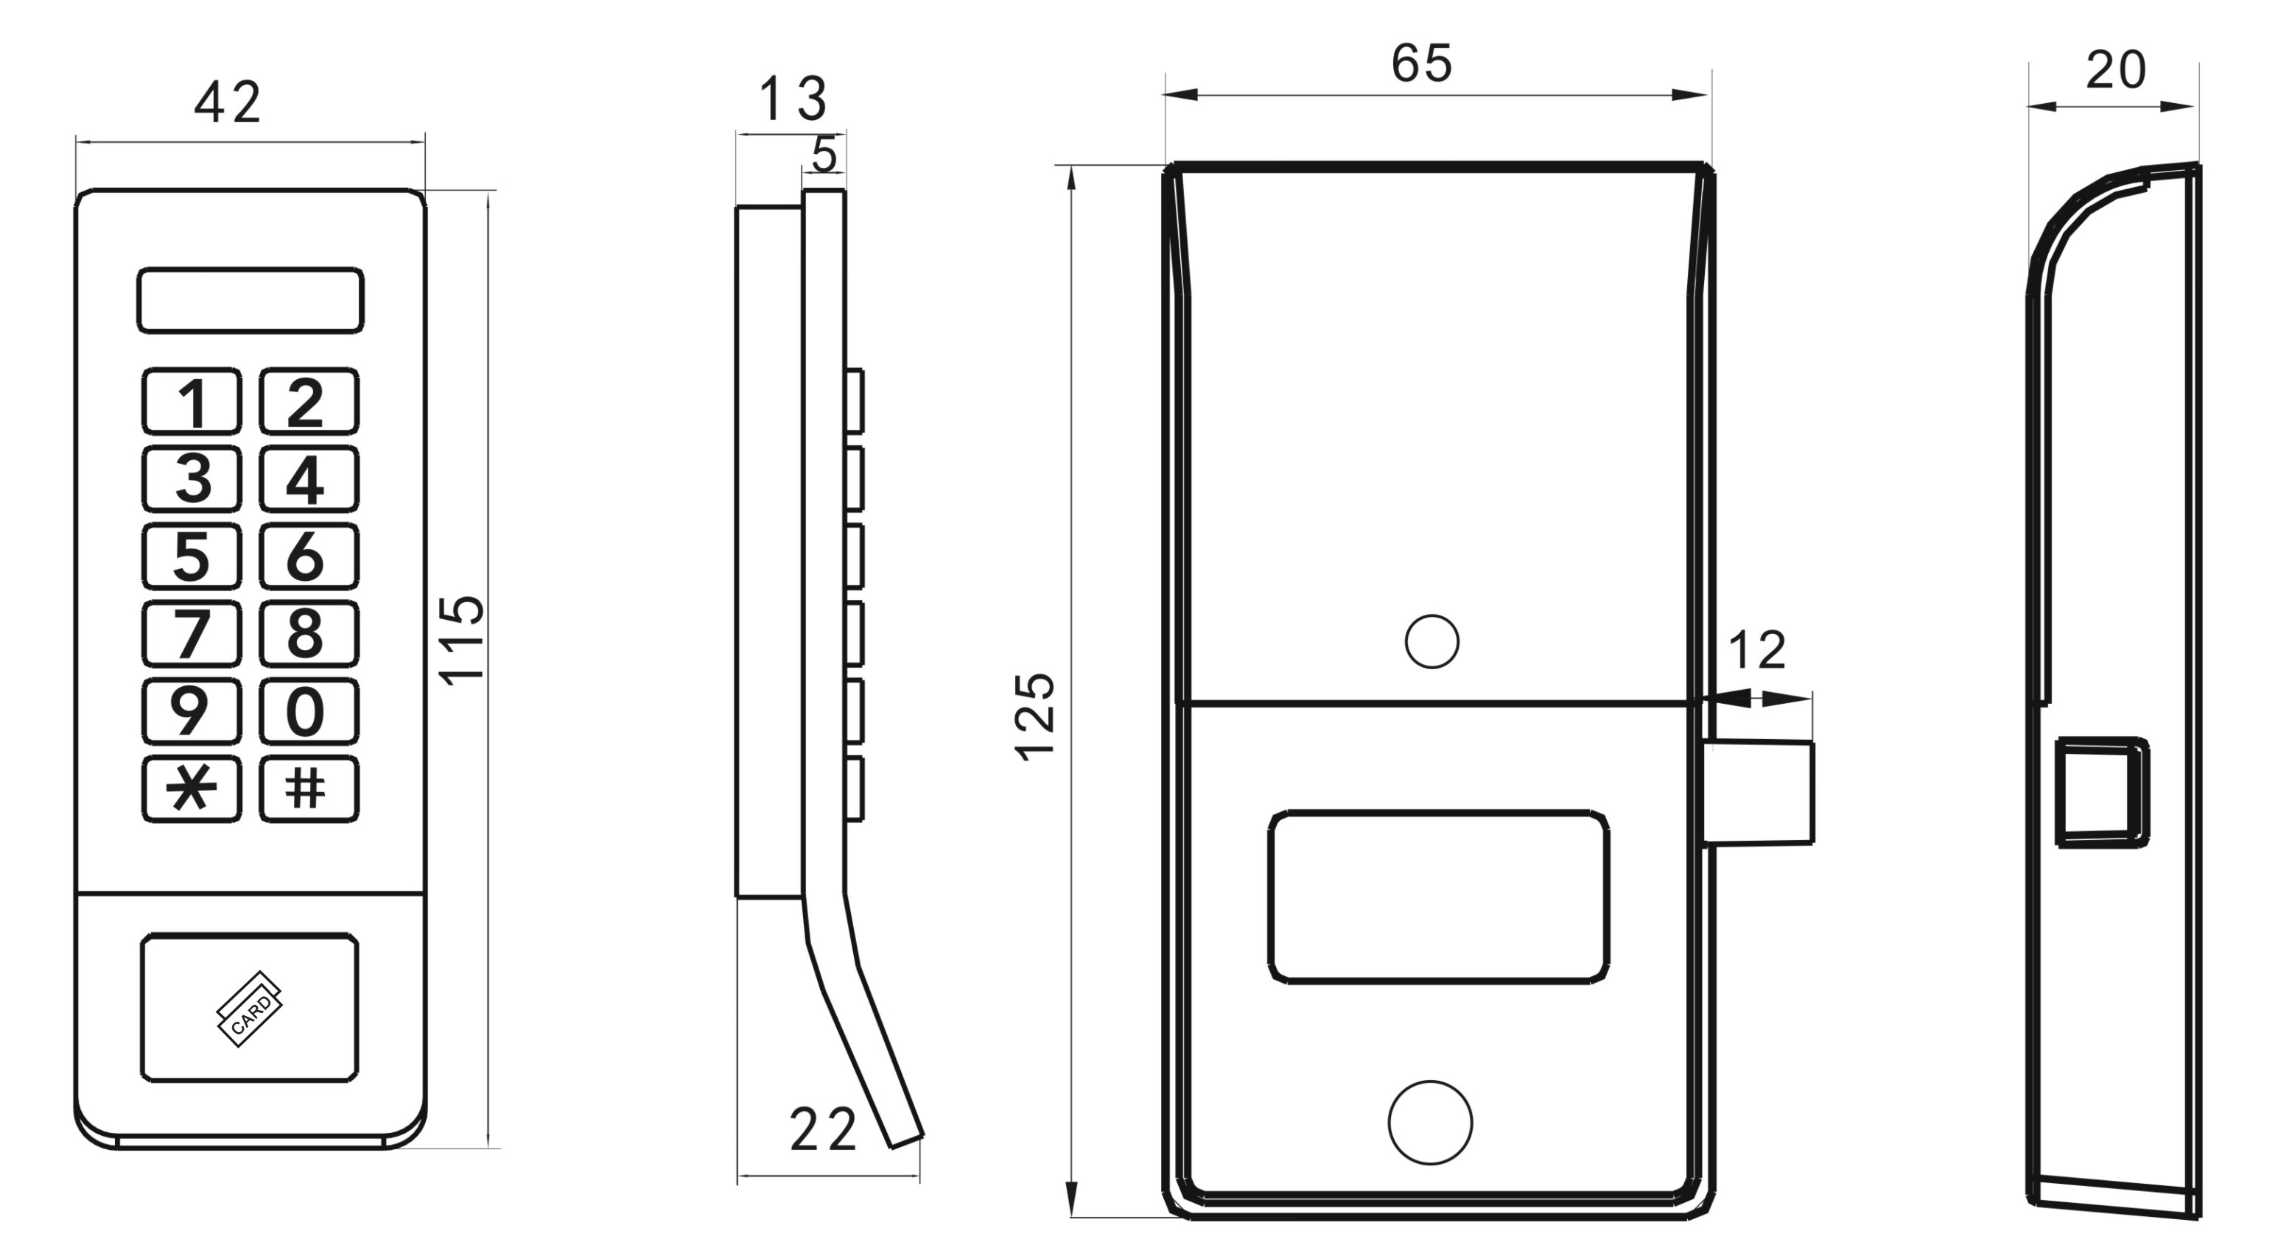

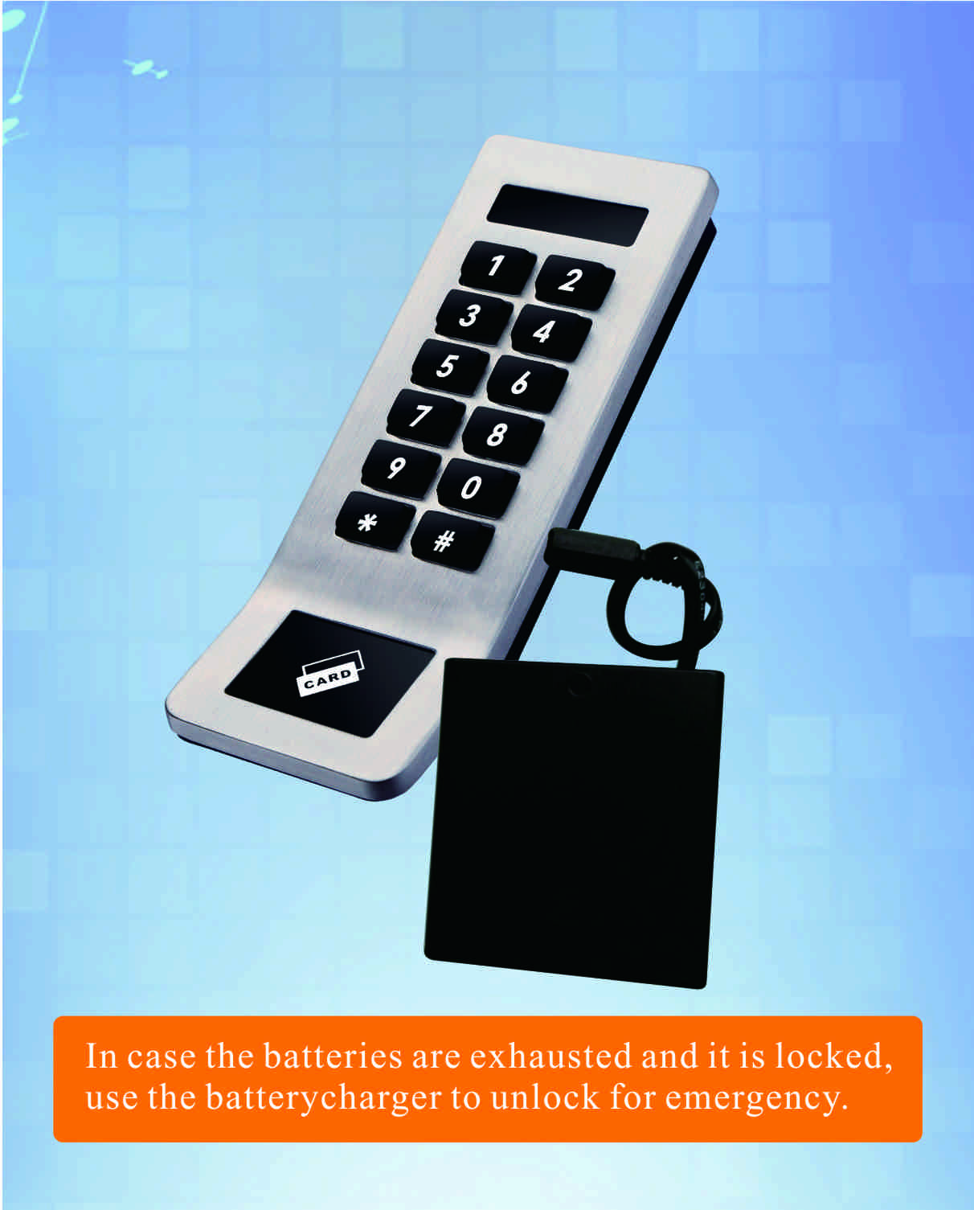

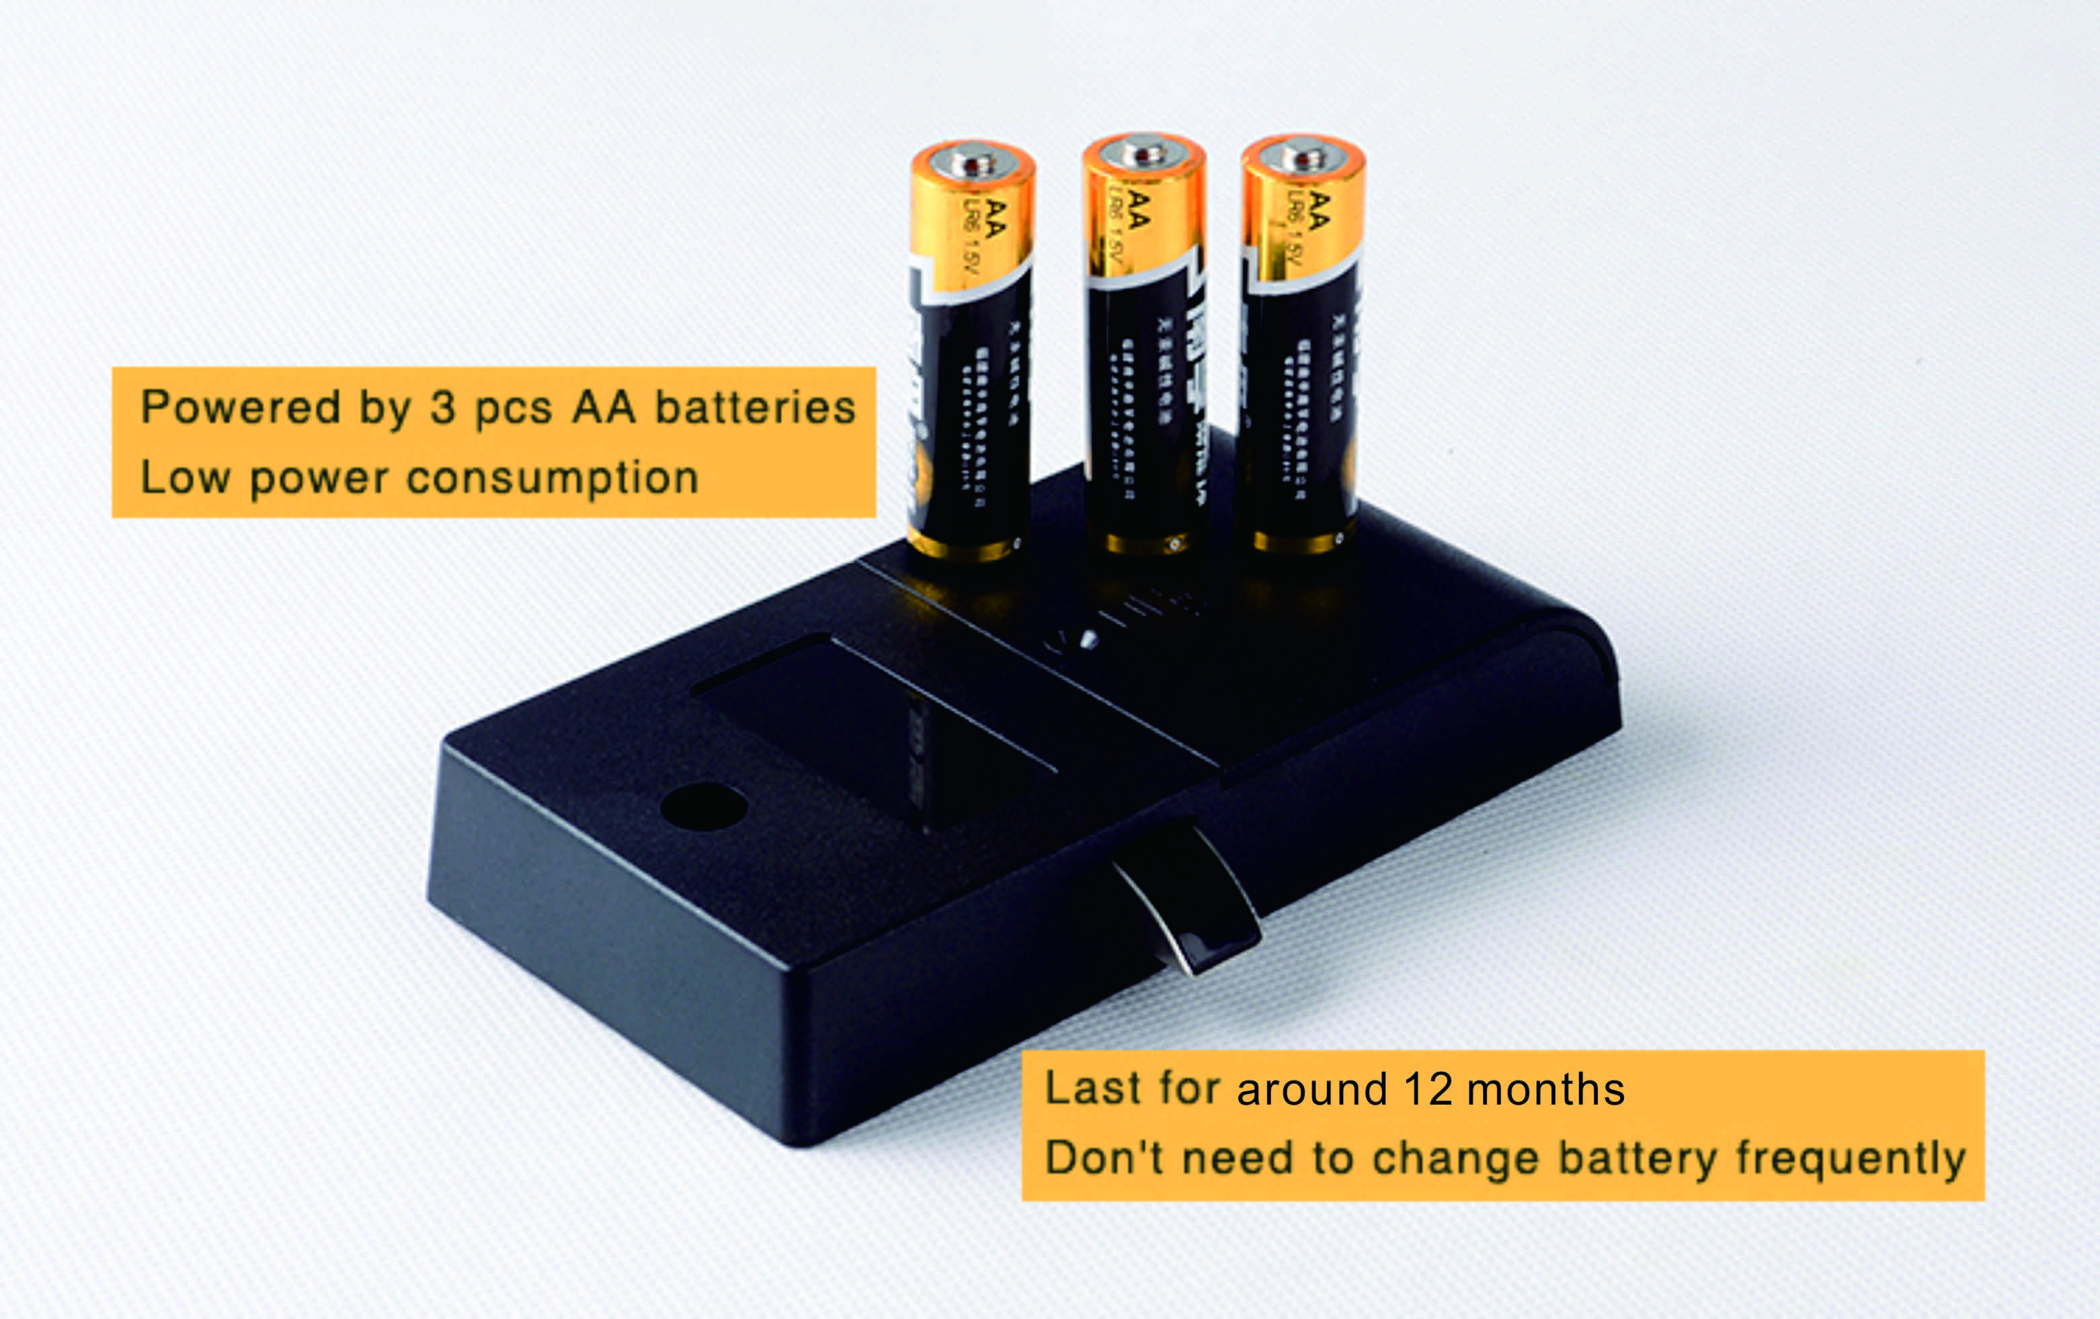
Latch mechanism: 300,000 life times (motor life times:450,000 times);
Tensile strength of the latch part against pulling force:1600N

Project Case:

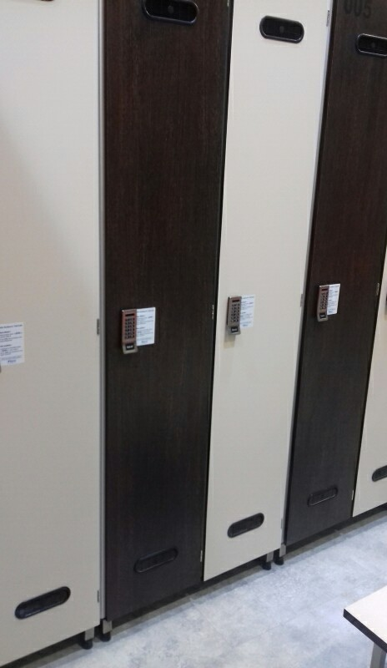
Package:
2pcs/inner box
Carton size: 430mm x 270mm x 220mm
60 pcs/ctn (11.50kg)

FAQ
Q:Can this password locker lock be used for public?
A:Yes, you can use it to public, use user code to lock it, then use the same code to
Unlock it.
Q:Is master card available for the digital locker lock?
A:It is available, it will be provided master card to open the lock for emergency.
Q:If user forgot password, how to open the locker?
A:Use master card to unlock it.

Q:What can we do if the power is exhausted.
A:There is consecutive 8 sounds as alarm from the locks, and please replace the batteries after sound alarm.
If the batteries are dead in the locker lock, use external power to open it and change batteries.

