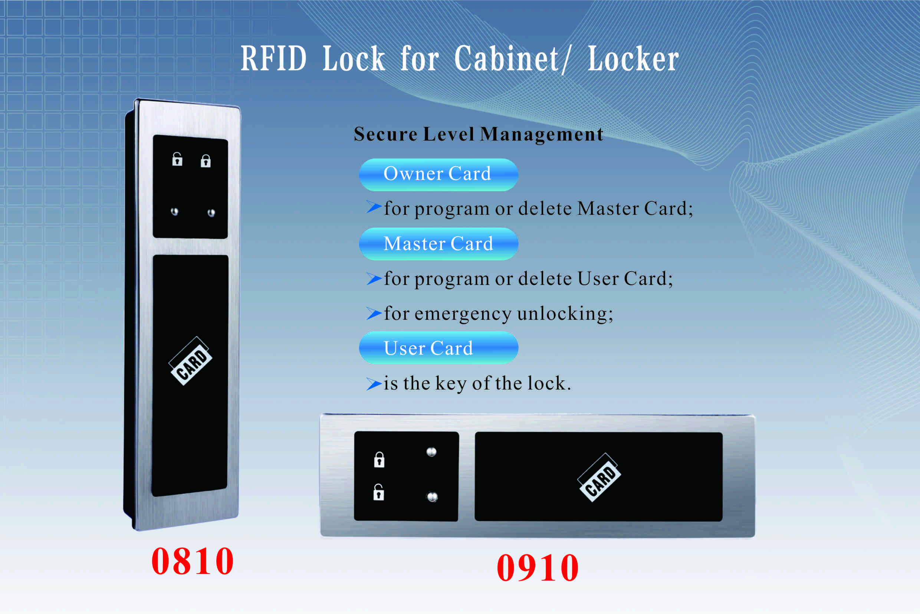
Features:
- 3-level management mode; easy to program;
- No need extra programming devices;
- LED in 2 colors for lock status(green and red)；
- Manual- or auto-locking optional;
- Indicator blinks while in locked status;
- Illegal card alarm;
- Low battery alarm;
- Anti-picked (prized) alarm;
- External power back up;
- ABS plastic material

Technical Parameters
Power supply | 4 x AA alkaline batteries
Card type | 13.56MHz Mifare1 card
Static current | ≤25µA
Dynamic current | ≤200mA
Working temperature | -15 ～ +55℃
Working humidity | 20 ～ 95%RH
Alarm voltage | 4.5±0.2V
Card type | EM Low frequency 125KHz
Card type | Mifare1 High frequency 3.56MHz
Door thickness | ≥ 1mm

Dimension

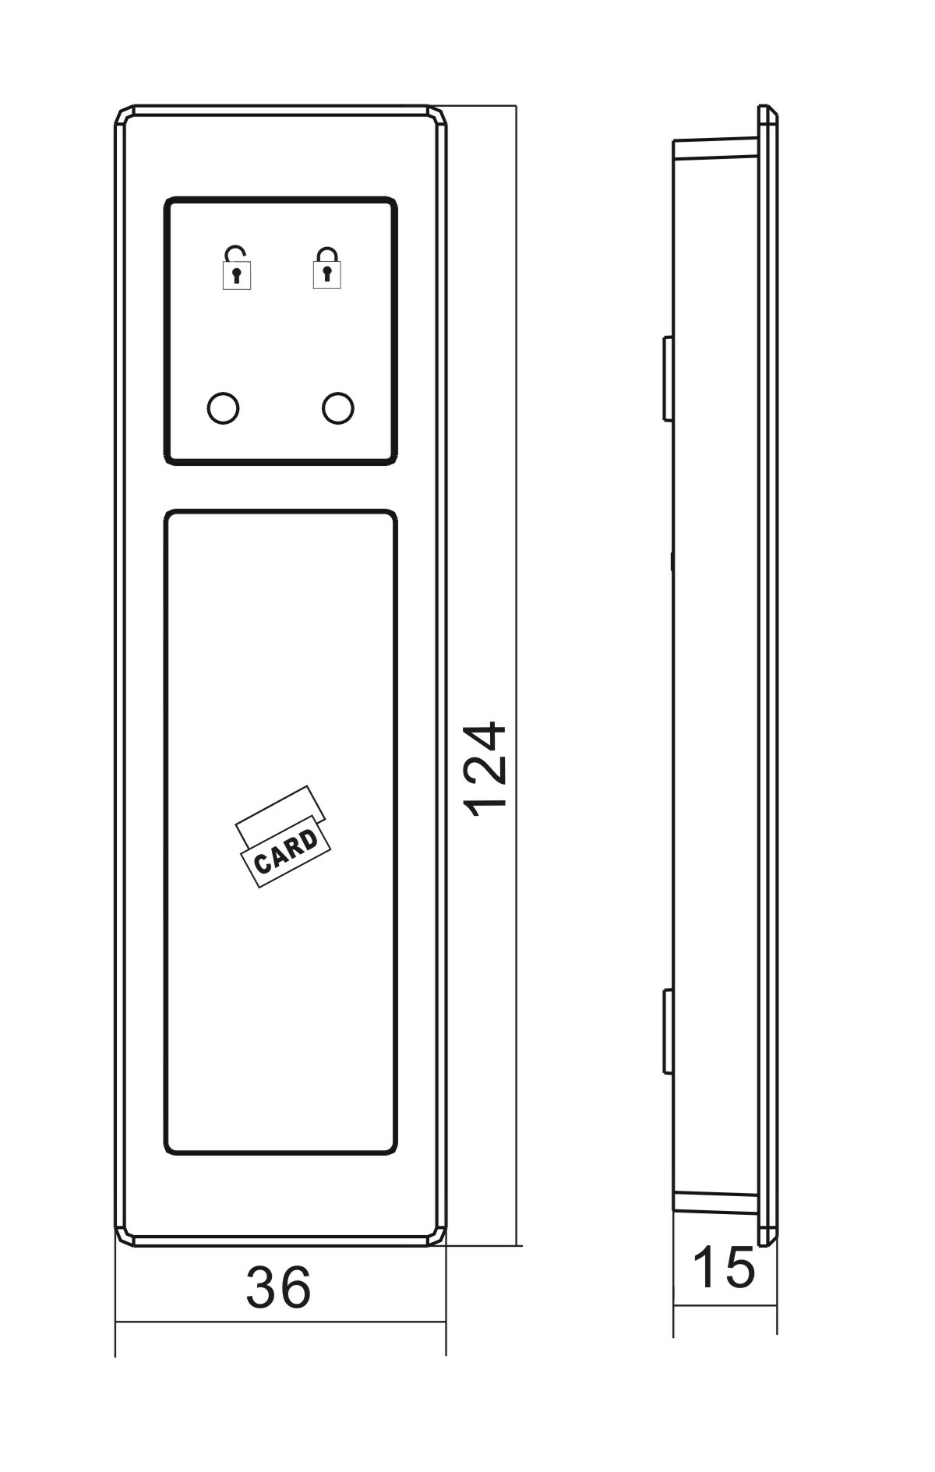
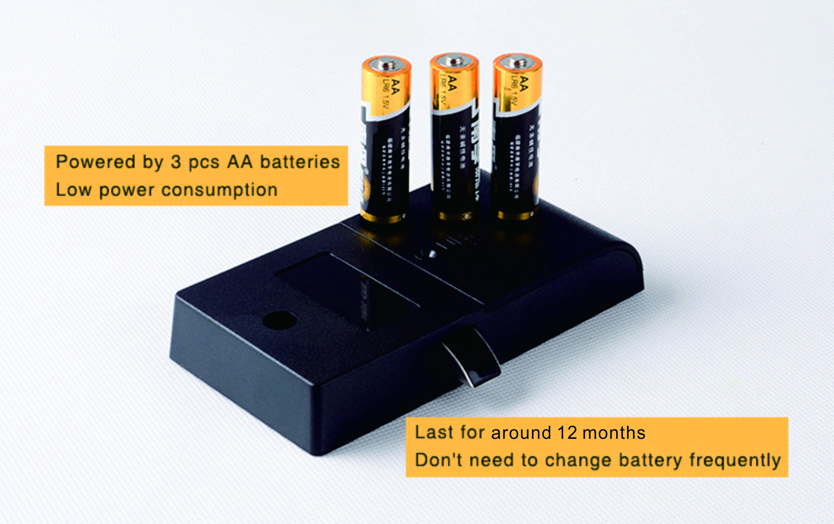
Latch mechanism: 300,000 life times (motor life times:450,000 times);

Emergency Unlocking by holding the 9V battery charger on the emergency contacts when the batteries are exhausted.
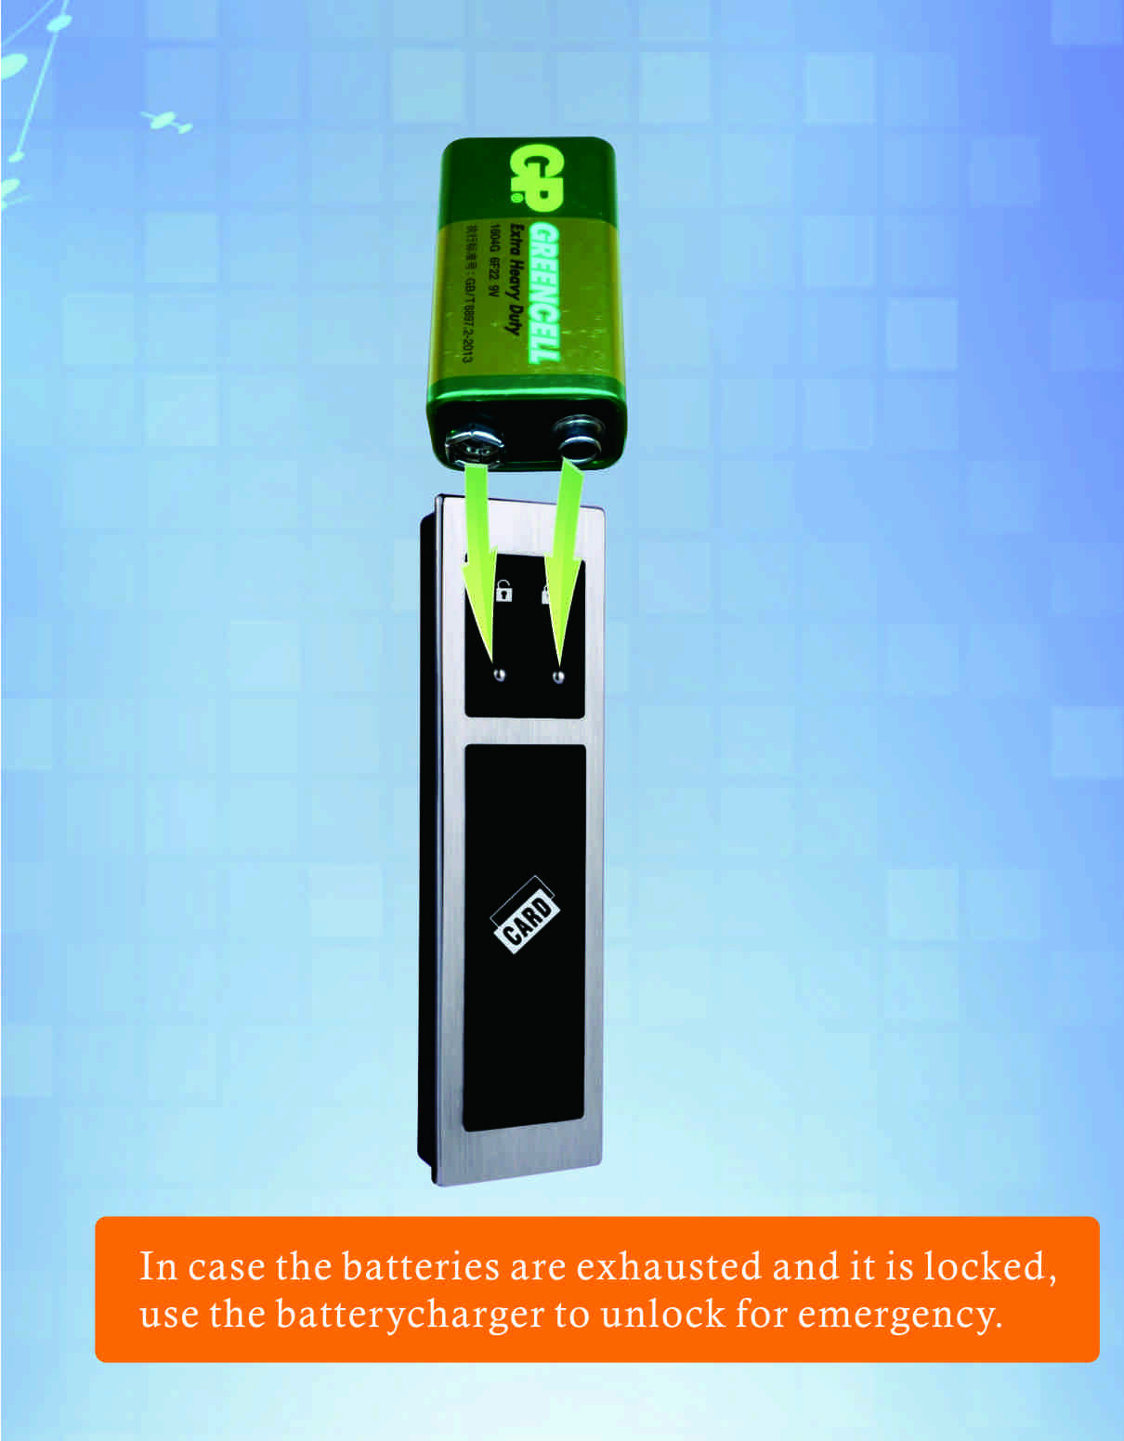

User Card & Wrist Keyband for Options:
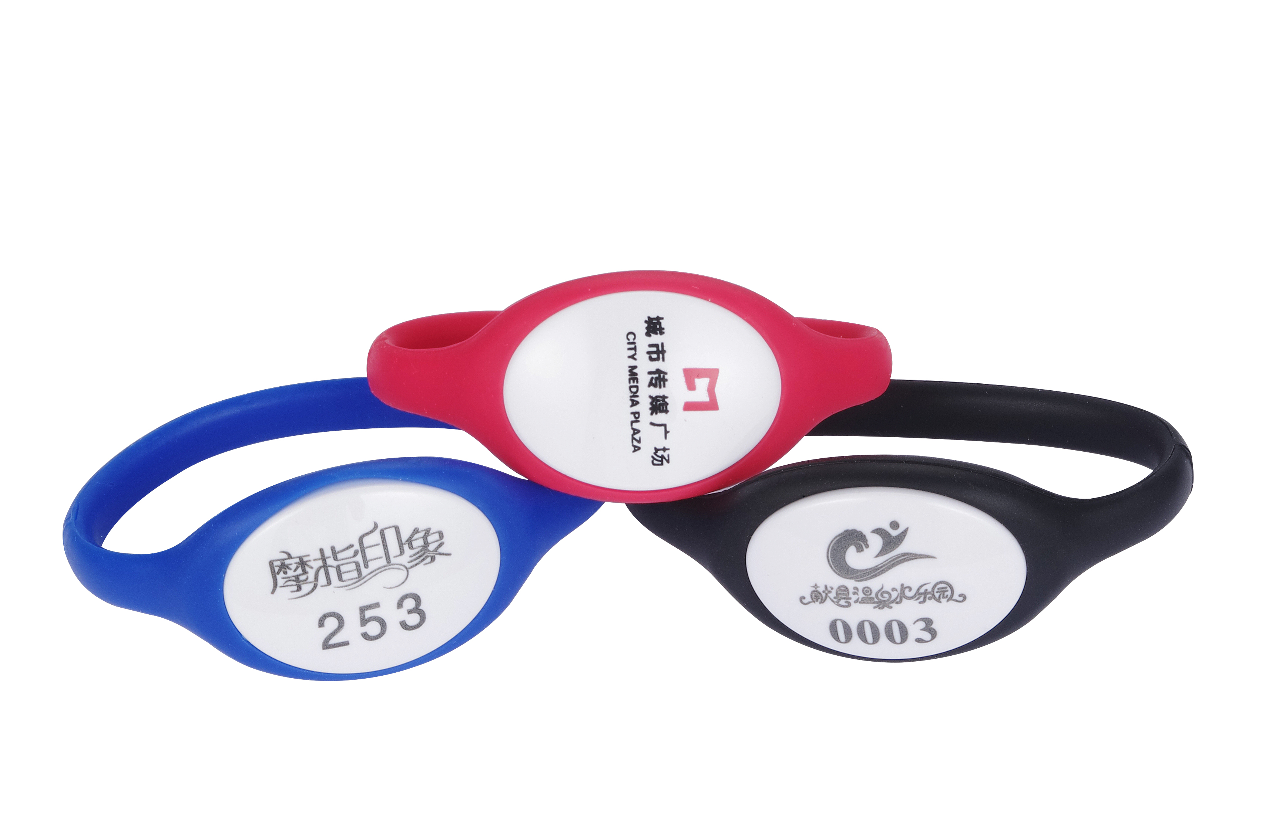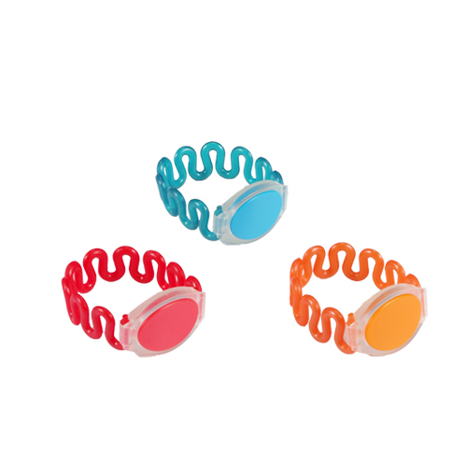
K512 K505

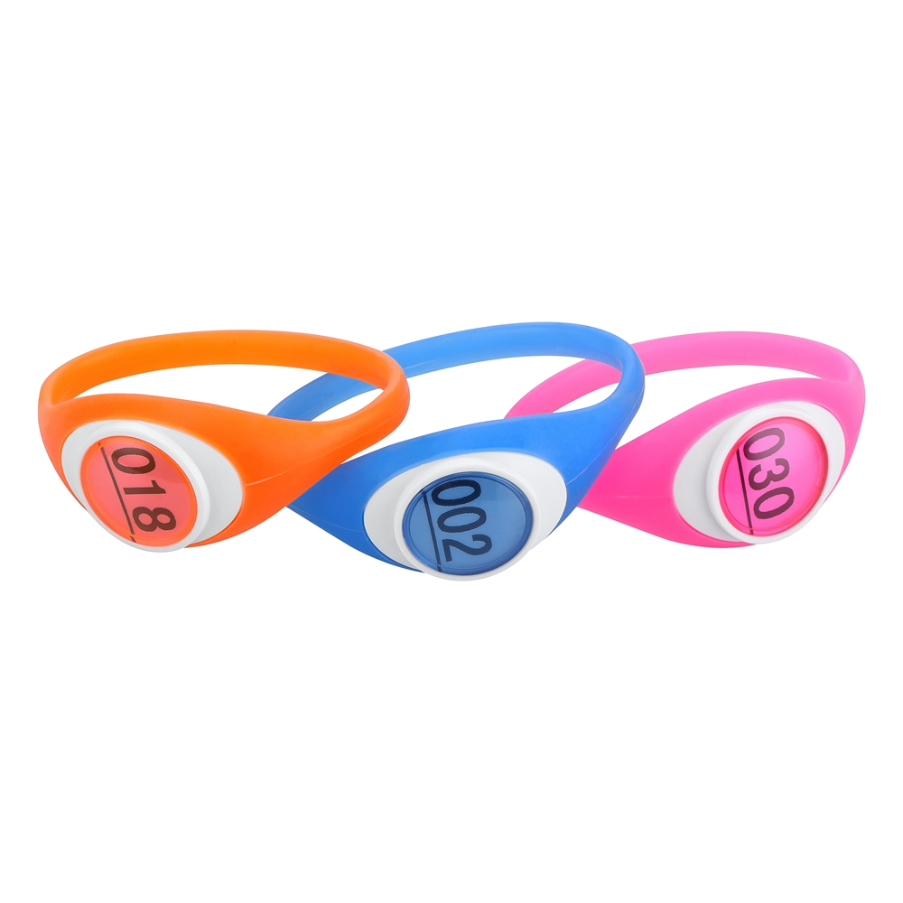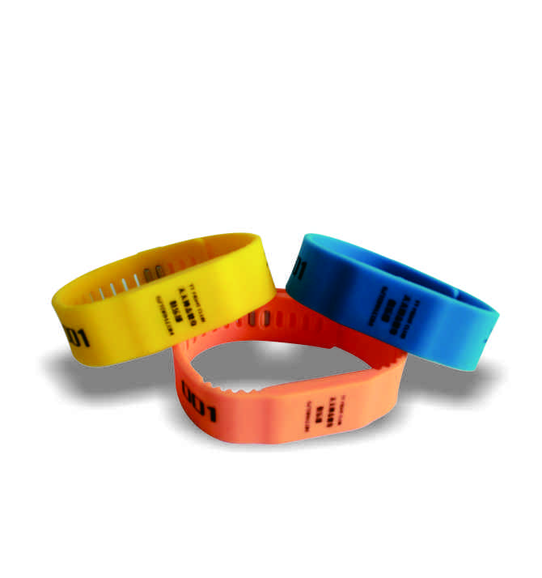
K506 K507

Applications:
Sauna, gyms, theme park, golf club; swimming center, office filing cabinet; school, hospital, library, spa & resort, drawer, etc.

Project Case

How to Organize 3-level Card Management by Standalone Type?
Suppose: There is a project with 1200 lockers, and divide 2 different areas with 700 lockers for Male and 500 lockers for Female. Program an Owner card for the project with all the 1200 lockers and use the owner card to program 1 or 2 master cards for Male area 700 lockers, and program the other 1 or 2 master cards for Female area 500 lockers. The male manager are in charge in the Male area of 700 lockers while the female manager in charge of Female area of 500 lockers. the user uses his/her card to operate the lockers, In case the user couldn’t unlock his(or her) locker, ask the male(or female) manager to unlock the locker by his (or her)master card; If some user card is lost or taken away by the user, just use the master card to delete the lost card or the taken-away card on the specific lock and program a new user card to replace the lost card or taken-away card.(the original user card can not unlock the locker again and the new user card programmed by the master card can be used).
If the manager loses the master card or takes away the master card when leaving the job, just use the owner card to delete the master card on each lock and use the owner card to program one or 2 new master cards for each lock to replace the deleted master card.

FAQ
Q: What kind of card you are using?
A: Standard Mifare-1 card (high frequency 13.56MHz) is used, the card can be standalone type or software-management type.
Q: How about other type of card such as Temic T5557, HID card, Felica, etc. can be used in the lock?
A: Yes. We can develop and make the lock with any type of special card, but minimum quantity is required.

Package
Carton size: 45mm x30mmx25mm
60pcs/ctn 11.50kg

