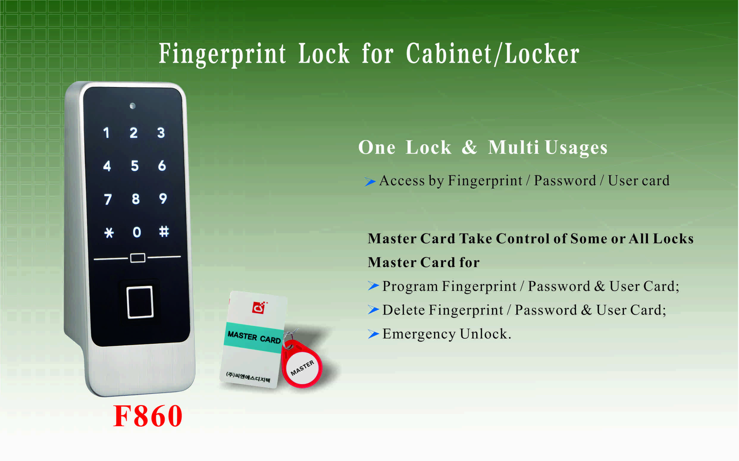

Features:
- Secure control by level-management；
- Touch screen digital with card type;
- Multiple unlock modes: Fingerprint, Digital code,
Card ;
- Indicator blinks while in locked status;
- Wrong code or illegal card alarm;
- Low battery alarm;
- Anti-picked (prized) alarm;
- External power back up;
- Zinc alloy material;

Technical Parameters
Power supply | 3 x AA alkaline batteries
Static current | ≤20µA
Dynamic current | ≤200mA
Working temperature | -15 ～ +55℃
Working humidity | 20 ～ 95%RH
Alarm voltage | 3.7±0.2V
Fingerprint capacity | 40 pcs
FP | 500DPI
FRR | ≤0.01%
FAR | ≤0.00004%
Door thickness | ≥ 13mm
Dimension
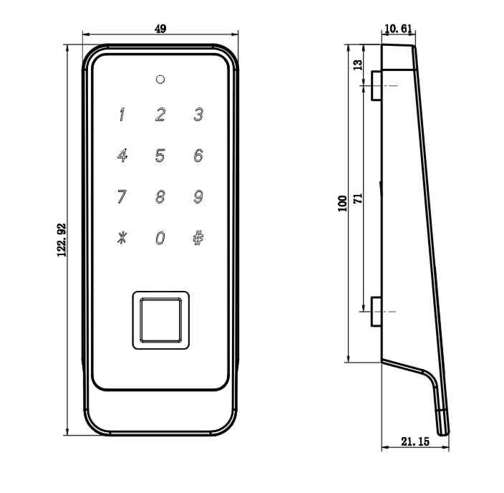

Emergency Unlocking
In case the batteries are exhausted and it is locked, use a USB
charger to insert the USB port at the bottom of the front panel to unlock.

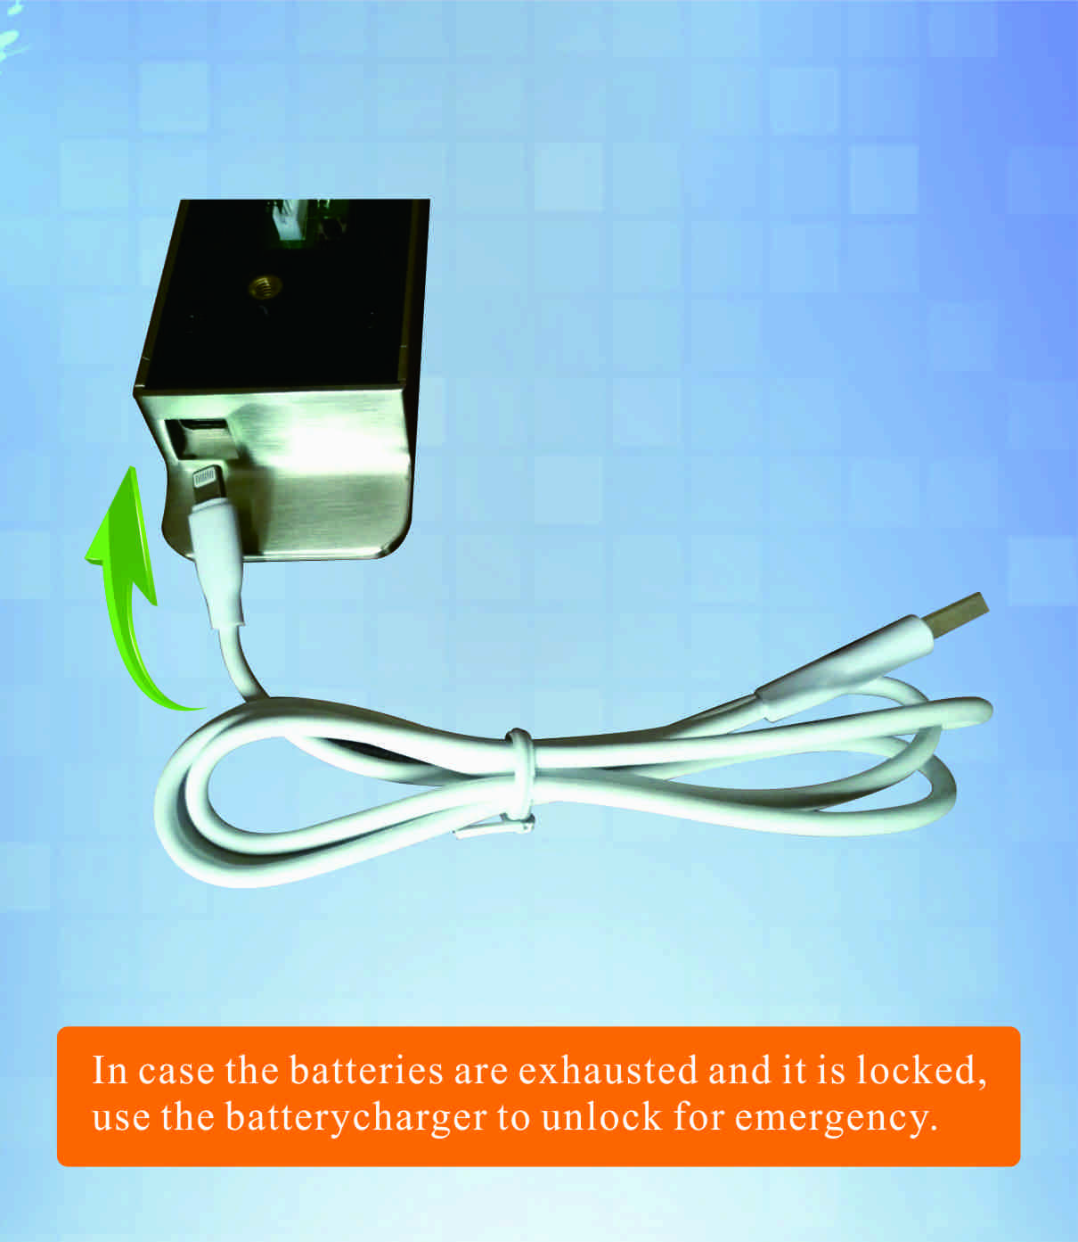

Powered by 3 AA alkaline batteries and batteries last around 12 months.
Latch mechanism: 300,000 life times (motor life times:450,000 times);
Tensile strength of the latch part against pulling force:1600N

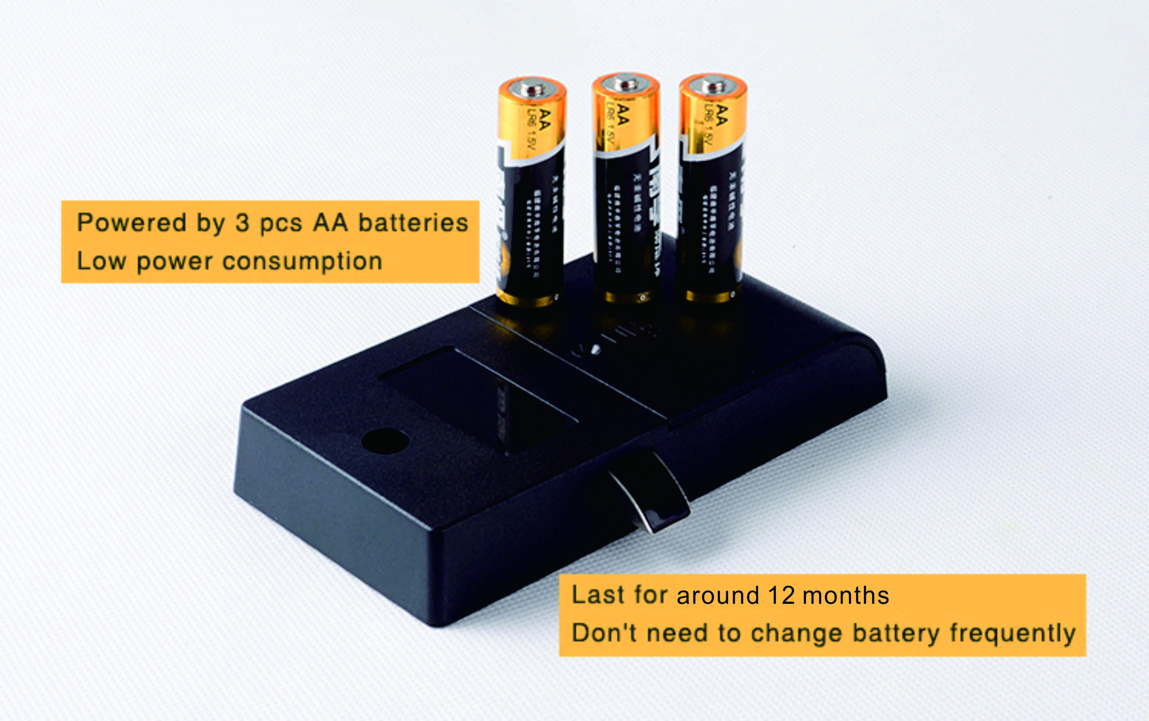

Standard Package for project:
2pcs/inner box
Carton size: 430mm x 270mm x 220mm
40 pcs/ctn (12.30kg)

