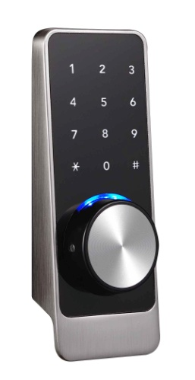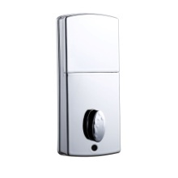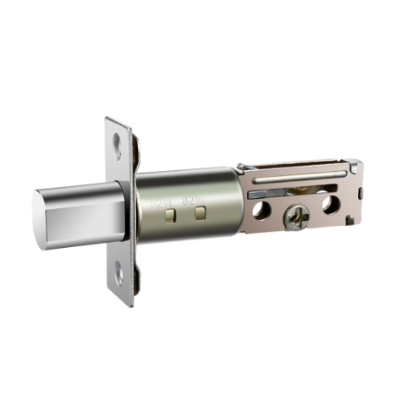
M006-0A

Features
- Tilted structure design for better view and convenient operation;
- Audio (and menu) guide facilitates set up and operation;
- Multiple Unlock modes: mobile phone App /password/M1 card;
- Wrong password (or illegal card) alarm;
- Low voltage alarm;
- Pickproof alarm;
- Security password; Access records can be queried for monitoring;
- Security locking by switch from inside;
- Emergency power back-up;
- Mechanical key override;

Technical Parameter

Power supply | 4.5 ~ 6.5V（4 pcs AA alkaline batteries）
Blue tooth standard | 4.0 BLE (adopt Nordic 51822 blue tooth chip)
Support phone system | Android 4.3/IOS 7.0 above
Alarm voltage | 4.8V ±0.2V
Static current | ≤60µA
Dynamic current | ≤200 mA
Operating temperature | -40 ~ 70℃
Operating humidity | 20 ~ 93%RH
Opening time | around 1.5 seconds
Mobile phone app | no limitation
Card (Mifare1 card) capacity | 100 pcs
Password capacity | APP send password | no limitation
Password capacity | Custom password | 150 pcs

Dimension
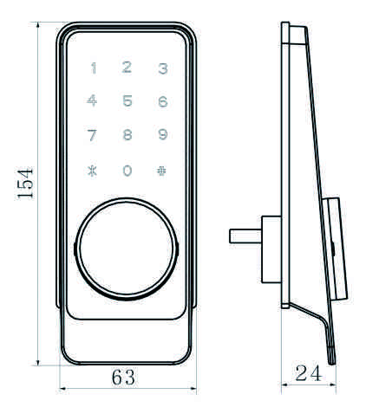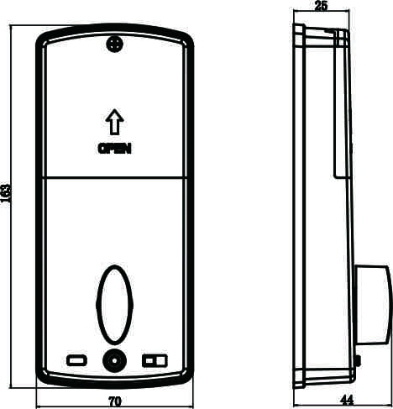

Package:
Inner box: 24 x 21.5x11.40cm 1.10kg/pc
Carton: 45 x 25x58cm 10pcs/ctn（12.00kg）

