KD550 Keypad Lock for Cabinet/Locker/Furniture

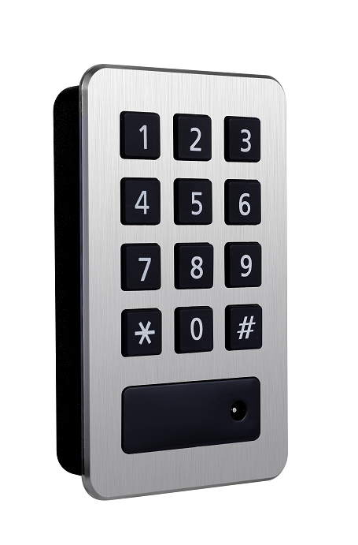
Features:
- Secure control by level-management;
- Permanent code or one-time code convertible;
- Keypad with back light for easy distinction;
- Indicator blinks while in locked status;
- Wrong code or illegal card alarm;
- Anti-picked (prized) alarm;
- Low battery alarm;
- External power back up;
- Stainless steel(304) material

Technical Parameters
Power supply | 3 x AA alkaline batteries
Card type | EM card (125KHz)
Static current | ≤20µA
Dynamic current | ≤200mA
Working temperature | -15 ～ +55℃
Working humidity | 20 ～ 95%RH
Alarm voltage | 3.7±0.2V
Door thickness | ≥16mm

Dimension
