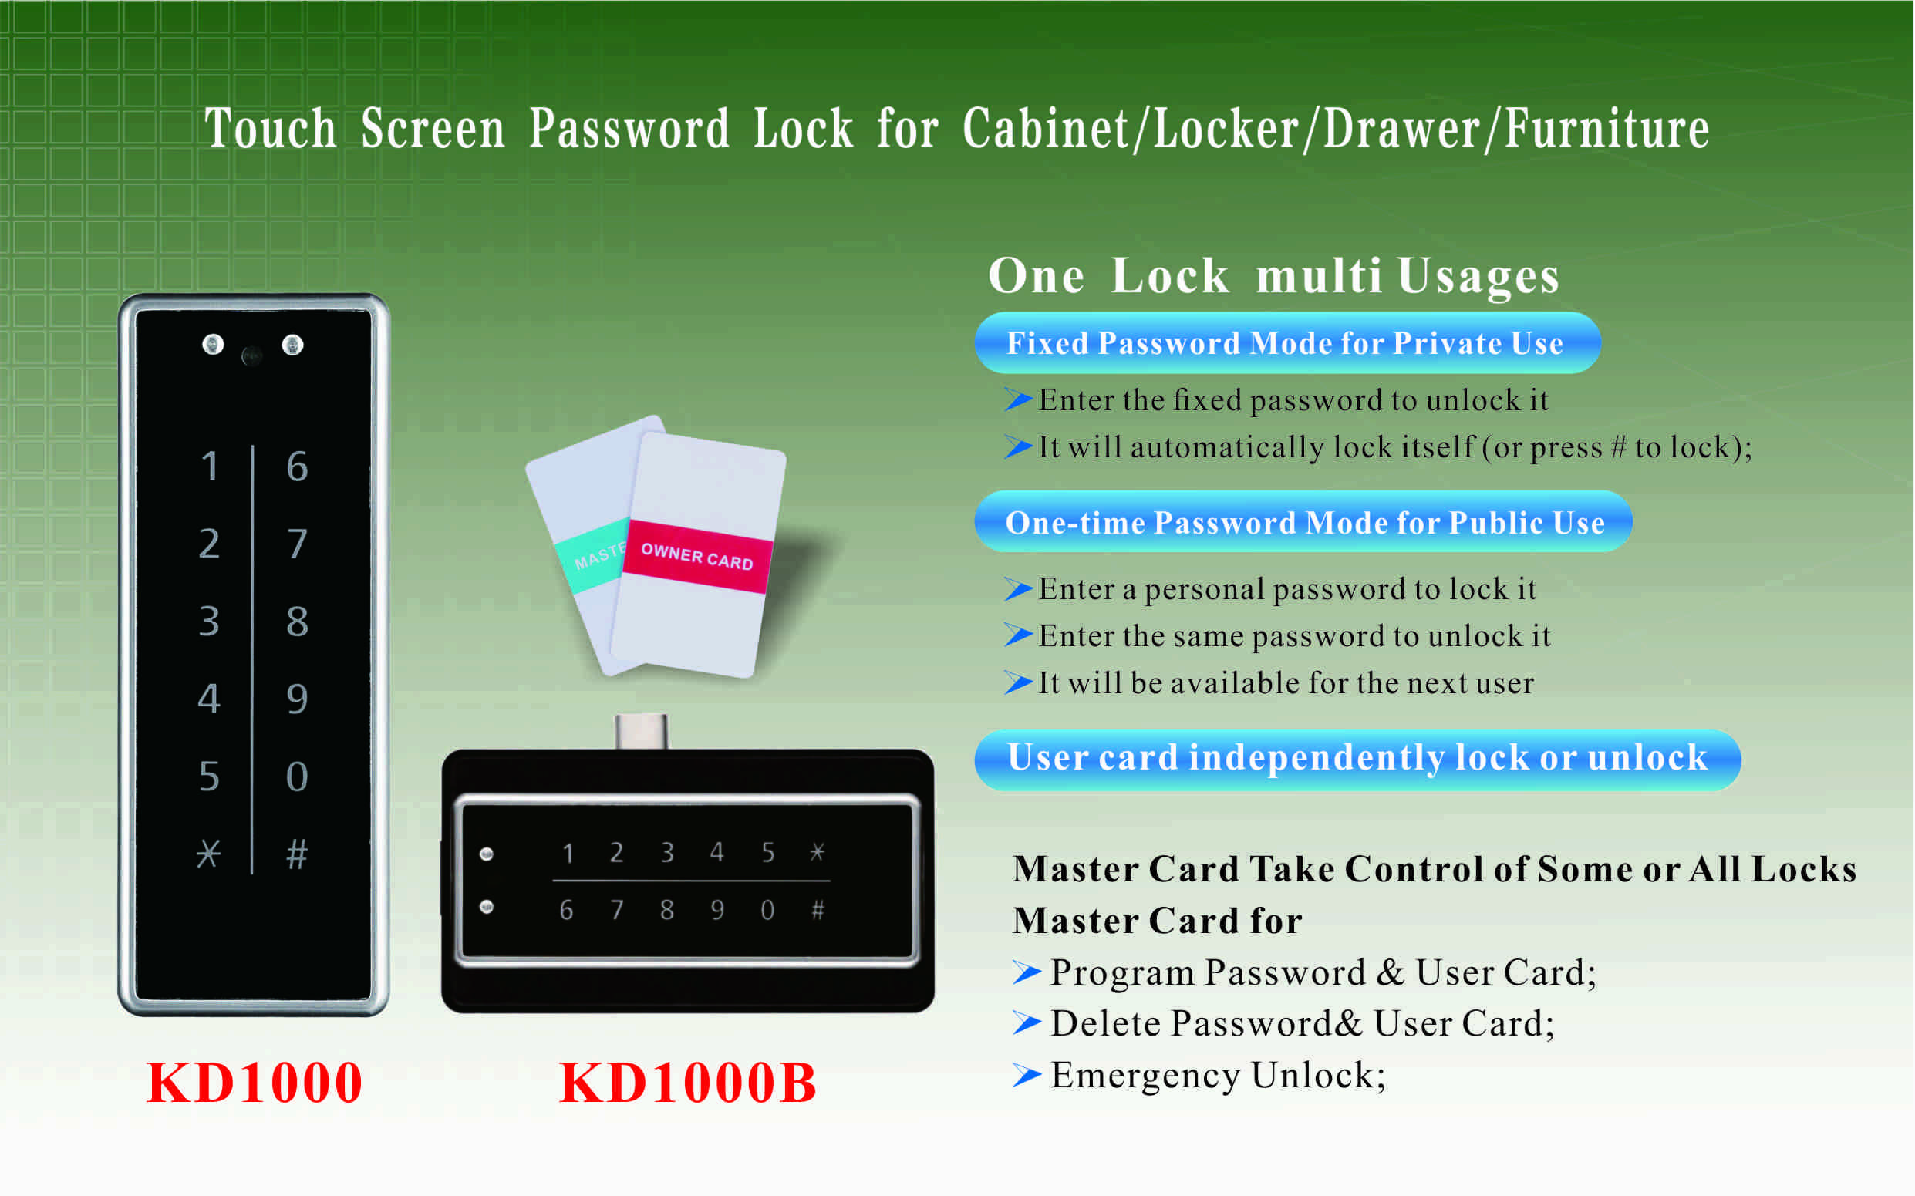

Features:
- Encased on the door, non-protruding design;
- Secure control by level management;
- Keyboard with backlight for easy distinction;
- Indicator blinks while in locked status;
- Wrong code or illegal card alarm;
- Low battery alarm;
- Anti-picked (prized) alarm;
- External power back up;
- ABS plastic material.

Technical Parameters
Power supply | 3 x AA alkaline batteries  DC3.6Ｖ～ DC4.8V
Battery life | 12 months around
Alarm voltage | 3.7±0.2V
Card type | EM card (125KHz)
Card type | Mifare1 card(13.56MHz)
Static current | ≤20µA
Dynamic current | ≤200mA
Working temperature | -15 ～ +55℃
Working humidity | 20 ～ 95%RH
Door thickness | 13 ～ 25 mm

Dimension
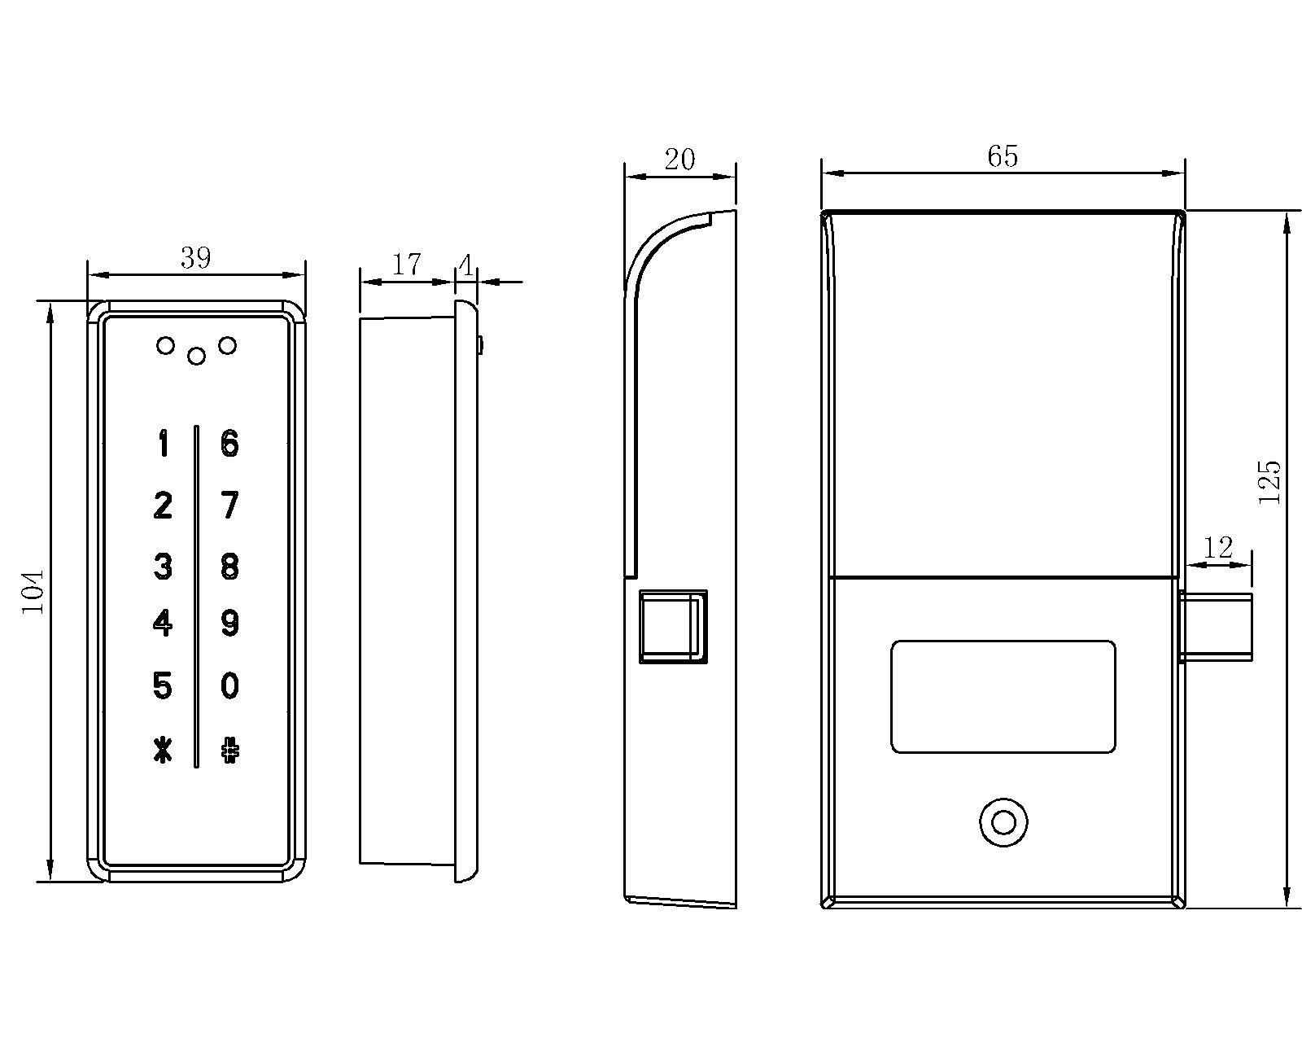

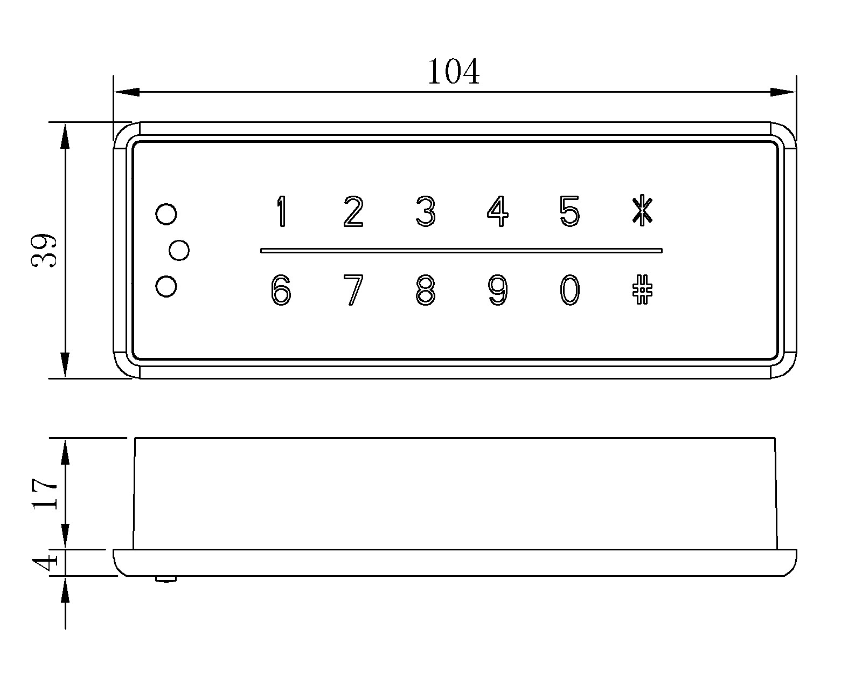

Latch mechanism: 300,000 life times (motor life times:450,000 times);

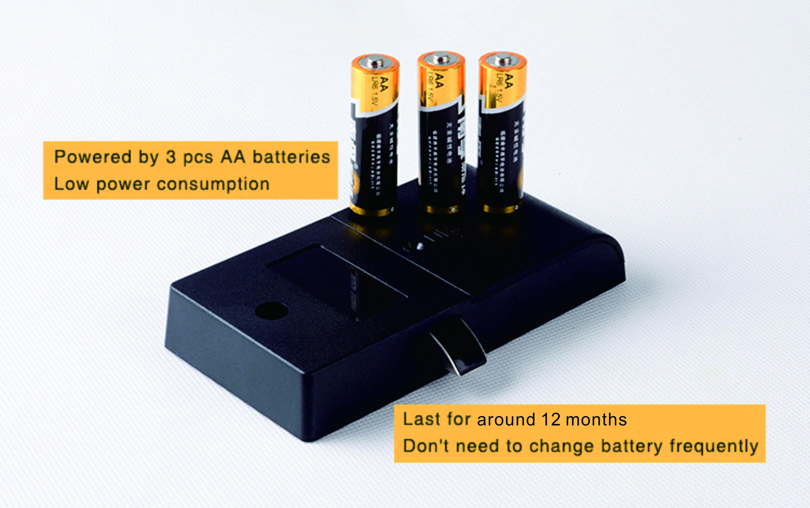

Emergency Unlocking
When the batteries are exhausted and the lock is locked, use a 9V external charger to contact the 2 contact-points and enter code or scan card to unlock.
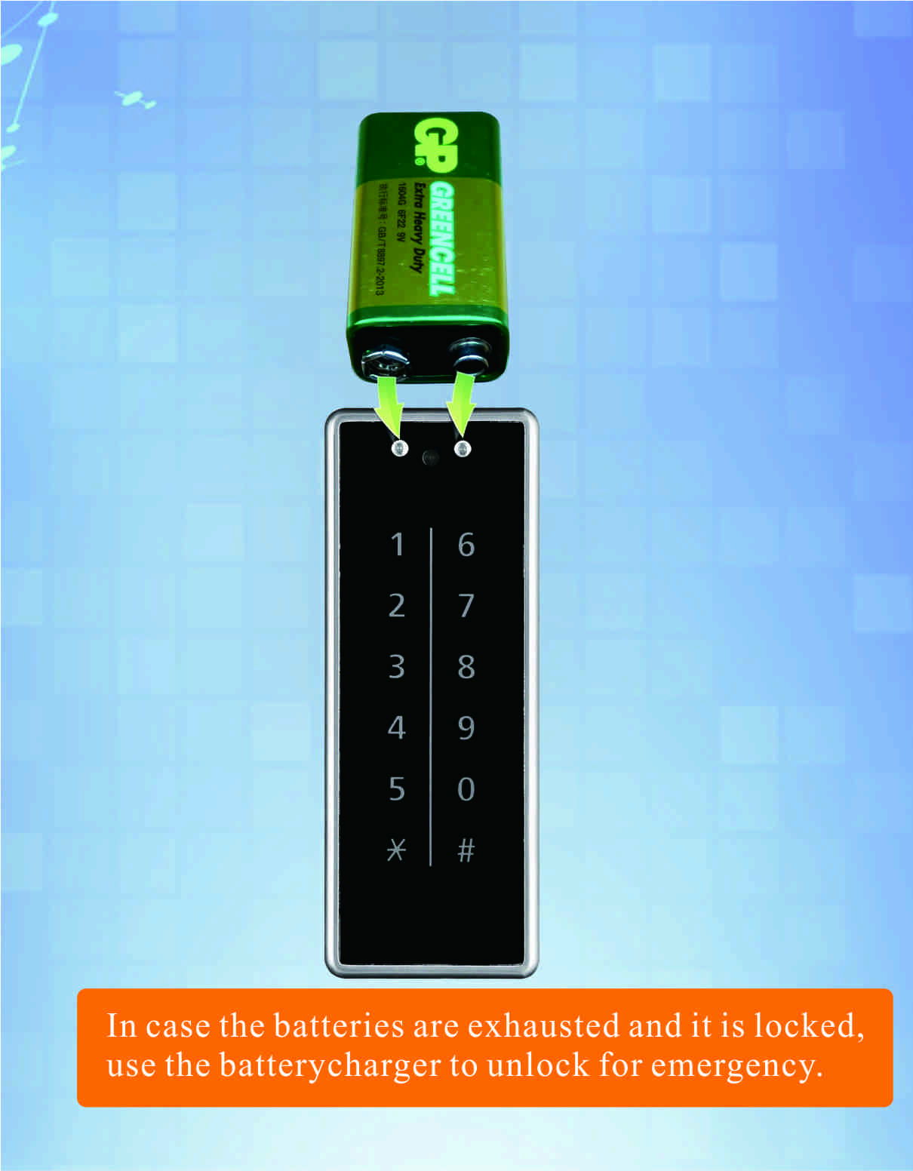

Package:
2 pcs/inner box
Carton size: 430mm x 270mm x 220mm
40 pcs/ctn (8.00kg)

FAQ
Q:Can this password locker lock be used for public?
A:Yes, you can use it to public, use guest code to close it, then same code to open it.
Q:Is master card available for the digital locker lock?
A:It is available, it will be provided master card to open the lock for emergency.
Q:If user forgot password, how to open the locker?
A:Use master card to unlock it.

Q:What can we do if the power is exhausted.
A:There is consecutive 8 sounds as alarm from the locks, and please replace the batteries after sound alarm.
If the batteries are dead in the locker lock, use external power to open it and change batteries.

