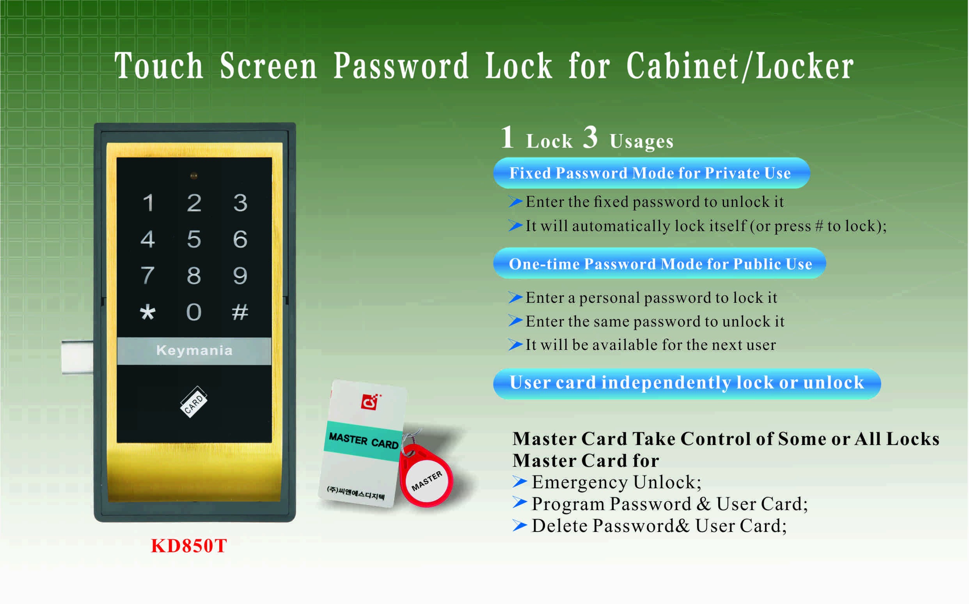

Features:
- Secure control by level management;
- Keyboard with backlight for easy distinction;
- Indicator blinks while in locked status;
- Wrong code or illegal card alarm;
- Low battery alarm;
- Anti-picked (prized) alarm;
- External power back up;
- Zinc alloy material.

Technical Parameters
Power supply | 3 x AA alkaline batteries  DC3.6Ｖ～ DC4.8V
Battery life | 12 months around
Card type | EM card (125KHz)
Card type | Mifare1 card(13.56MHz)
Static current | ≤20µA
Dynamic current | ≤200mA
Working temperature | -15 ～ +55℃
Working humidity | 20 ～ 95%RH
Alarm voltage | 3.7±0.2V
Door thickness | 13 ～ 25 mm

Dimension
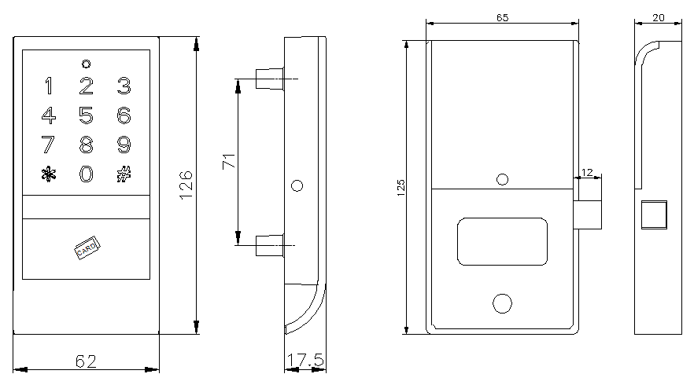

Emergency unlocking
When the batteries are dead and the lock is locked, use a battery charger to unlock.

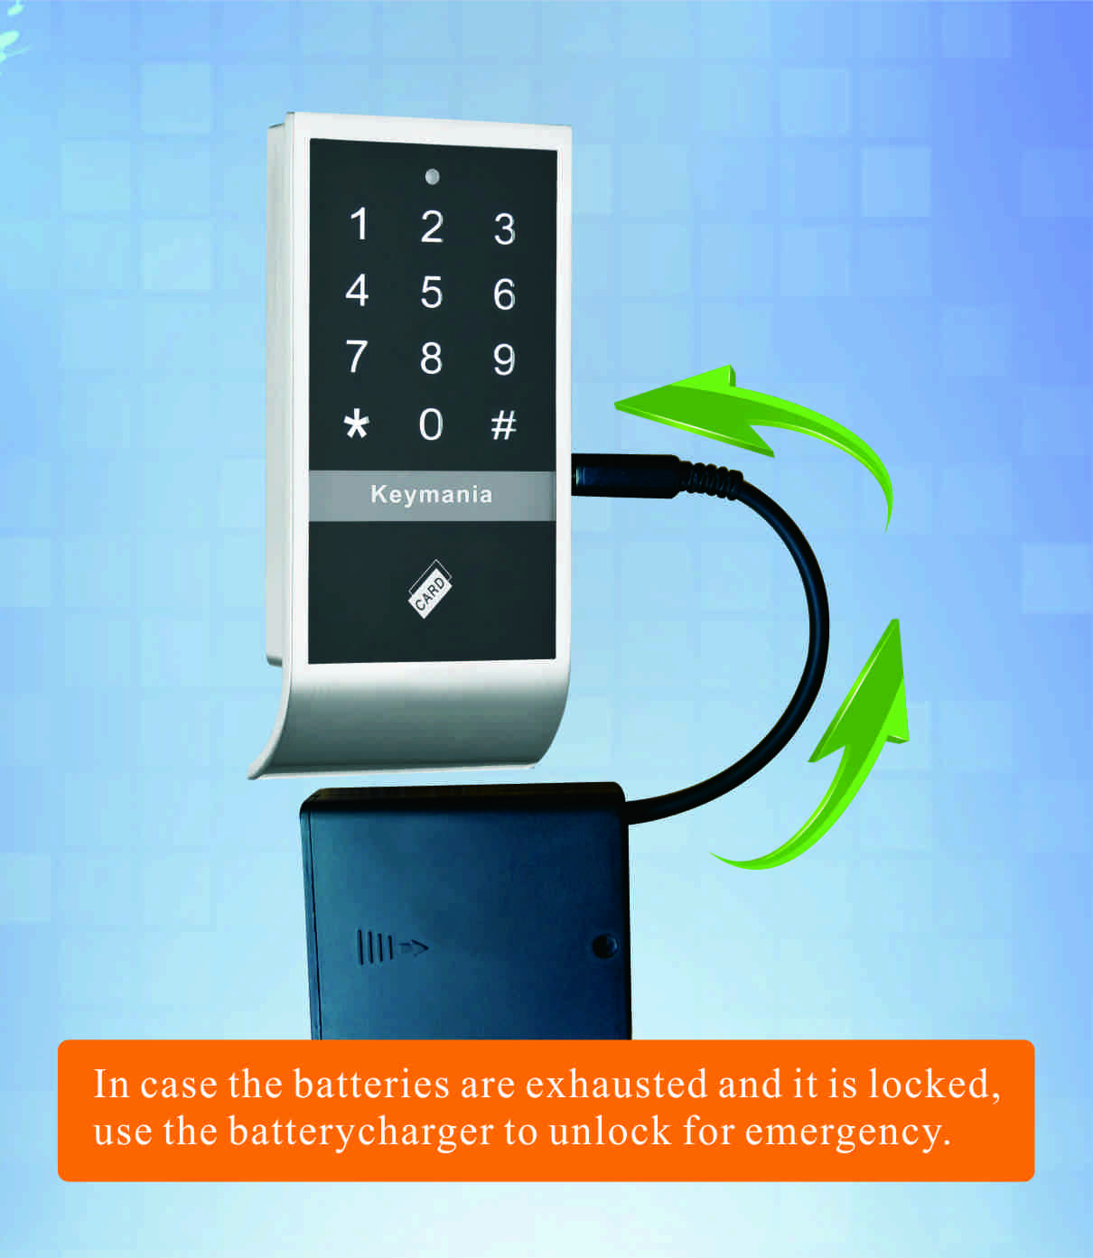

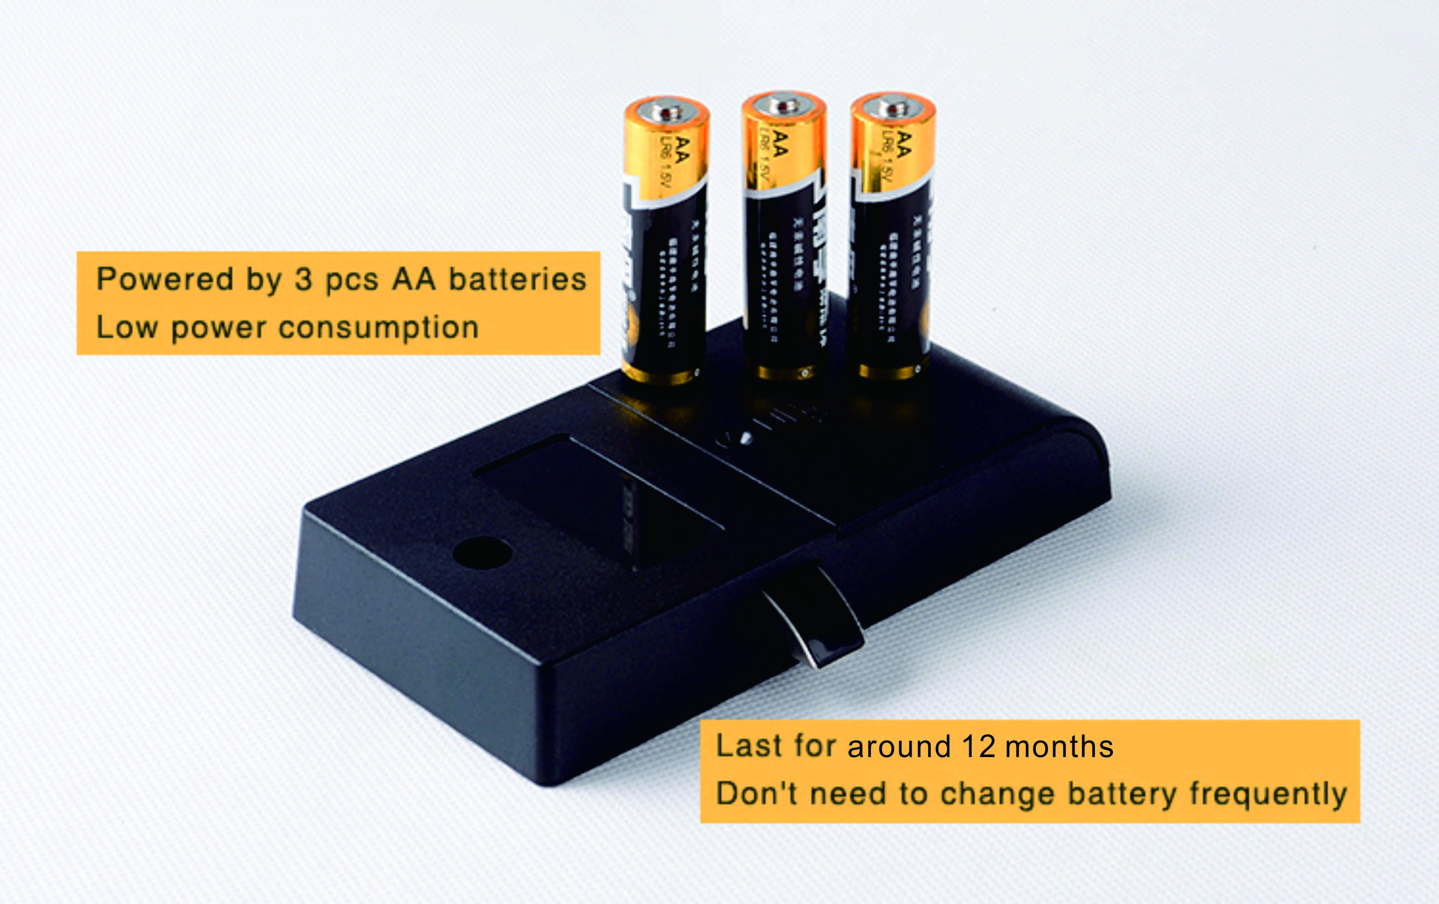

Latch mechanism: 300,000 life times (motor life times:450,000 times);

Project case
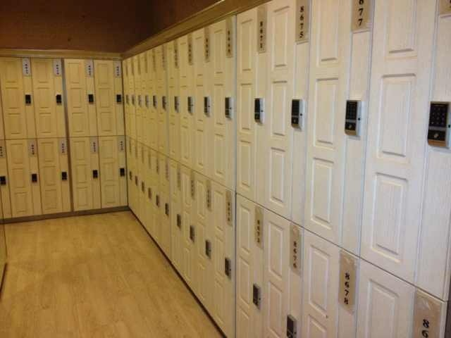

Standard Package for project
2pcs/inner box
Carton size: 430mm x 270mm x 220mm
40 pcs/ctn (13.75kg)

FAQ
Q:Can this password locker lock be used for public?
A:Yes, you can use it to public, use user code to lock it and then use the same code to
unlock

Q:Is master card available for the digital locker lock?
A:It is available, it will be provided master card to open the lock for emergency.
Q:If user forgot password, how to open the locker?
A:Use master card to unlock it.

Q:What can we do if the power is exhausted.
A:There is consecutive 8 sounds as alarm from the locks, and please replace the batteries after sound alarm.
If the batteries are dead in the locker lock, use external power to open it and change batteries.

