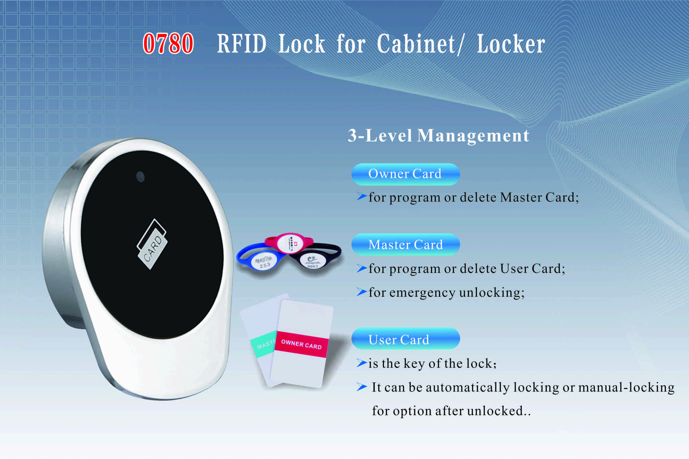

Features:
- Unique design with appearance patent;
- 3-level management mode;
- Manual- locking or auto-locking optional;
- Indicator blinks while in locked status;
- Illegal card alarm;
- Low battery alarm;
- Anti-picked (prized) alarm;
- External power back up;
- Zinc alloy material;

Technical Parameters
Power supply | 3 x AA alkaline batteries
Static current | ≤25µA
Dynamic current | ≤200mA
Working temperature | -15 ～ +55℃
Working humidity | 20 ～ 95%RH
Alarm voltage | 3.7±0.2V
Door thickness | ≥11.50mm

Dimension

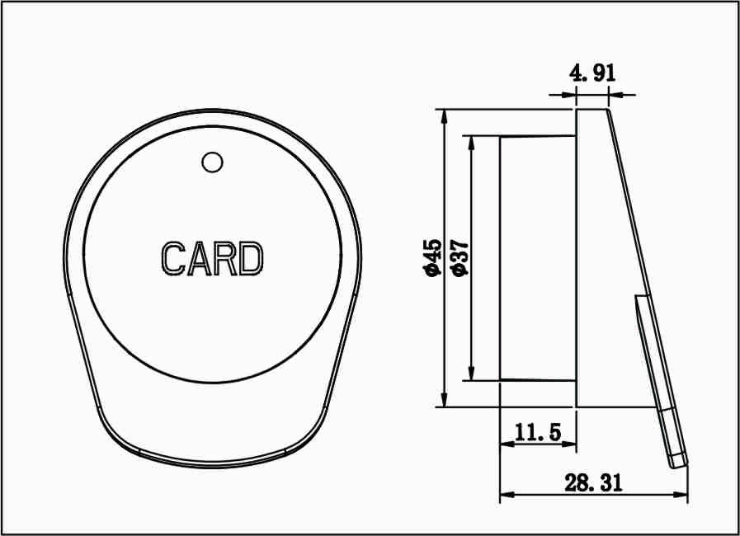

Powered by 3 AA alkaline batteries and batteries last at least 12 months;
Latch mechanism: 300,000 life times (motor life times:450,000 times);

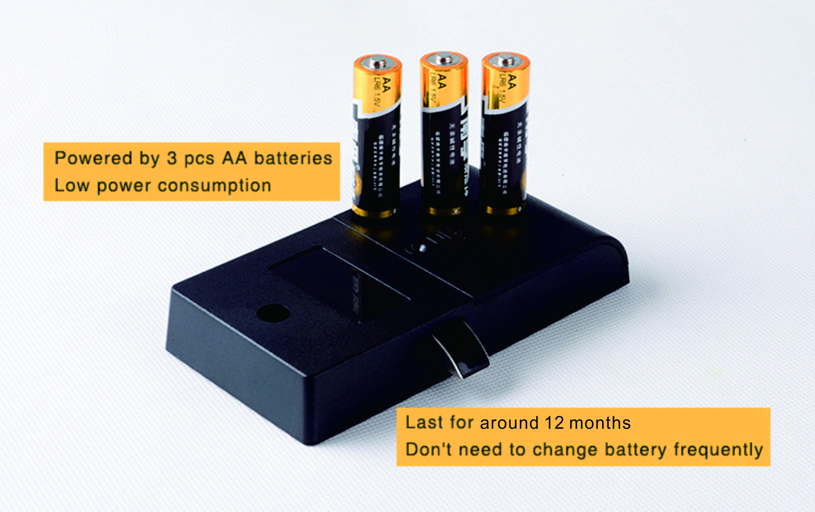

Emergency Unlocking by Inserting your mobile phone charger into the USB port at the side section of the front panel when the batteries are exhausted.

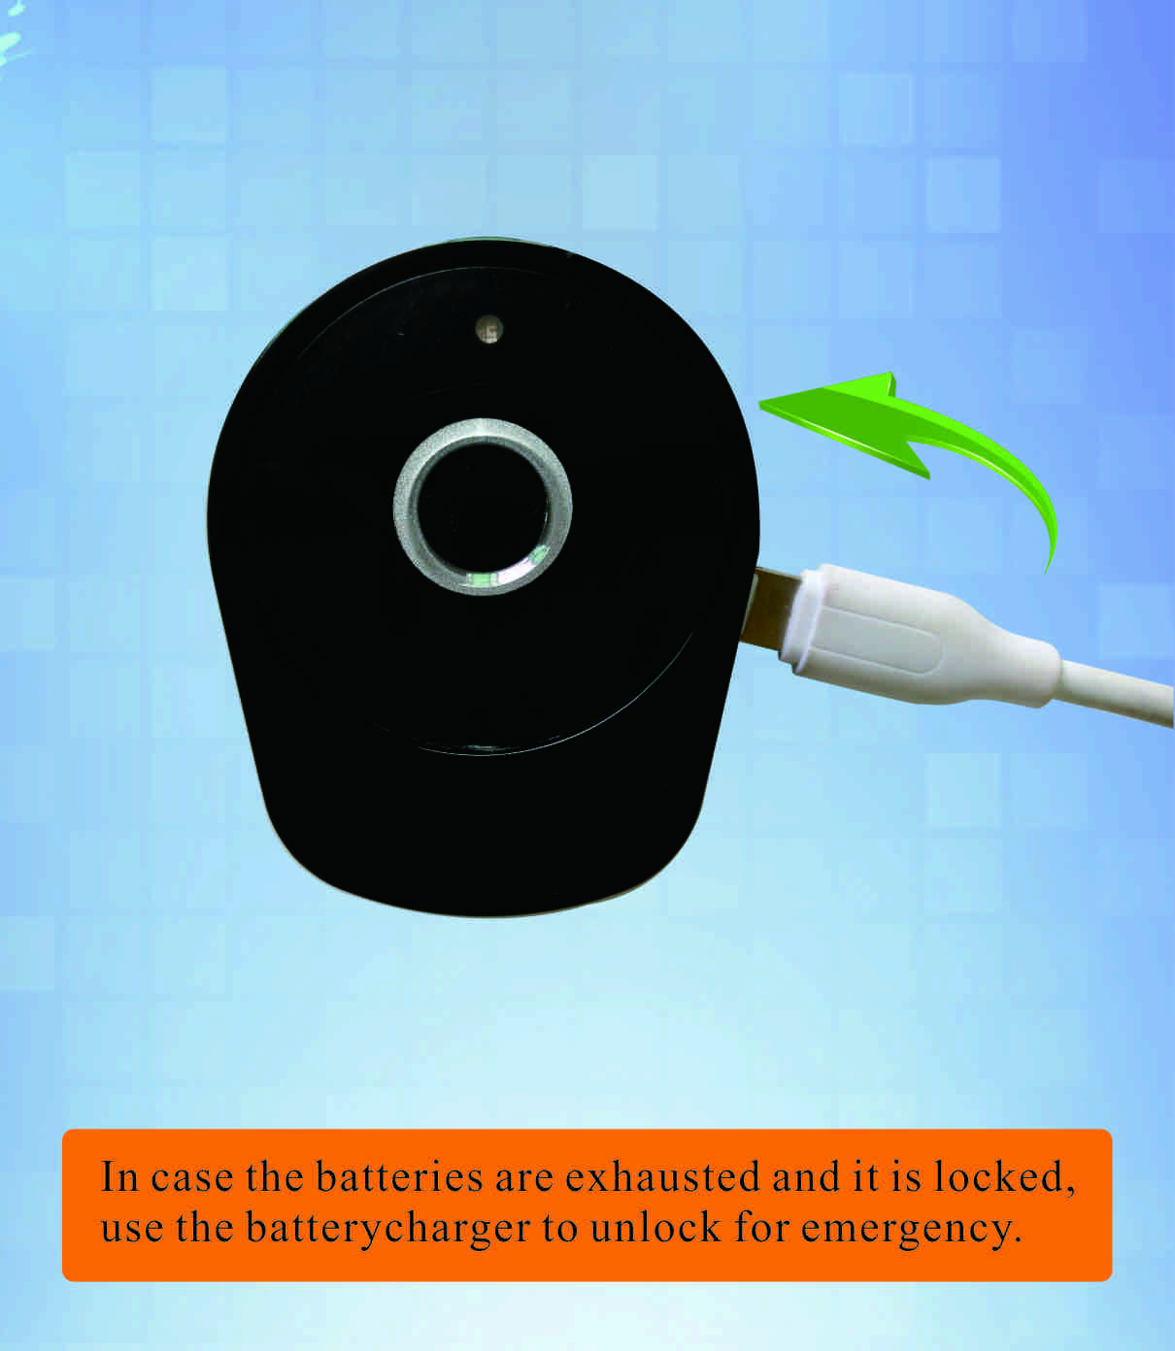

User Card & Wrist Keyband for Options:
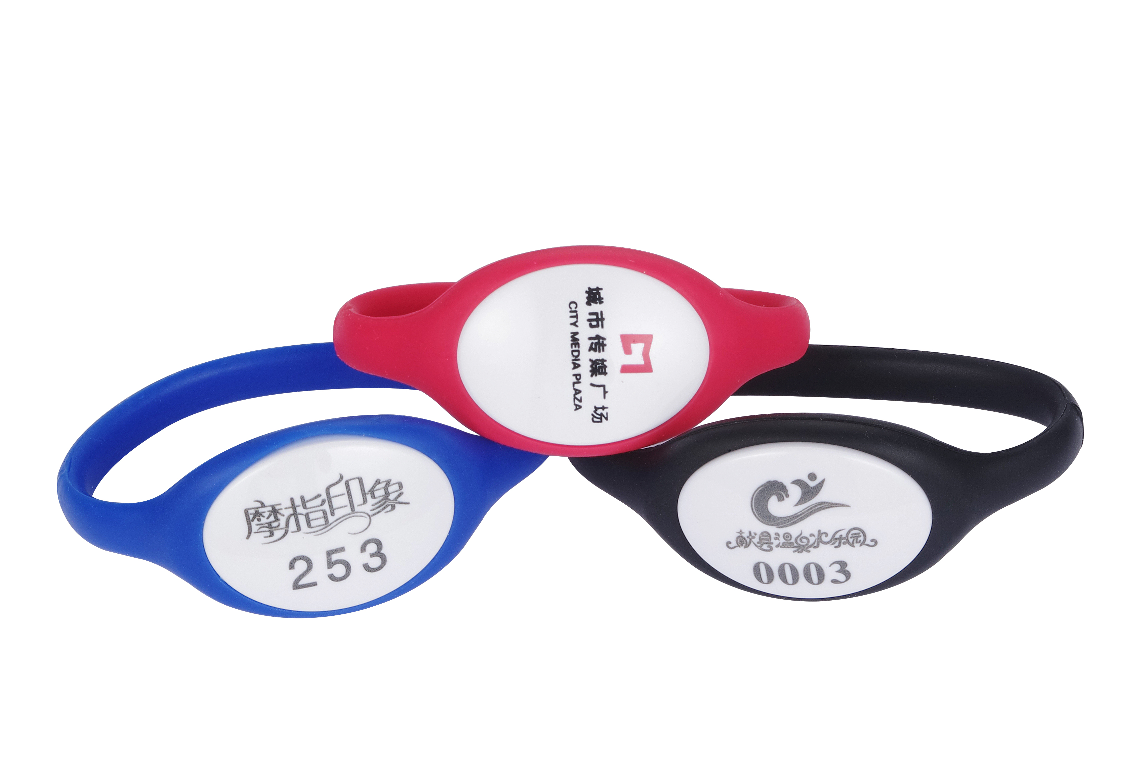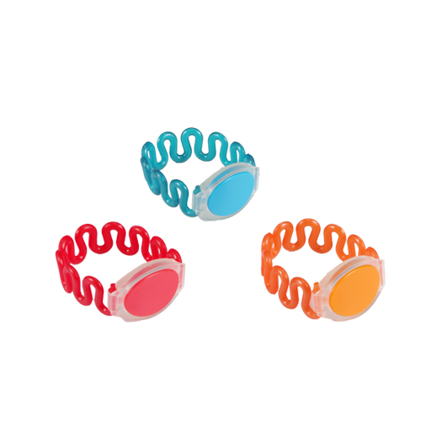
K512 K505

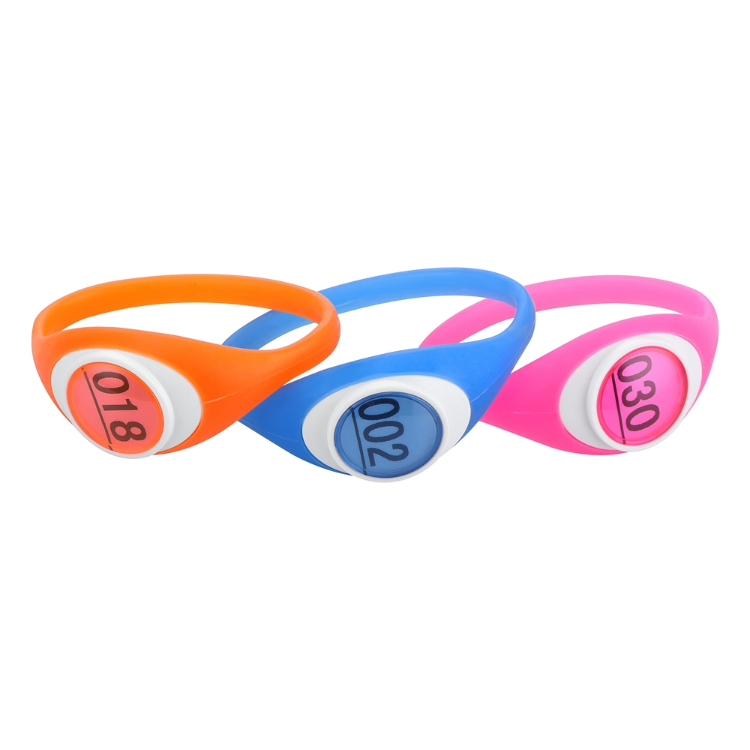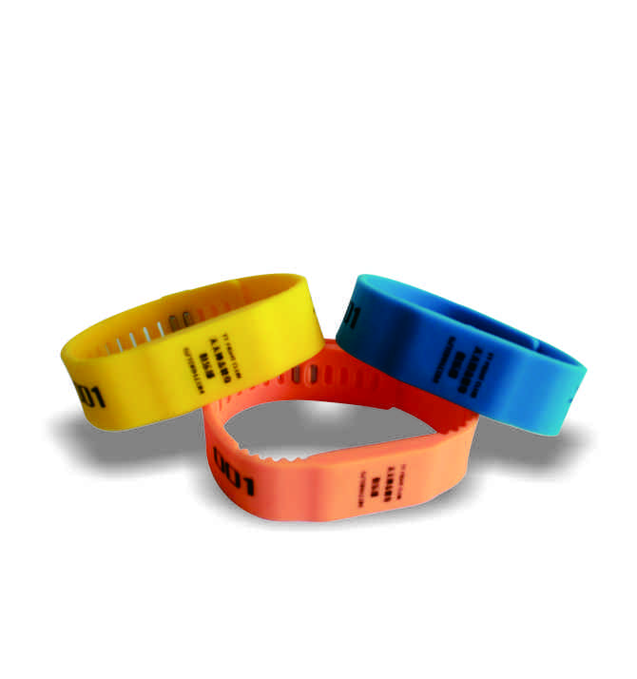
K506 K507

Applications:
Sauna, gyms, theme park, golf club; swimming center, office filing cabinet; school, hospital, library, spa & resort, drawer, etc.

How to Organize 3-level Card Management by Standalone Type?
Suppose: There is a project with 1200 lockers, and divide 2 different areas with 700 lockers for Male and 500 lockers for Female. Program an Owner card for the project with all the 1200 lockers and use the owner card to program 1 or 2 master cards for Male area 700 lockers, and program the other 1 or 2 master cards for Female area 500 lockers. The male manager are in charge in the Male area of 700 lockers while the female manager in charge of Female area of 500 lockers. the user uses his/her card to operate the lockers, In case the user couldn’t unlock his(or her) locker, ask the male(or female) manager to unlock the locker by his (or her)master card; If some user card is lost or taken away by the user, just use the master card to delete the lost card or the taken-away card on the specific lock and program a new user card to replace the lost card or taken-away card.(the original user card can not unlock the locker again and the new user card programmed by the master card can be used).
If the manager loses the master card or takes away the master card when leaving the job, just use the owner card to delete the master card on each lock and use the owner card to program one or 2 new master cards for each lock to replace the deleted master card.

FAQ
Q: What kind of card you are using?
A: Standard Mifare-1 card (high frequency 13.56MHz) is used, the card can be standalone type or software-management type.
Q: How about other type of card such as Temic T5557, HID card, Felica, etc. can be used in the lock?
A: Yes. We can develop and make the lock with any type of special card, but minimum quantity is required.

