Free Mode of RFID Standalone Type （任意卡模式）
Main Features & Functions: (特征&功能)
- Simple program & operation just by a Handset;
- Master card is used to control one whole project and for emergency unlocking;
- Any one card can use any one locker at any time;
- Occupied lock will blinks to show the locker in use.

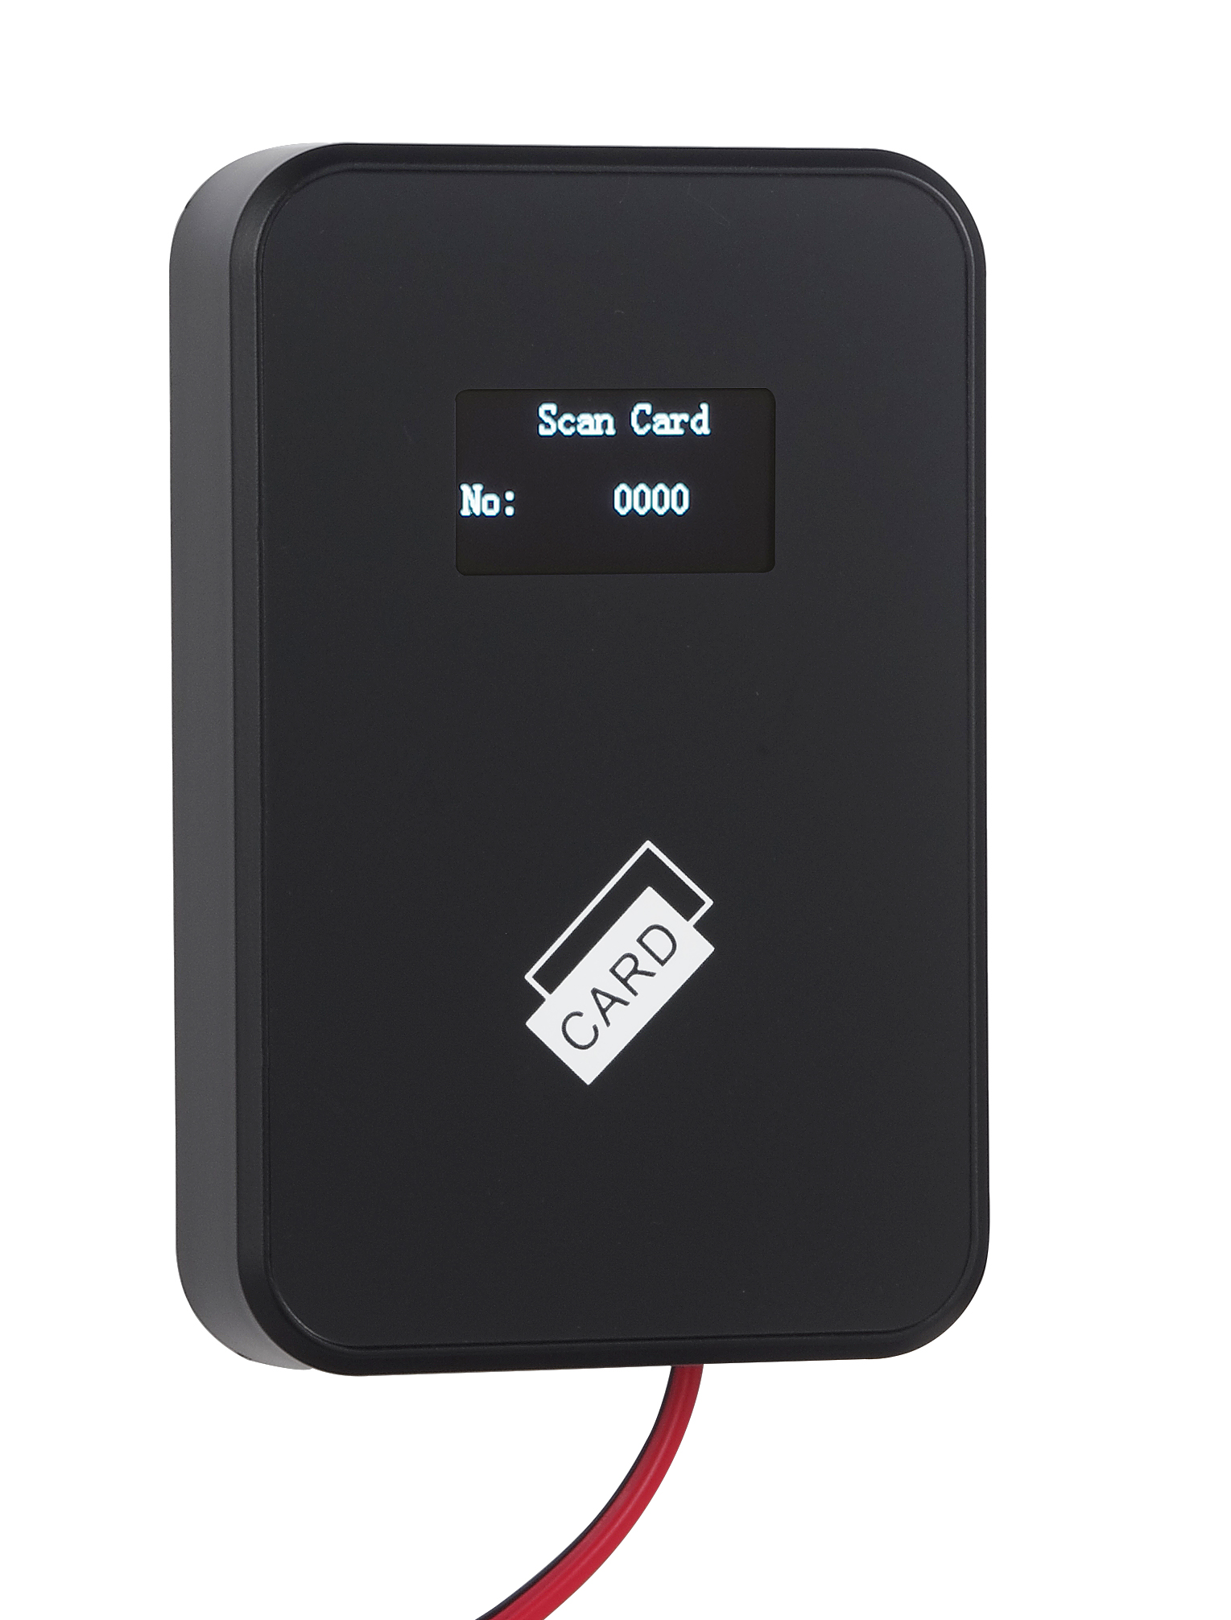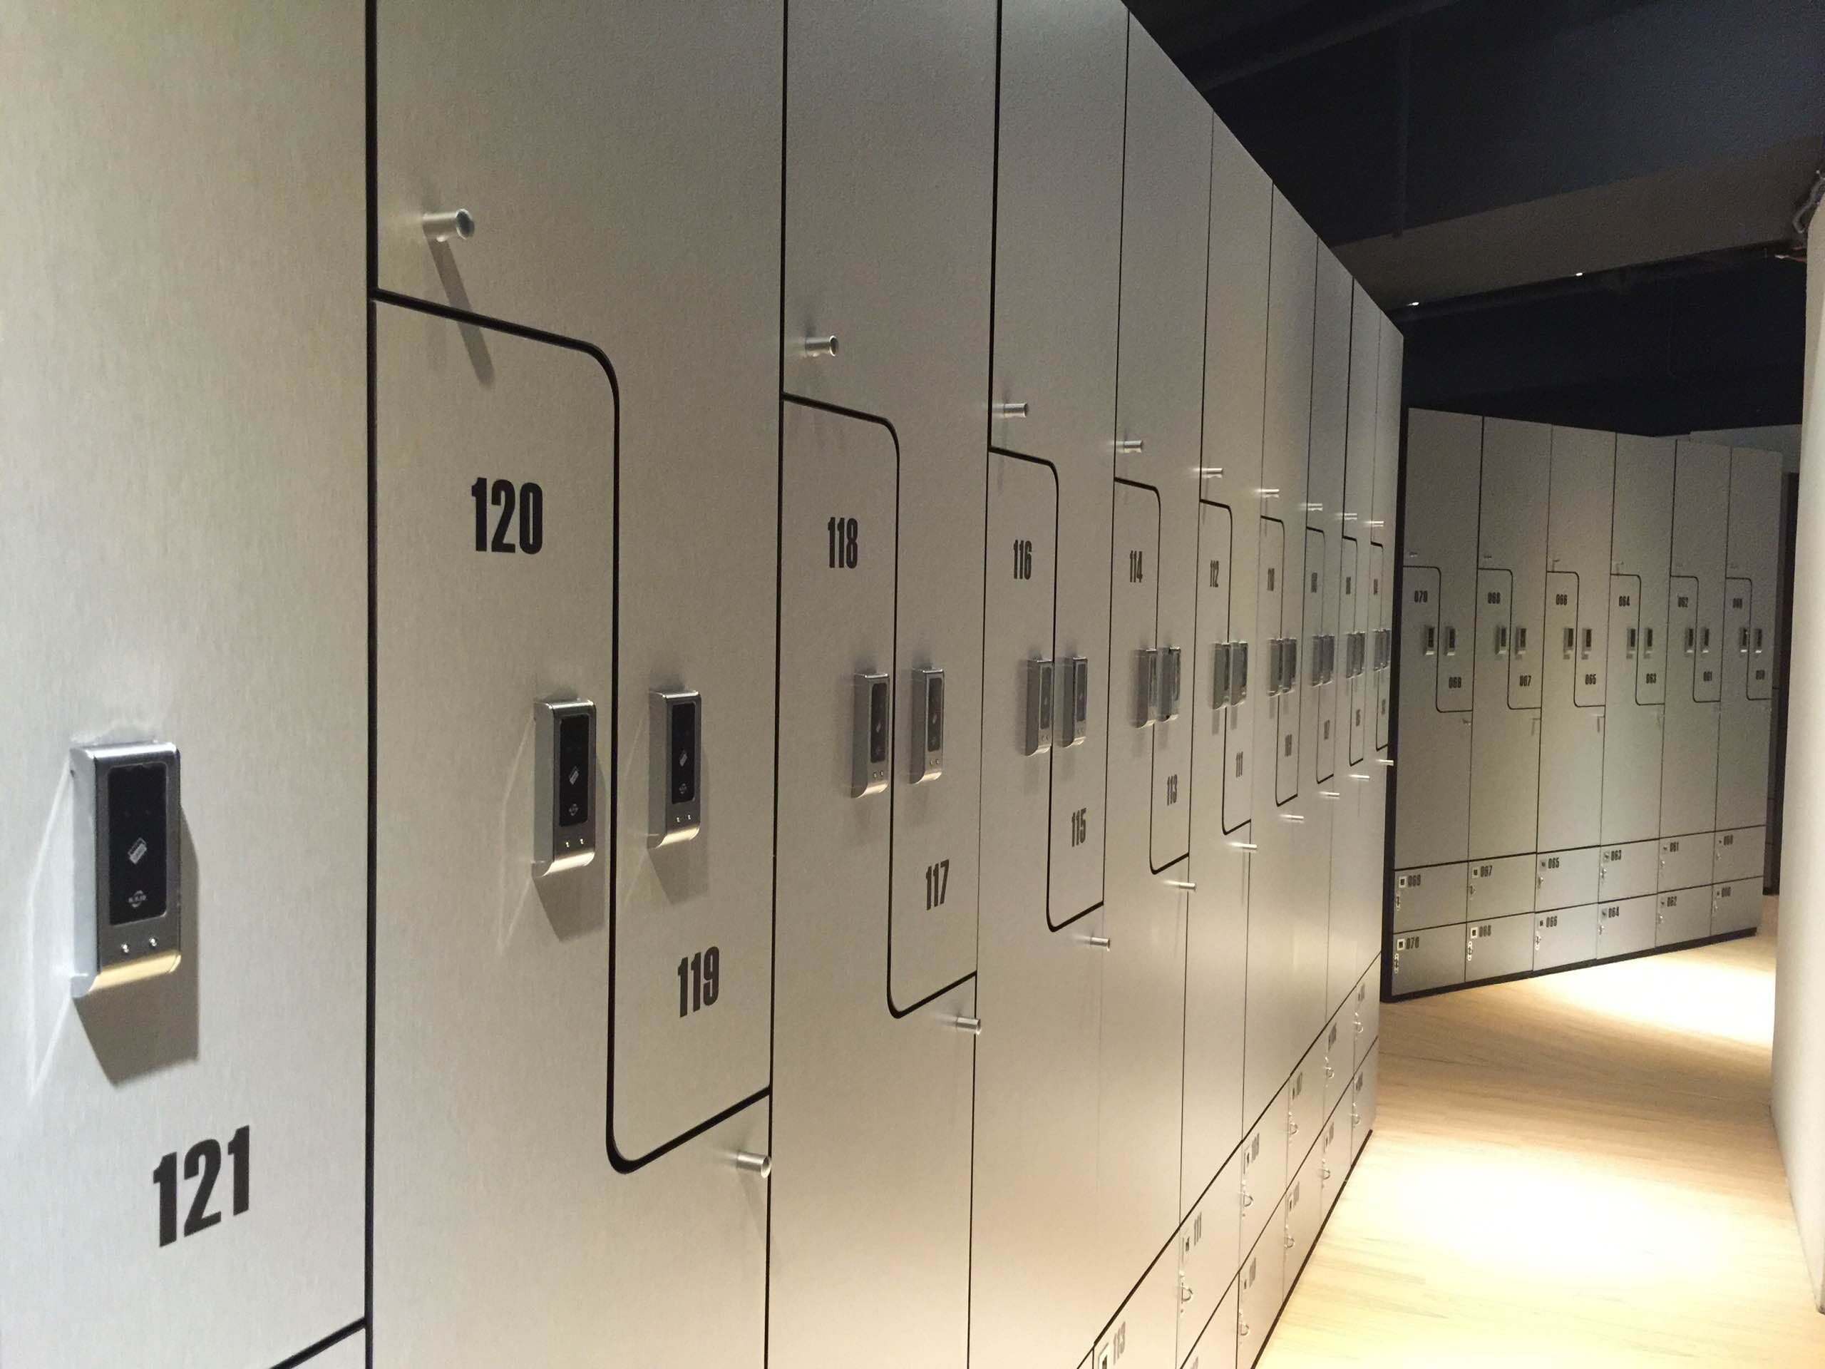
Locker No. Reader

When the user forgets which locker he/she locked, just scan the card on the Locker No. reader and the Locker No. will show on the screen of the reader, then the user knows which locker he/she used.

How to Use the Locker by Your Card

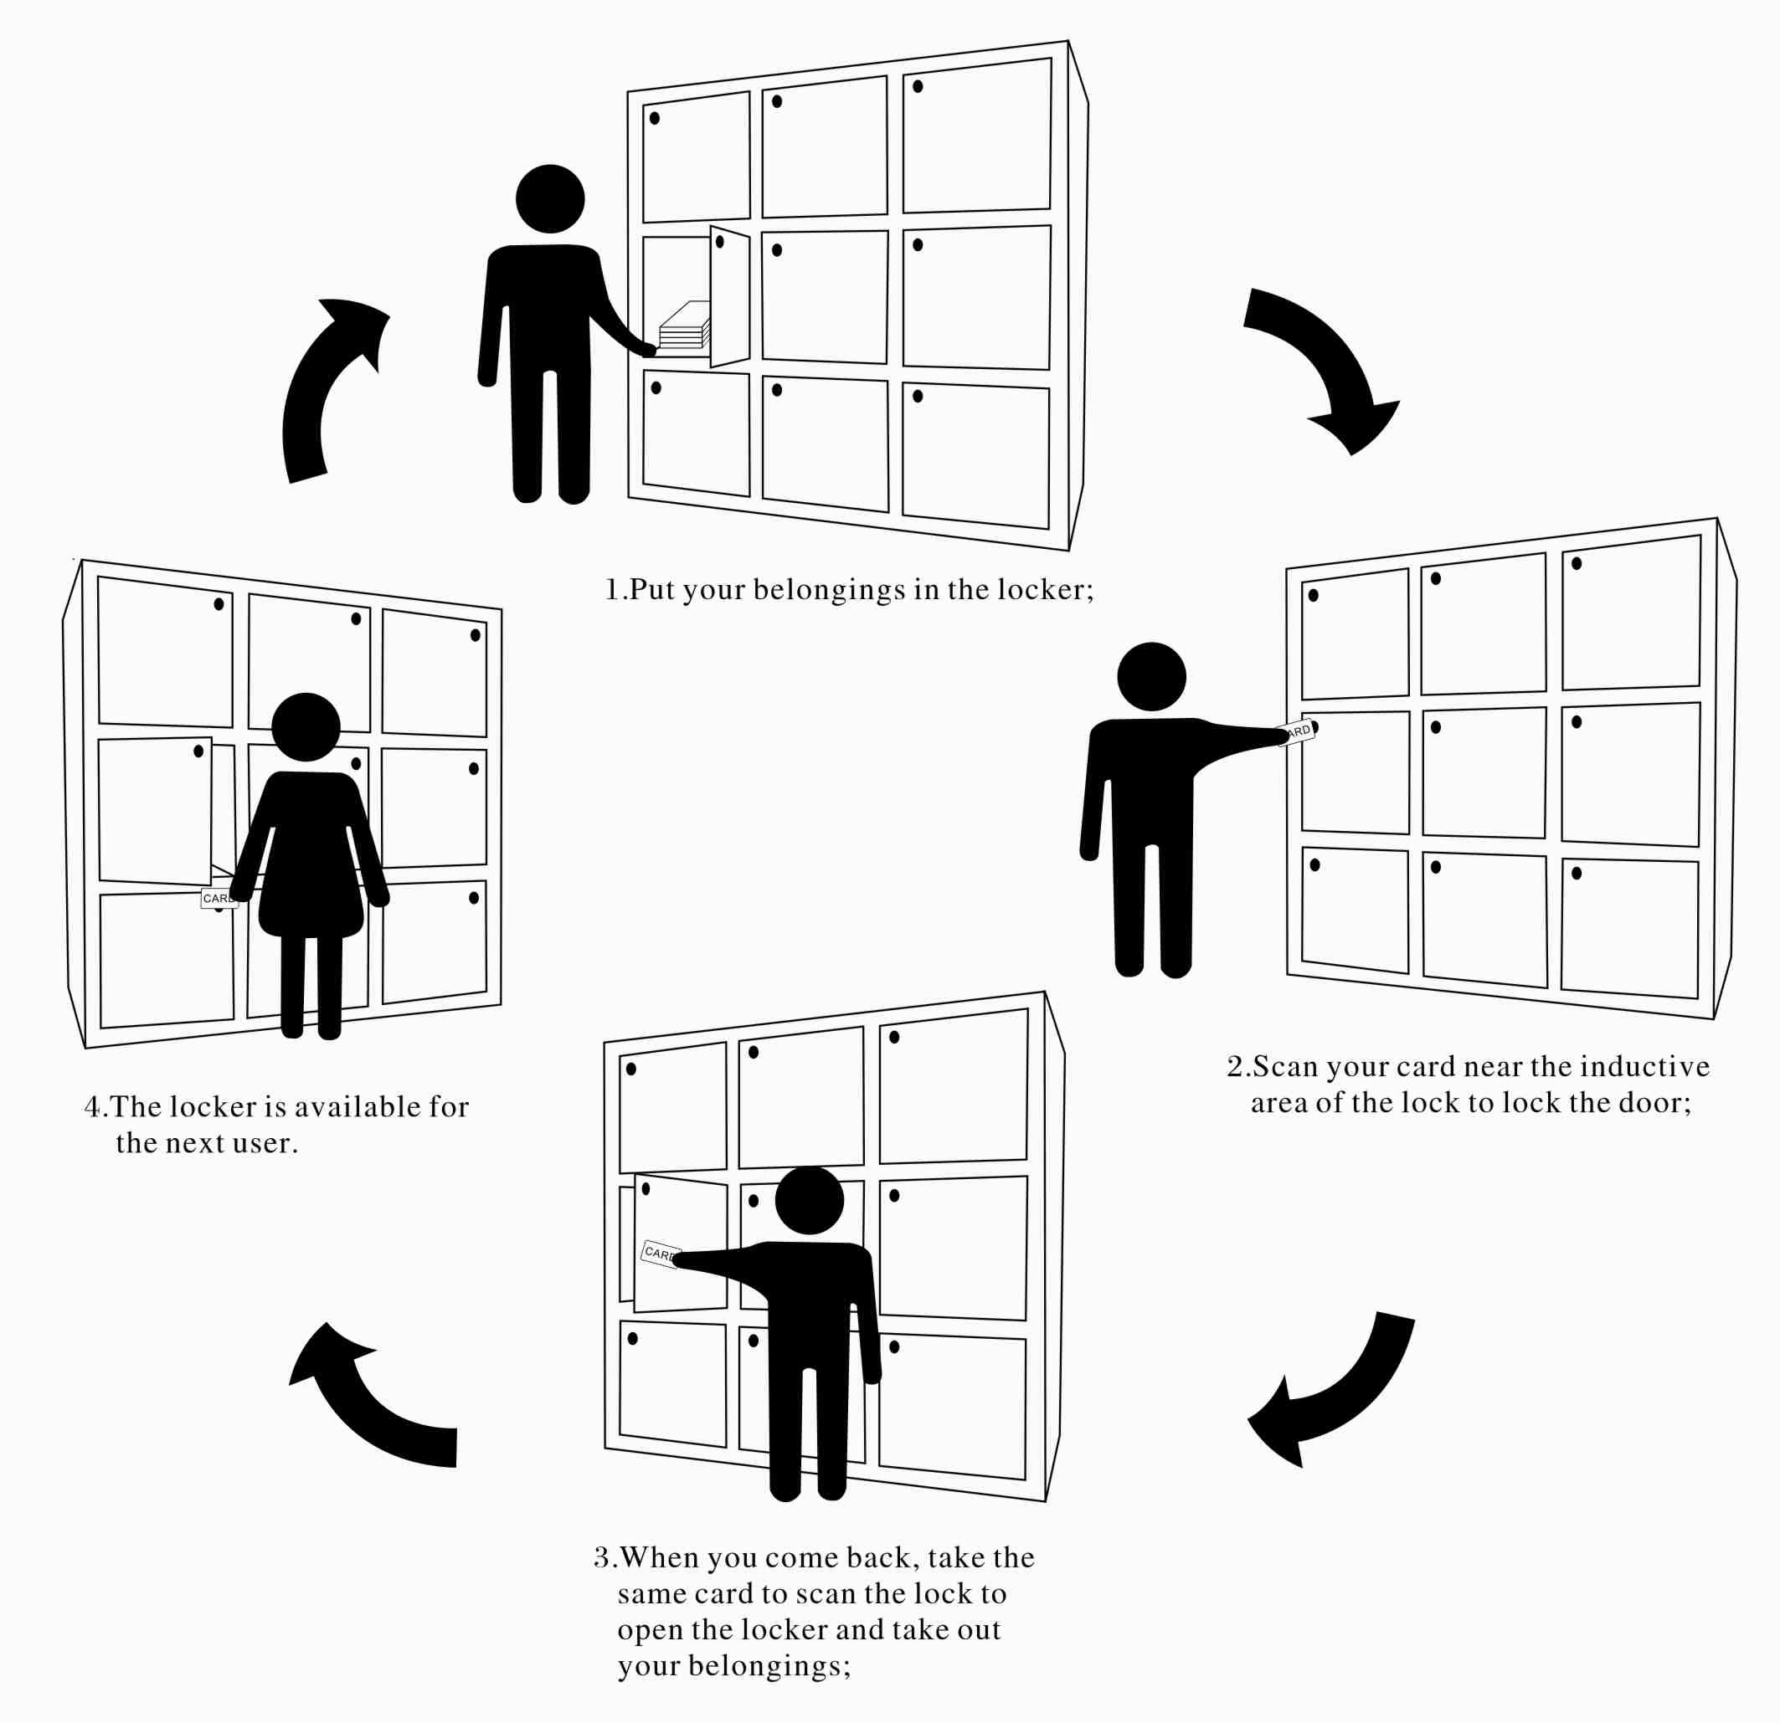

Free Mode Models as Below:
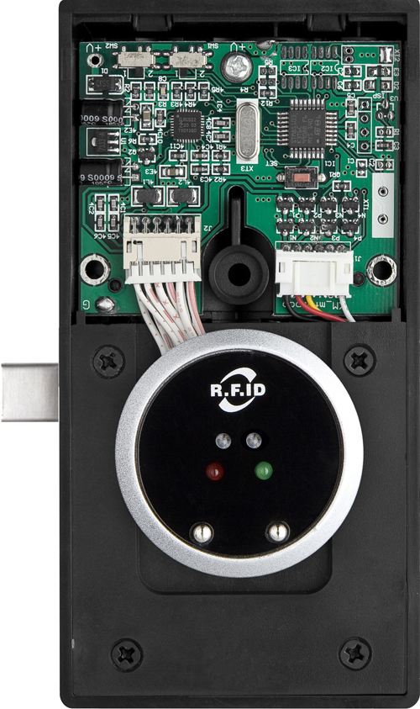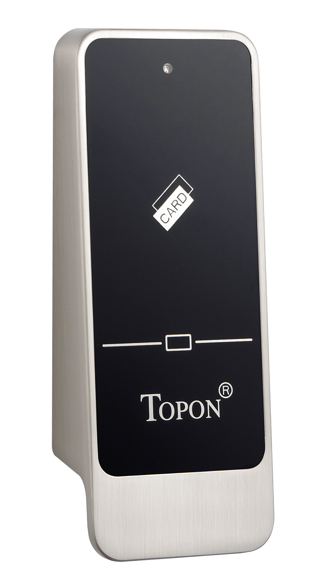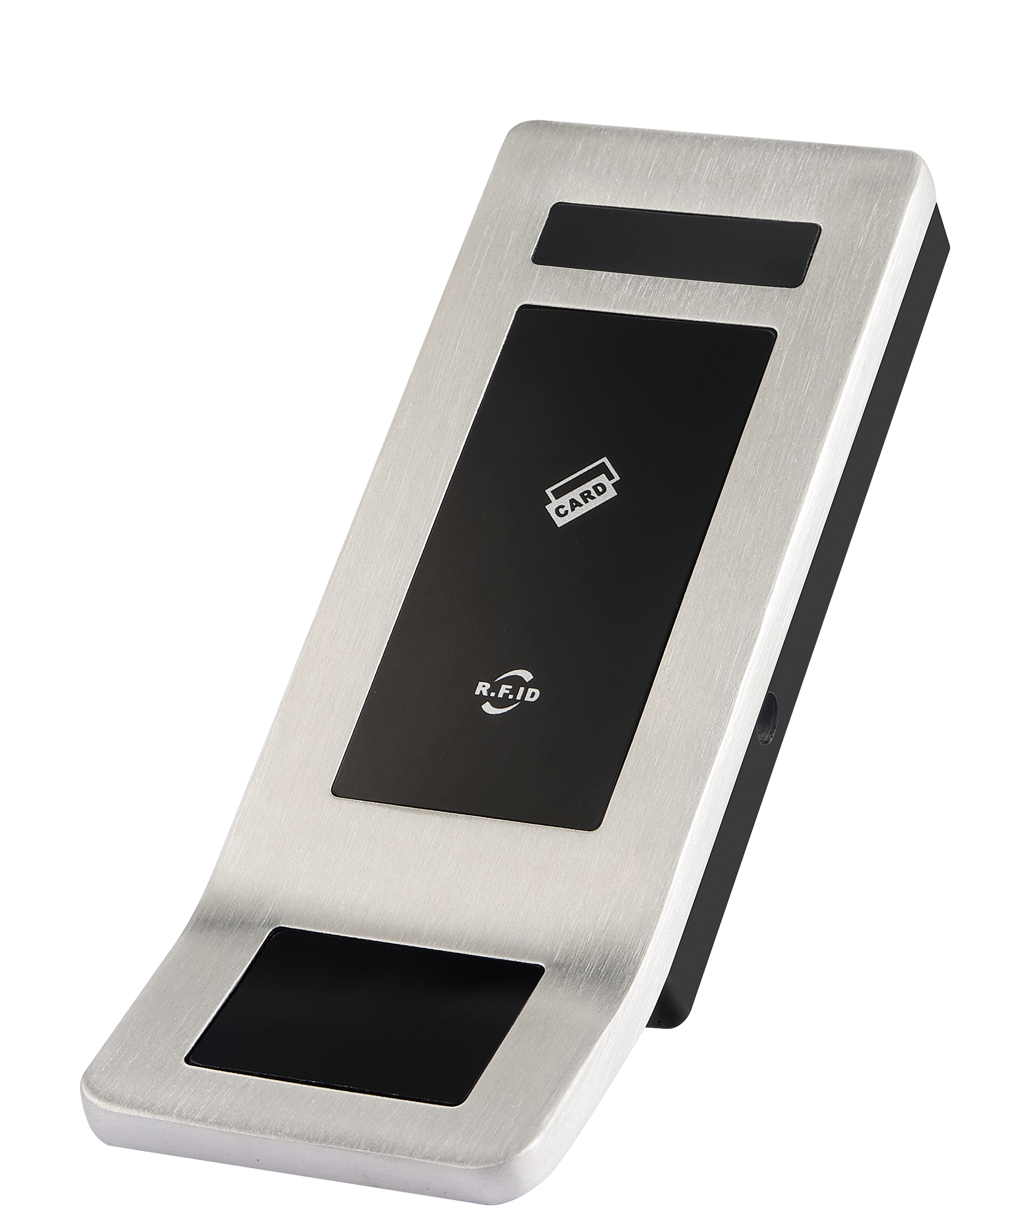

0200 0860 0880

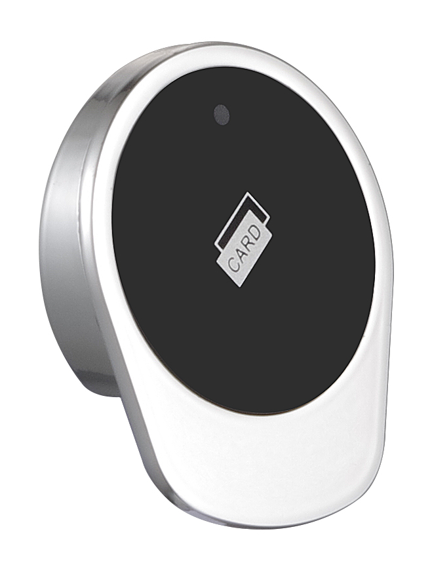
0780

