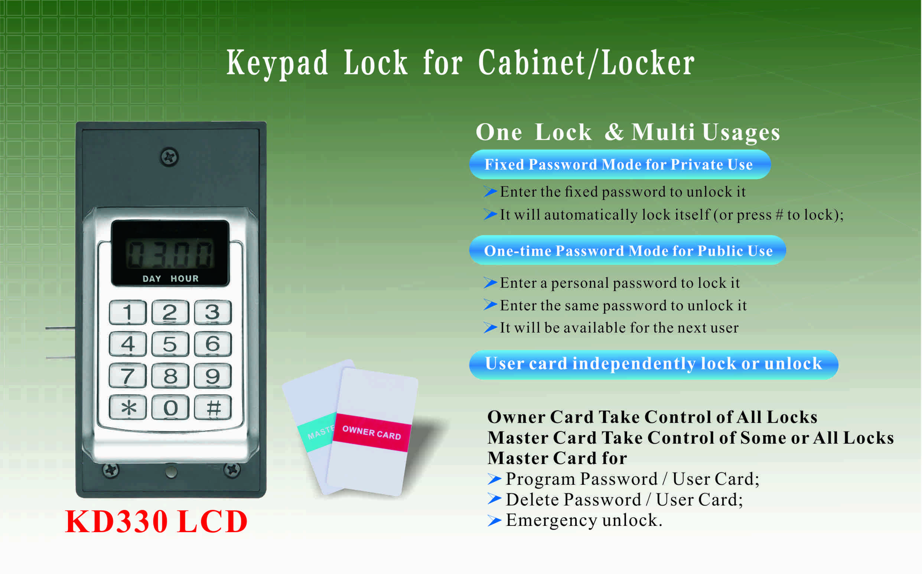
Features:
- Secure control by level management;
- Keypad with backlight for easy distinction;
- Indicator blinks while in locked status;
- Locking time will be shown on the screen;
- It will alarm when pre-set time reached;
- Wrong code or illegal card alarm;
- Low battery alarm;
- Anti-picked (prized) alarm;
- External power back up;
- 304 stainless steel material.

Technical Parameters
Power supply | 3 x AA alkaline batteries
Battery life | 12～15 months
Static current | ≤20µA
Dynamic current | ≤200mA
Working temperature | -15 ～ +55℃
Working humidity | 20 ～ 95%RH
Alarm voltage | 3.7±0.2V
Door thickness | 13～ 22mm

Dimension

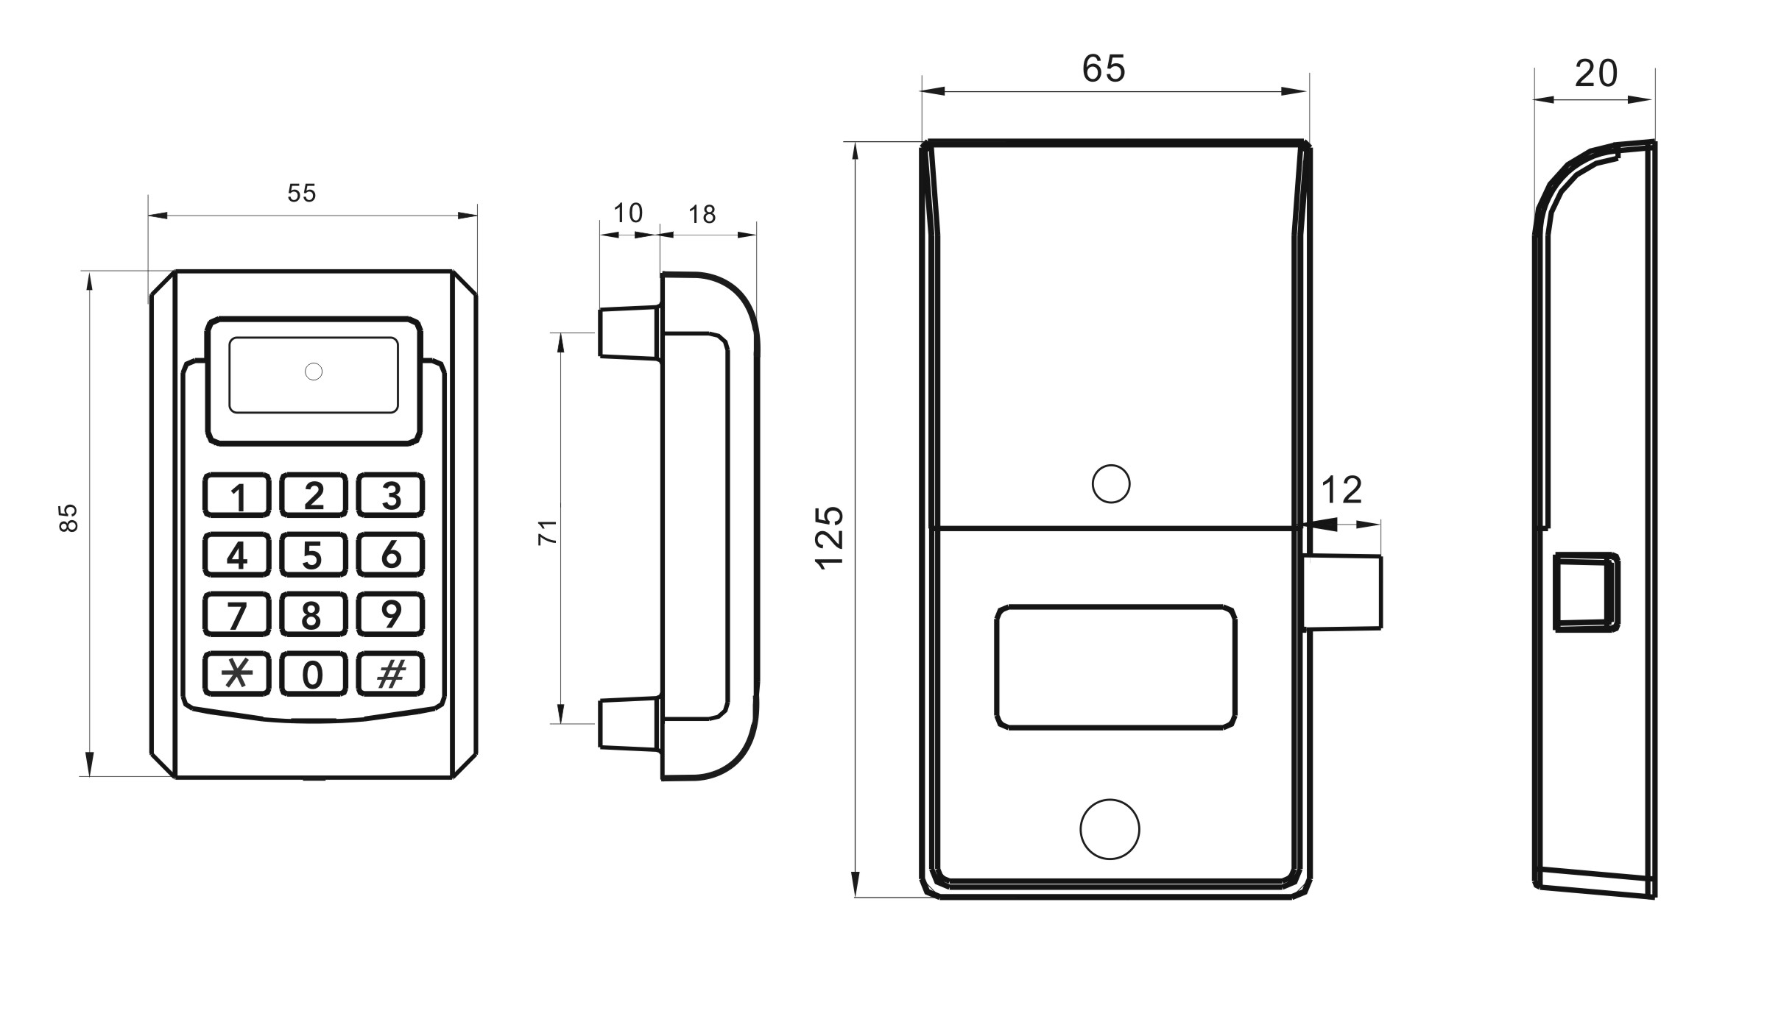

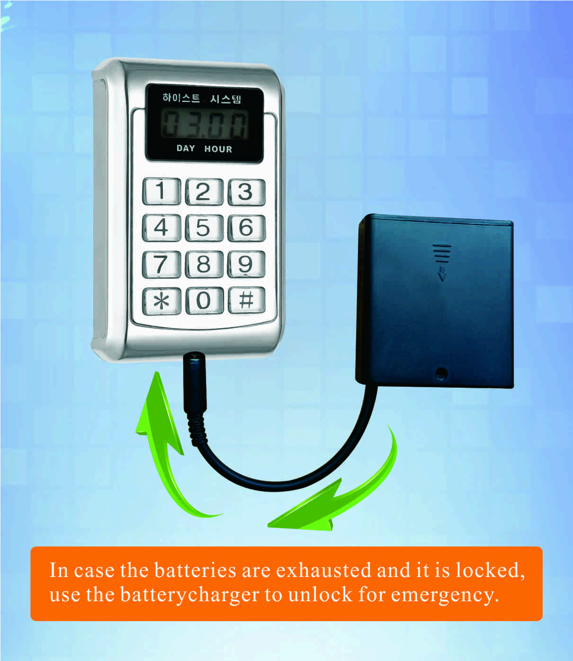
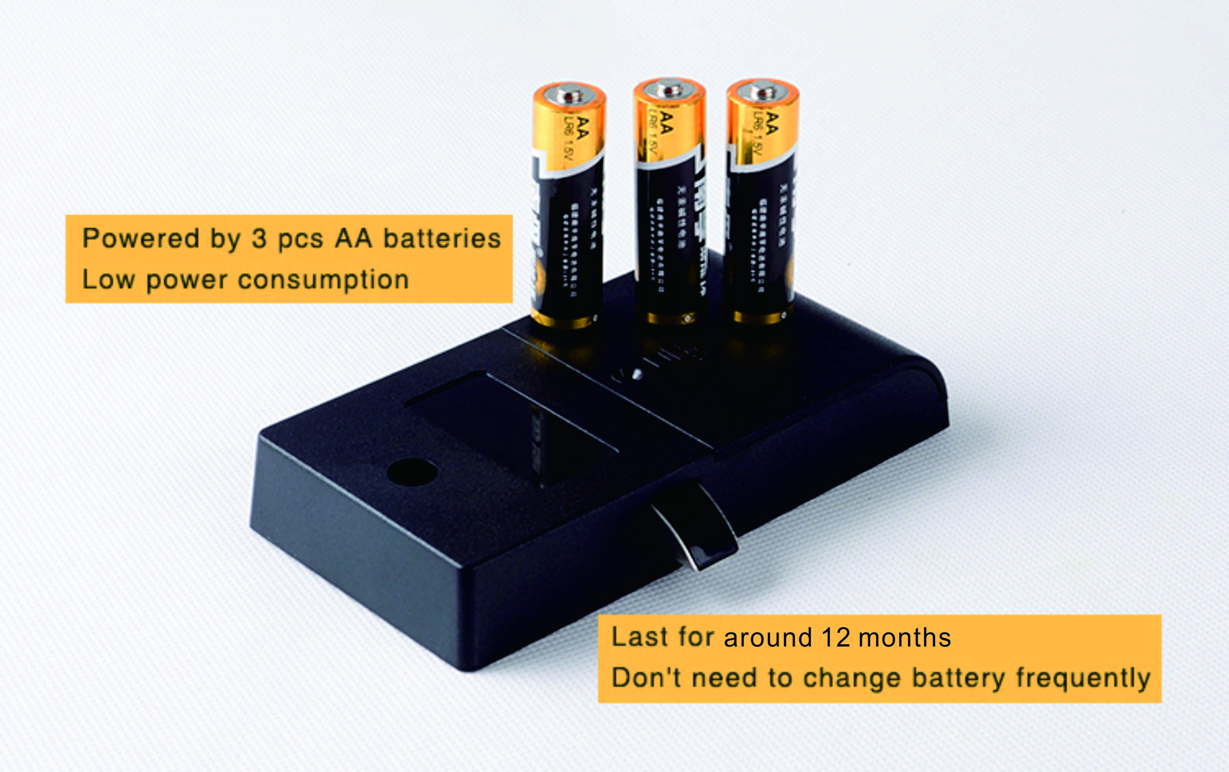

Latch mechanism: 300,000 life times (motor life times:450,000 times);
Tensile strength of the latch part against pulling force:1600N

Package:
2pcs/inner box
Carton size: 430mm x 270mm x 220mm
40 pcs/ctn ( 10.40kg)

FAQ
Q:Can this password locker lock be used for public?
A:Yes, you can use it to public, use guest code to close it, then same code to open it.
Q:Is master card available for the digital locker lock?
A:It is available, it will be provided master card to open the lock for emergency.
Q:If user forgot password, how to open the locker?
A:Use master card to unlock it.

Q:What can we do if the power is exhausted.
A:There is consecutive 8 sounds as alarm from the locks, and please replace the batteries after sound alarm.
If the batteries are dead in the locker lock, use external power to open it and change batteries.

