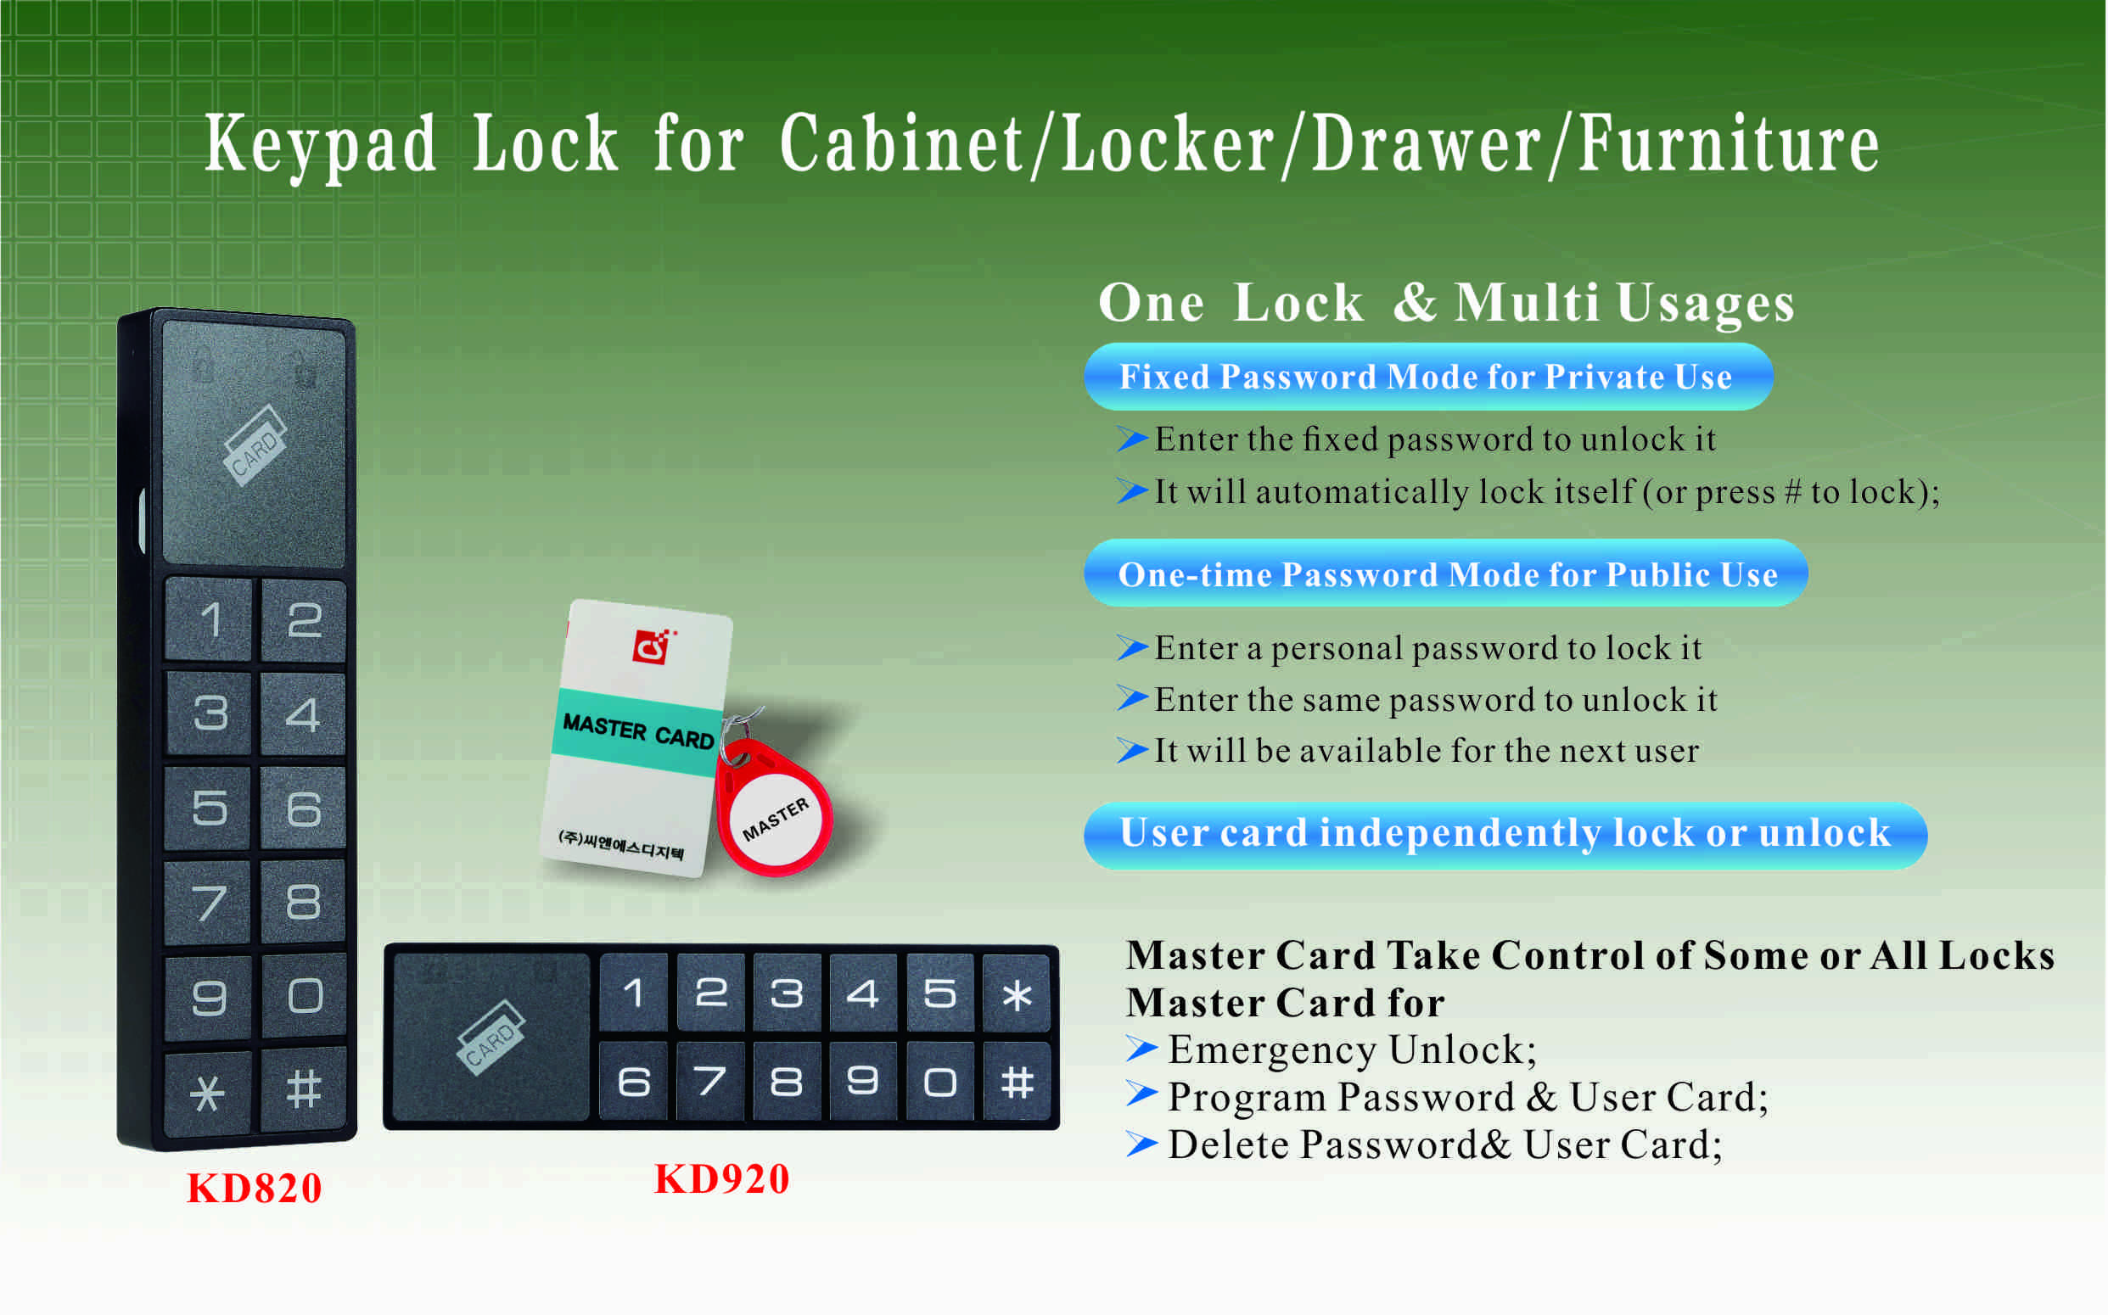

Features:
- Secure control by level management;
- Keypad with backlight for easy distinction;
- Indicator blinks while in locked status;
- Wrong code or illegal card alarm;
- Low battery alarm;
- Anti-picked (prized) alarm;
- USB External power back up;
- ABS material.

Technical Parameters
Power supply | 3 or 4 x AA alkaline batteries
Battery life | 12～15 months
Static current | ≤20µA
Dynamic current | ≤200mA
Working temperature | -15 ～ +55℃
Working humidity | 20 ～ 95%RH
Alarm voltage | 3.7±0.2V or 4.5±0.2V
Door thickness | ≥ 9mm

Dimension

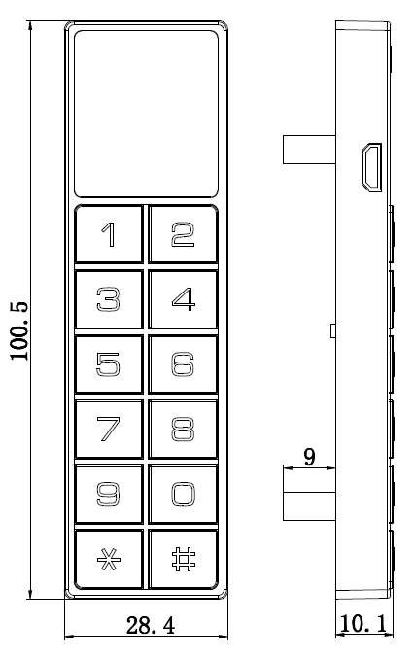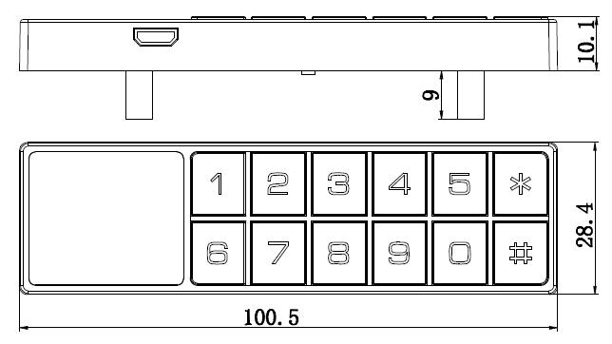

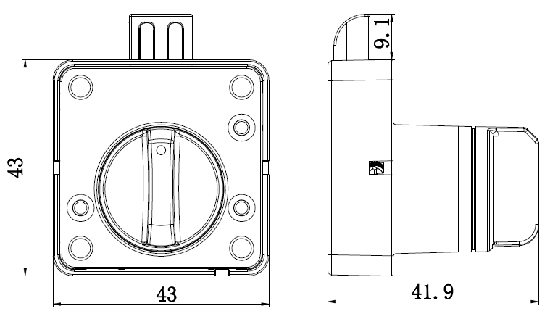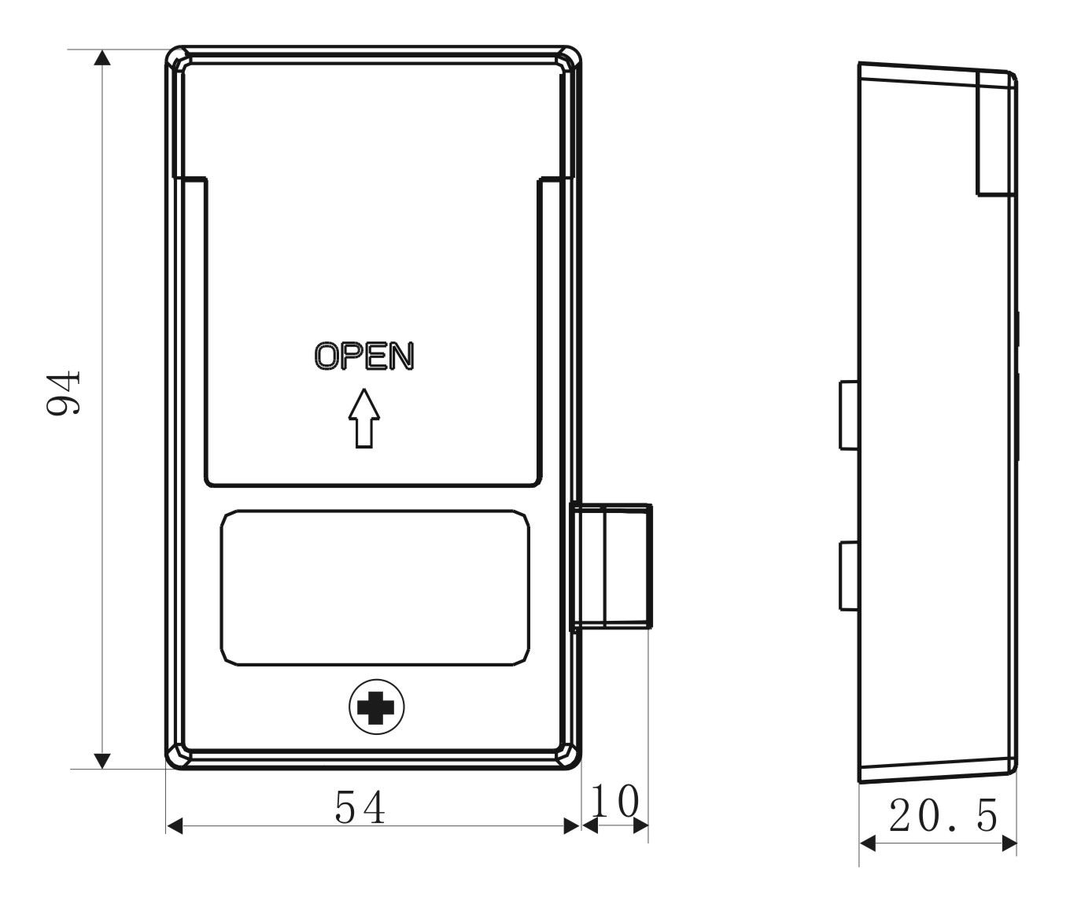

KD910 Match with:

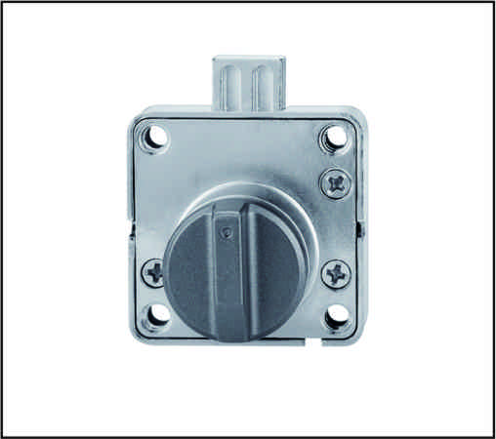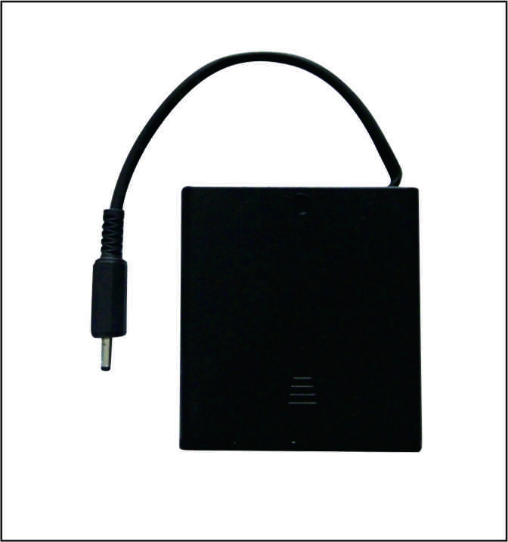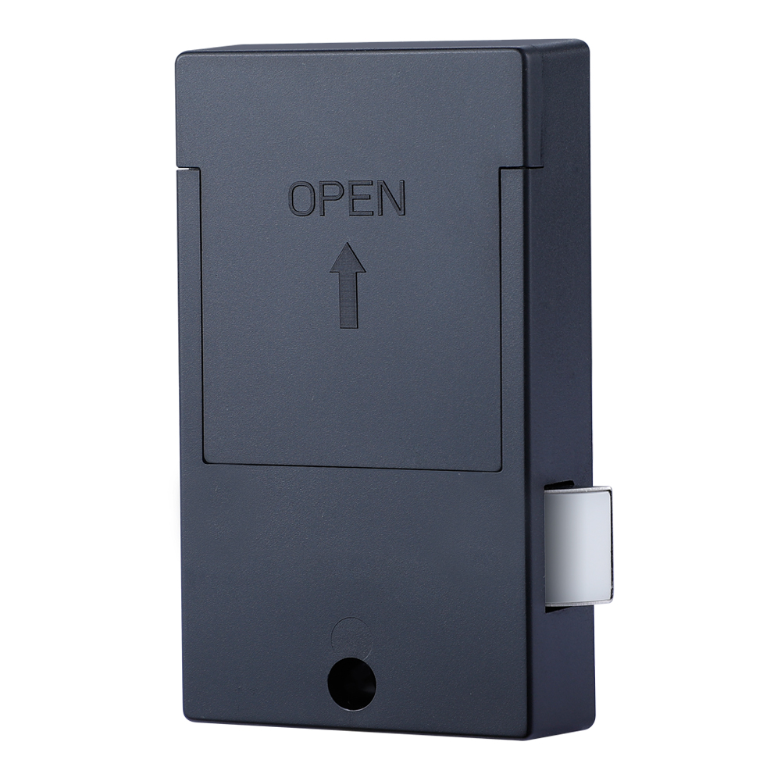
Knob + battery pack Rear panel
Detail Models:
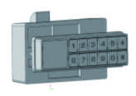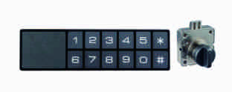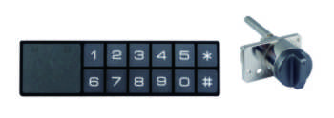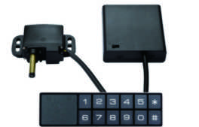
KD920A KD920B KD920C KD920D

2pcs/inner box
Carton size: 430mm x 270mm x 220mm
60 pcs/ctn (7.0KG )

