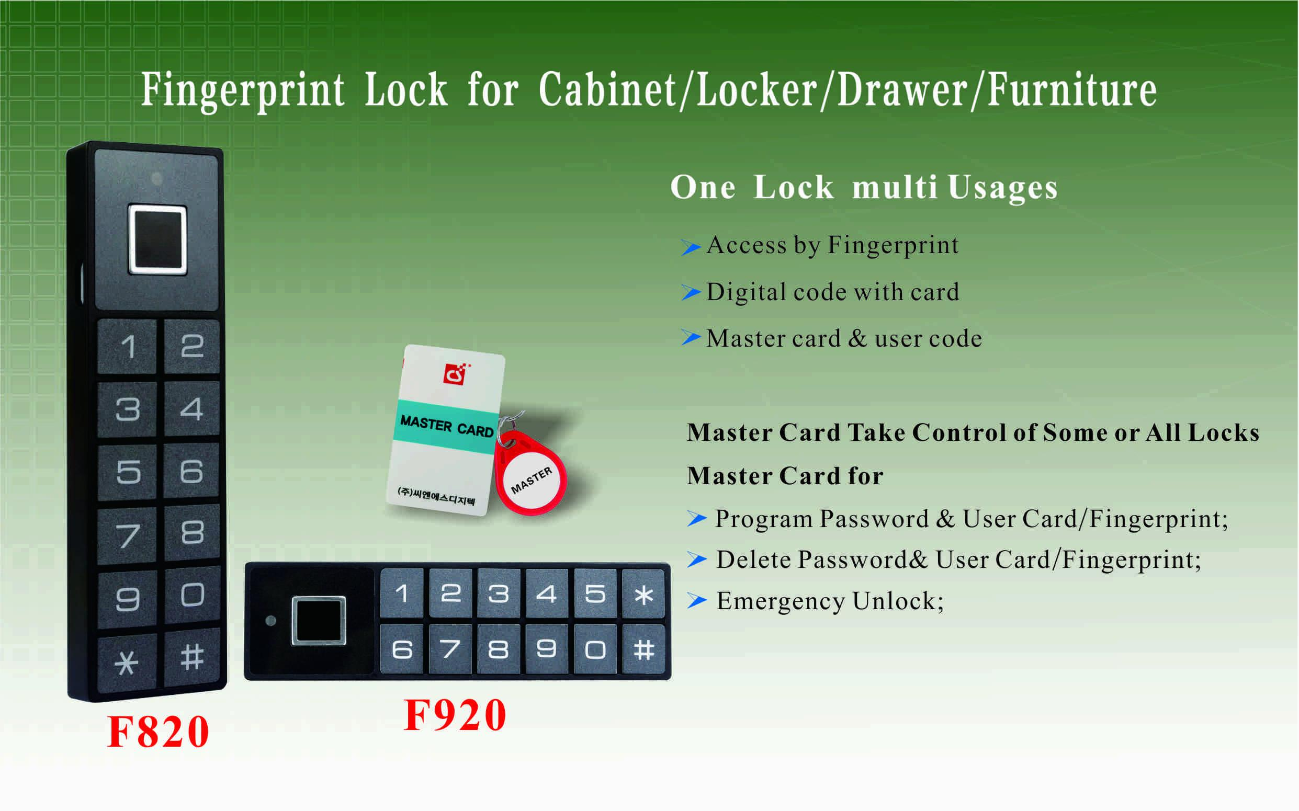

Features:
- Secure control by level-management；
- Unlock by: Fingerprint & Code & Card,
Wrong code or illegal card alarm;
- Low battery alarm;
- Anti-picked (prized) alarm;
- External power back up;
- ABS material;

Technical Parameters
Power supply | 3 or 4 x AA alkaline batteries available
Static current | ≤20µA
Dynamic current | ≤200mA
Working temperature | -15 ～ +55℃
Working humidity | 20 ～ 95%RH
Alarm voltage | 3.7±0.2V or 4.5±0.2V
Fingerprint capacity | 40 pcs
Door thickness | ≥ 9mm
Dimension

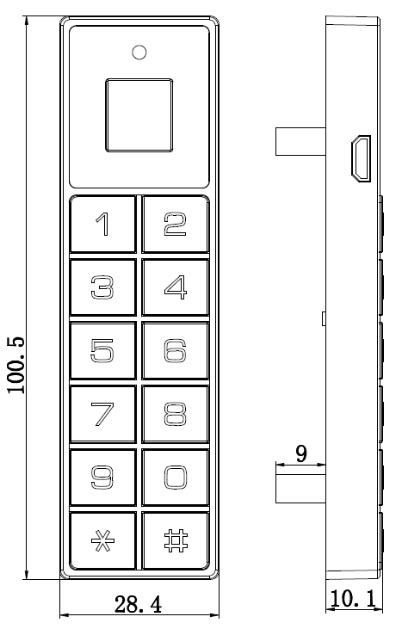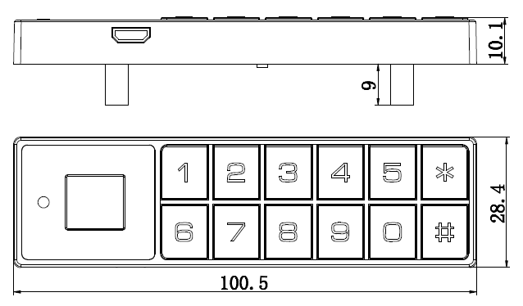

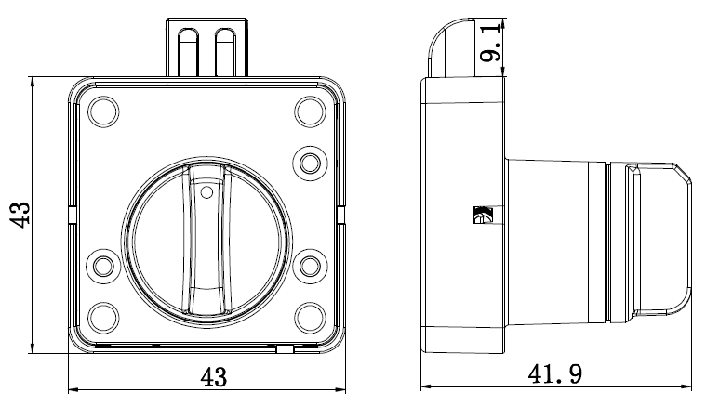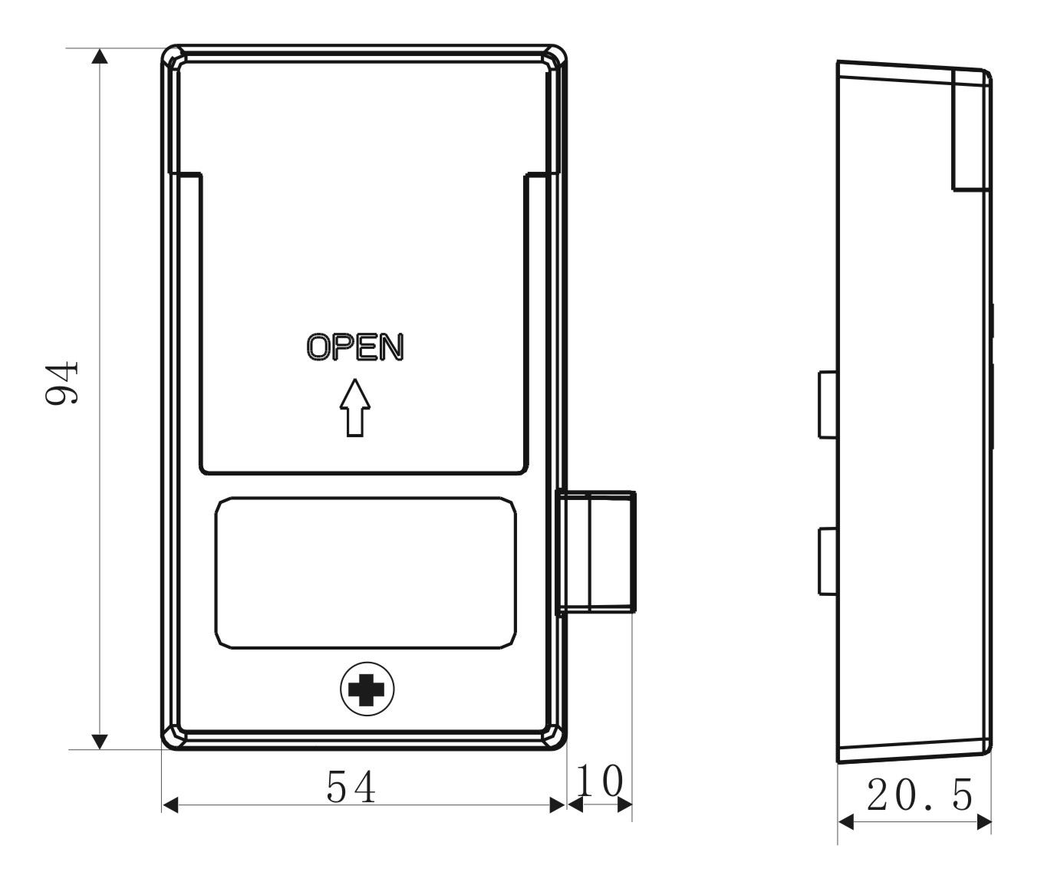

F910 Match with:

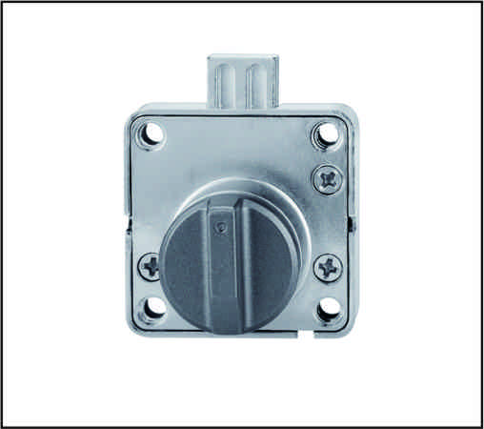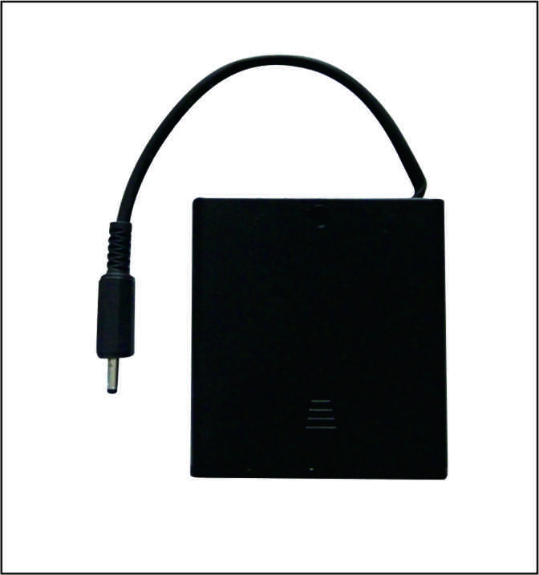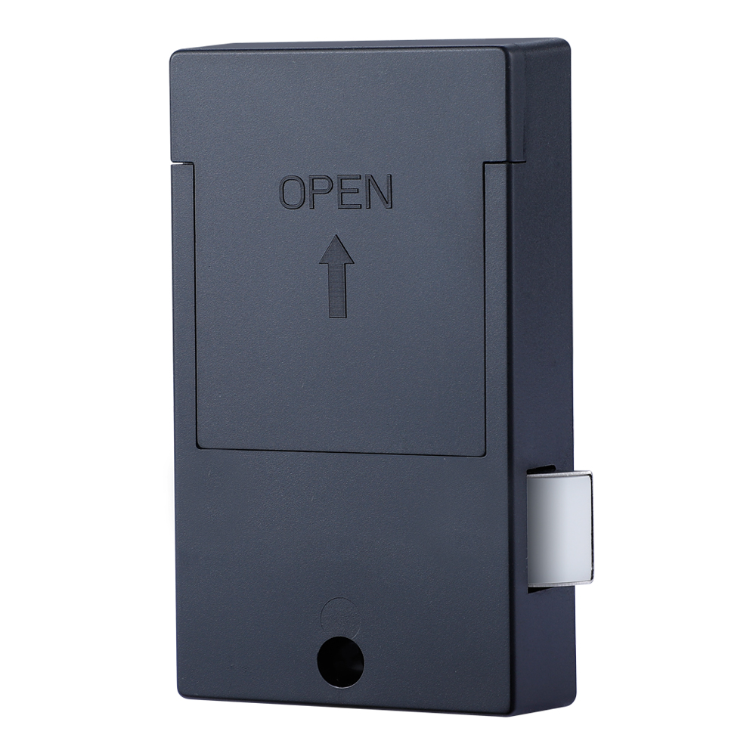
Knob + battery pack Rear panel
Detail Models
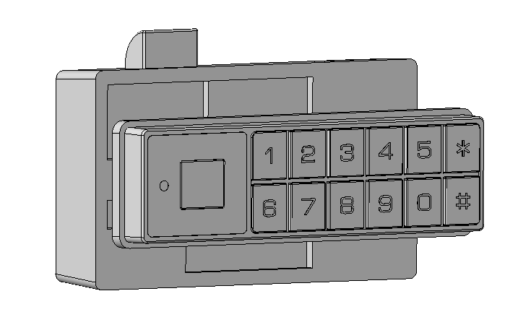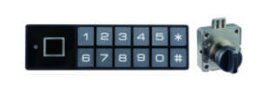
F920A F920B
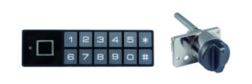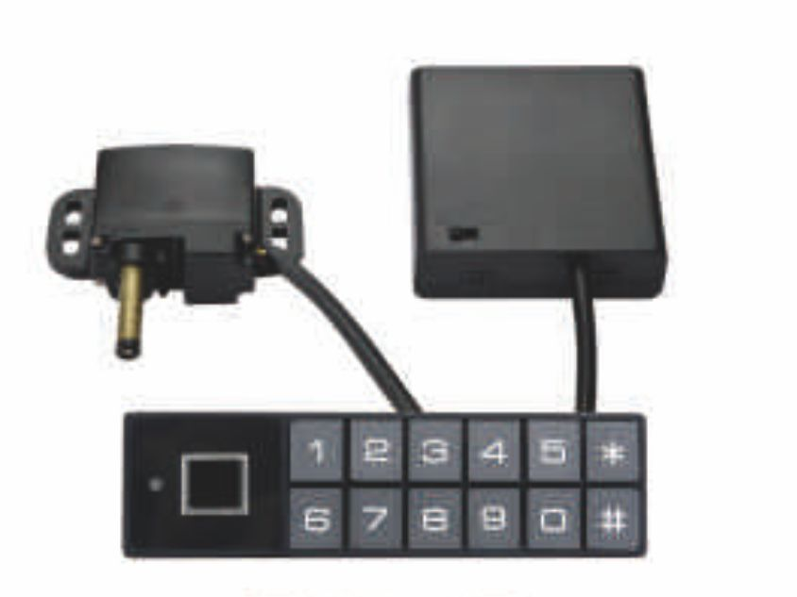

F920C F920D

Emergency unlocking
In case the batteries are exhausted and it is locked, use a USB charger to insert into the USB port which is located at the side section for emergency unlocking.

Applications:
Suitable for Cabinet/Locker/Drawer/Furniture, etc.

Standard Package for project:
2pcs/inner box
Carton size: 430mm x 270mm x 220mm
40 pcs/ctn (7.50 kg)

