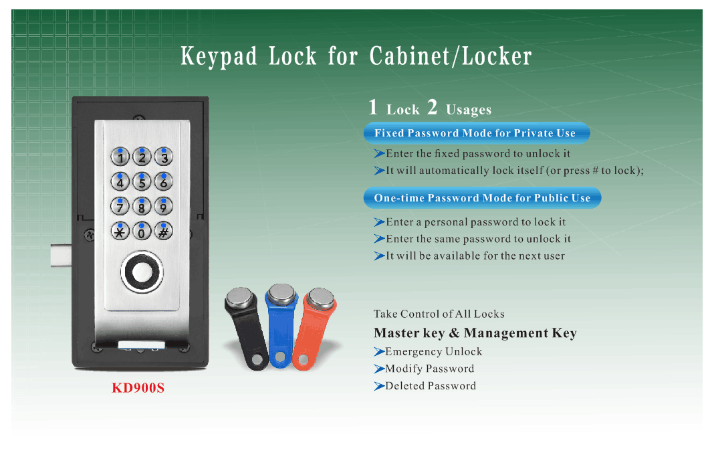
Features:
- Secure control by level-management;
- Permanent code or one-time code convertible;
- Keypad with backlight for easy distinction;
- Indicator blinks while in locked status;
- Wrong code or illegal key alarm;
- Anti-picked (prized) alarm;
- Low battery alarm;
- External power back up;
- Stainless steel material;
Technical Parameters
Power supply | 3 x AA alkaline batteries
Static current | ≤20µA
Dynamic current | ≤200mA
Working temperature | -15 ～ +55℃
Working humidity | 20 ～ 95%RH
Alarm voltage | 3.7±0.2V

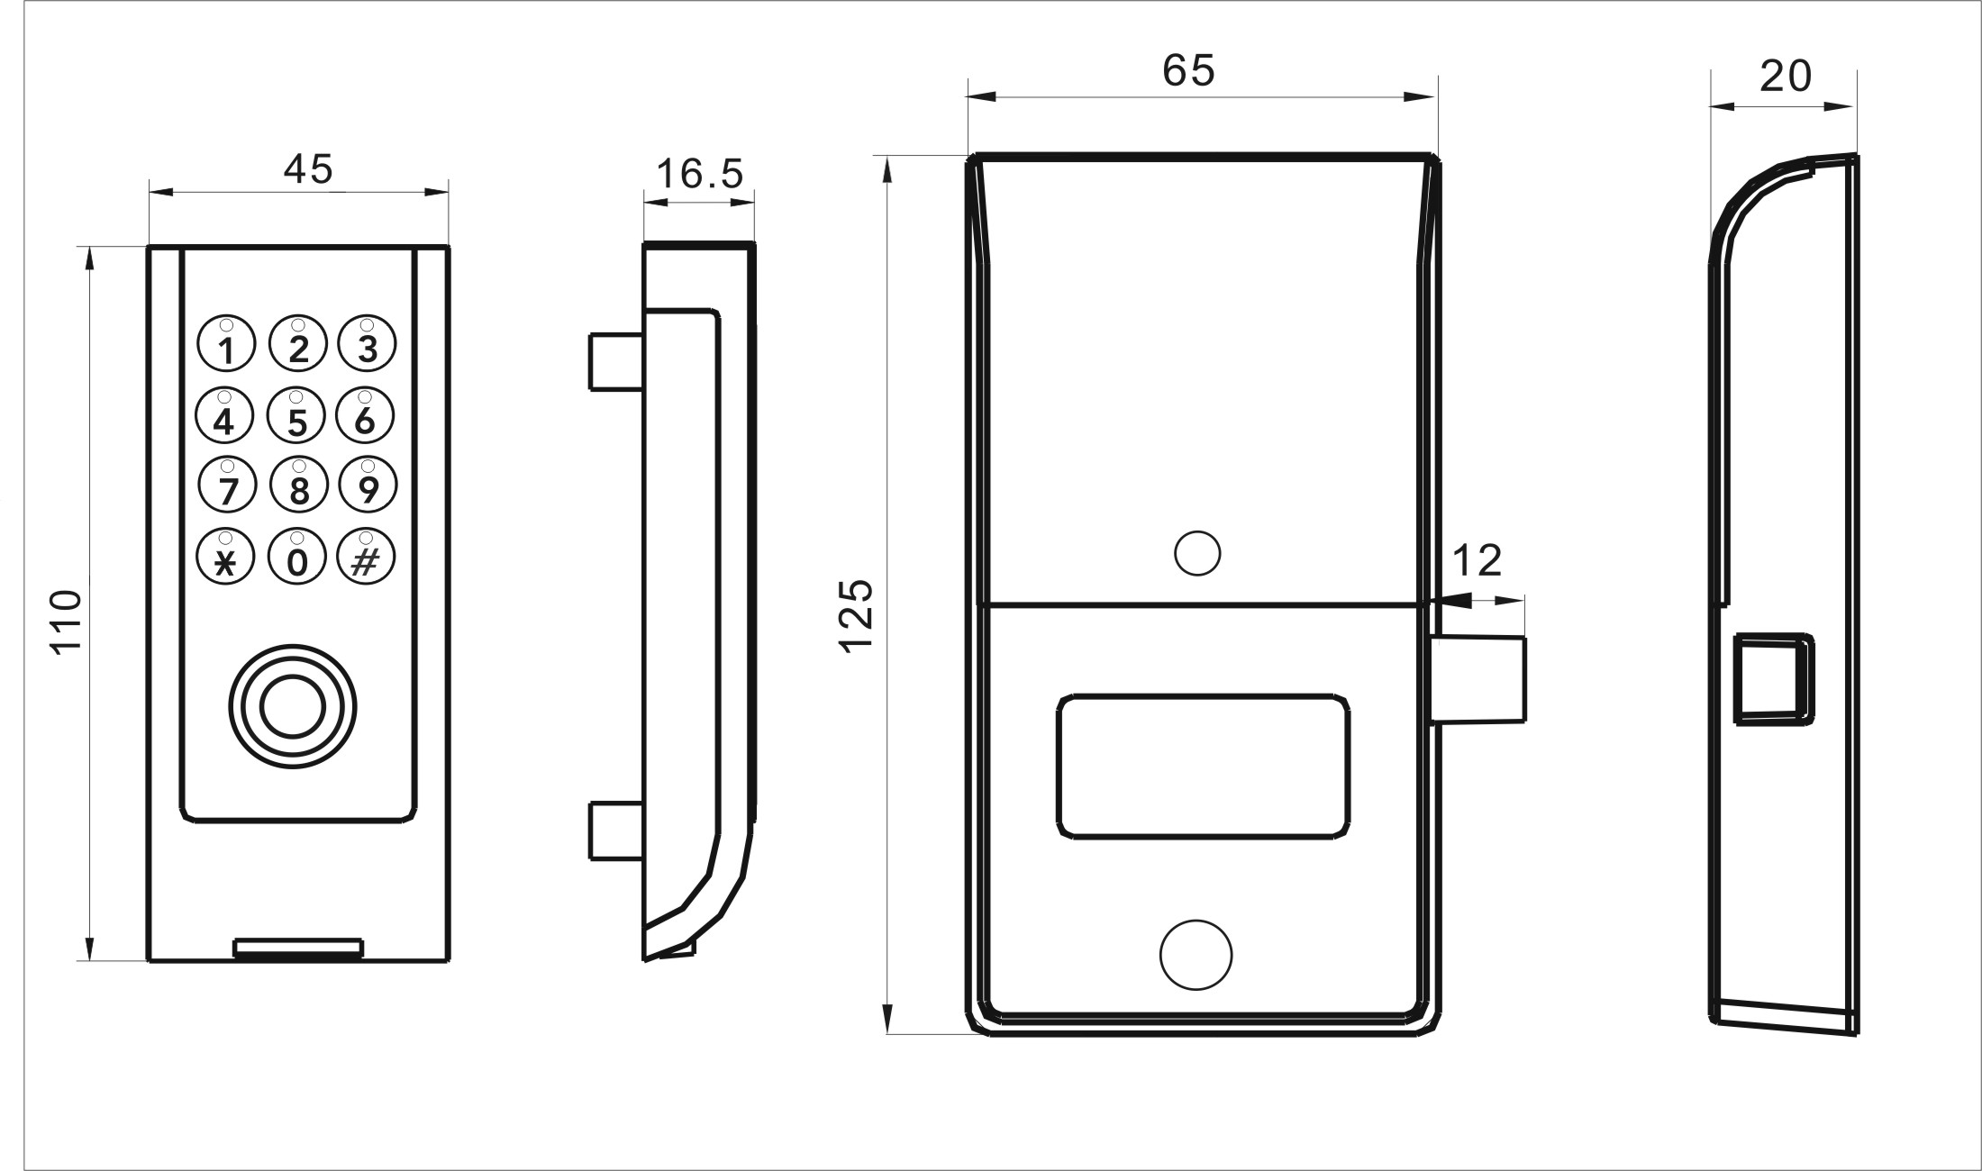

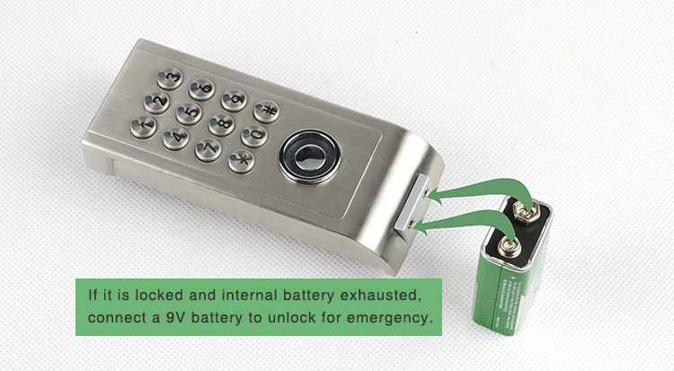
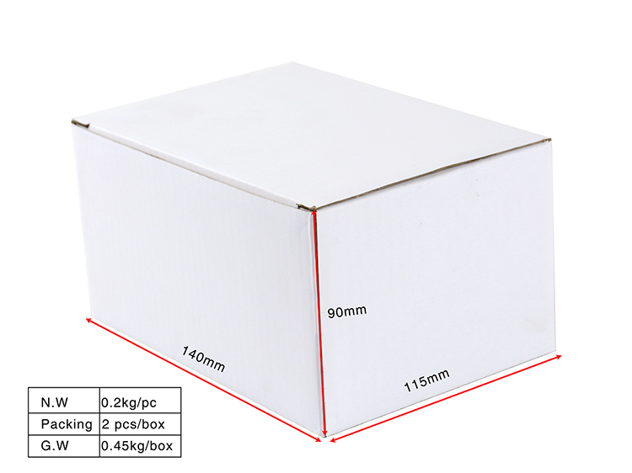

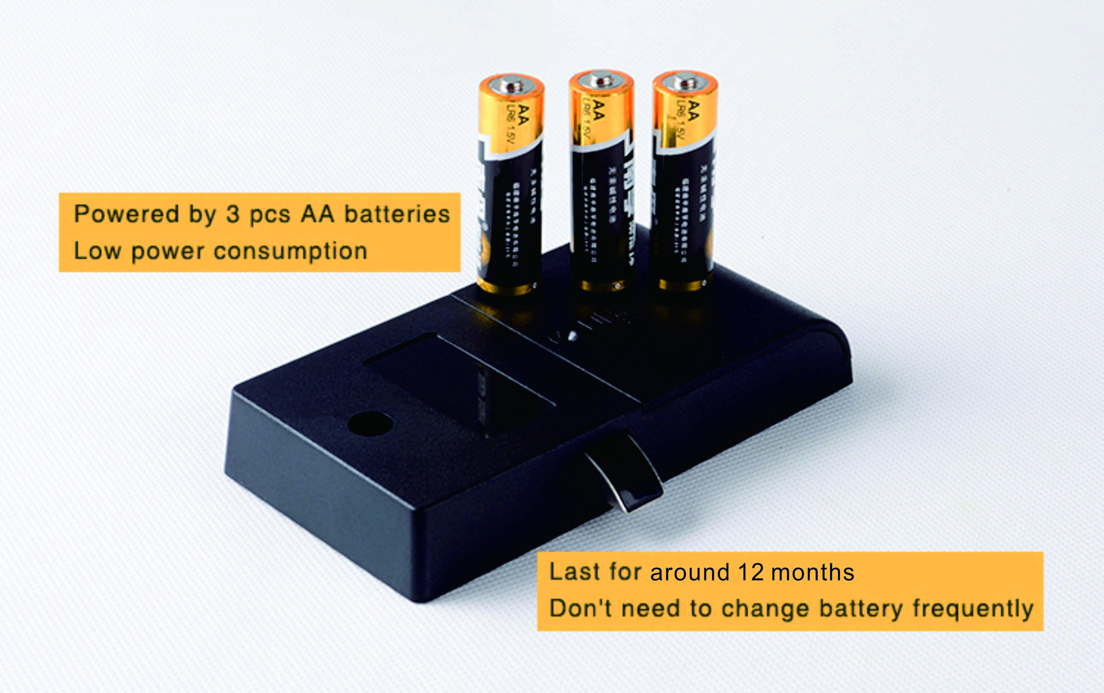
Project case
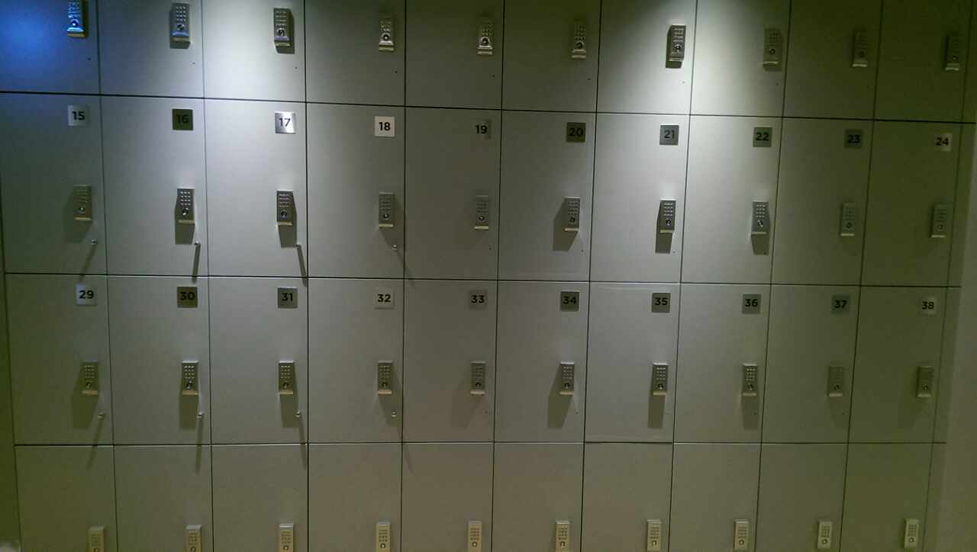

FAQ
Q:How to supply power to this password locker locks?
A:Standard 3pcs AA alkaline batteries, last 10-12 months normally.
Q:Can this password locker lock be used for public?
A:Yes, you can use it to public, use guest code to close it, then same code to open it.
Q:Is master key available for the digital locker lock?
A:It is available, we will supply TM key to open the lock for emergency.
Q:What can we do if the power is exhausted.
A:There is consecutive 8 sounds as alarm from the locks, and please replace the batteries after sound alarm.
If the batteries are dead in the locker lock, use external power to open it and change batteries.
Q:If user forgot password, how to open the locker?
A:Use master TM key to unlock it.
Q:Is customized logo available?
A:Yes, free logo on lock assembly body if over 500 pcs.
Q:What about payment?
A:We support T/T, Western Union, PayPal Cash etc.
Q:How about the shipping?
We cooperate with DHL, FedEx, TNT, UPS, EMS etc, of course by sea for bulk order
Or you can choose your own shipping forwarder.

