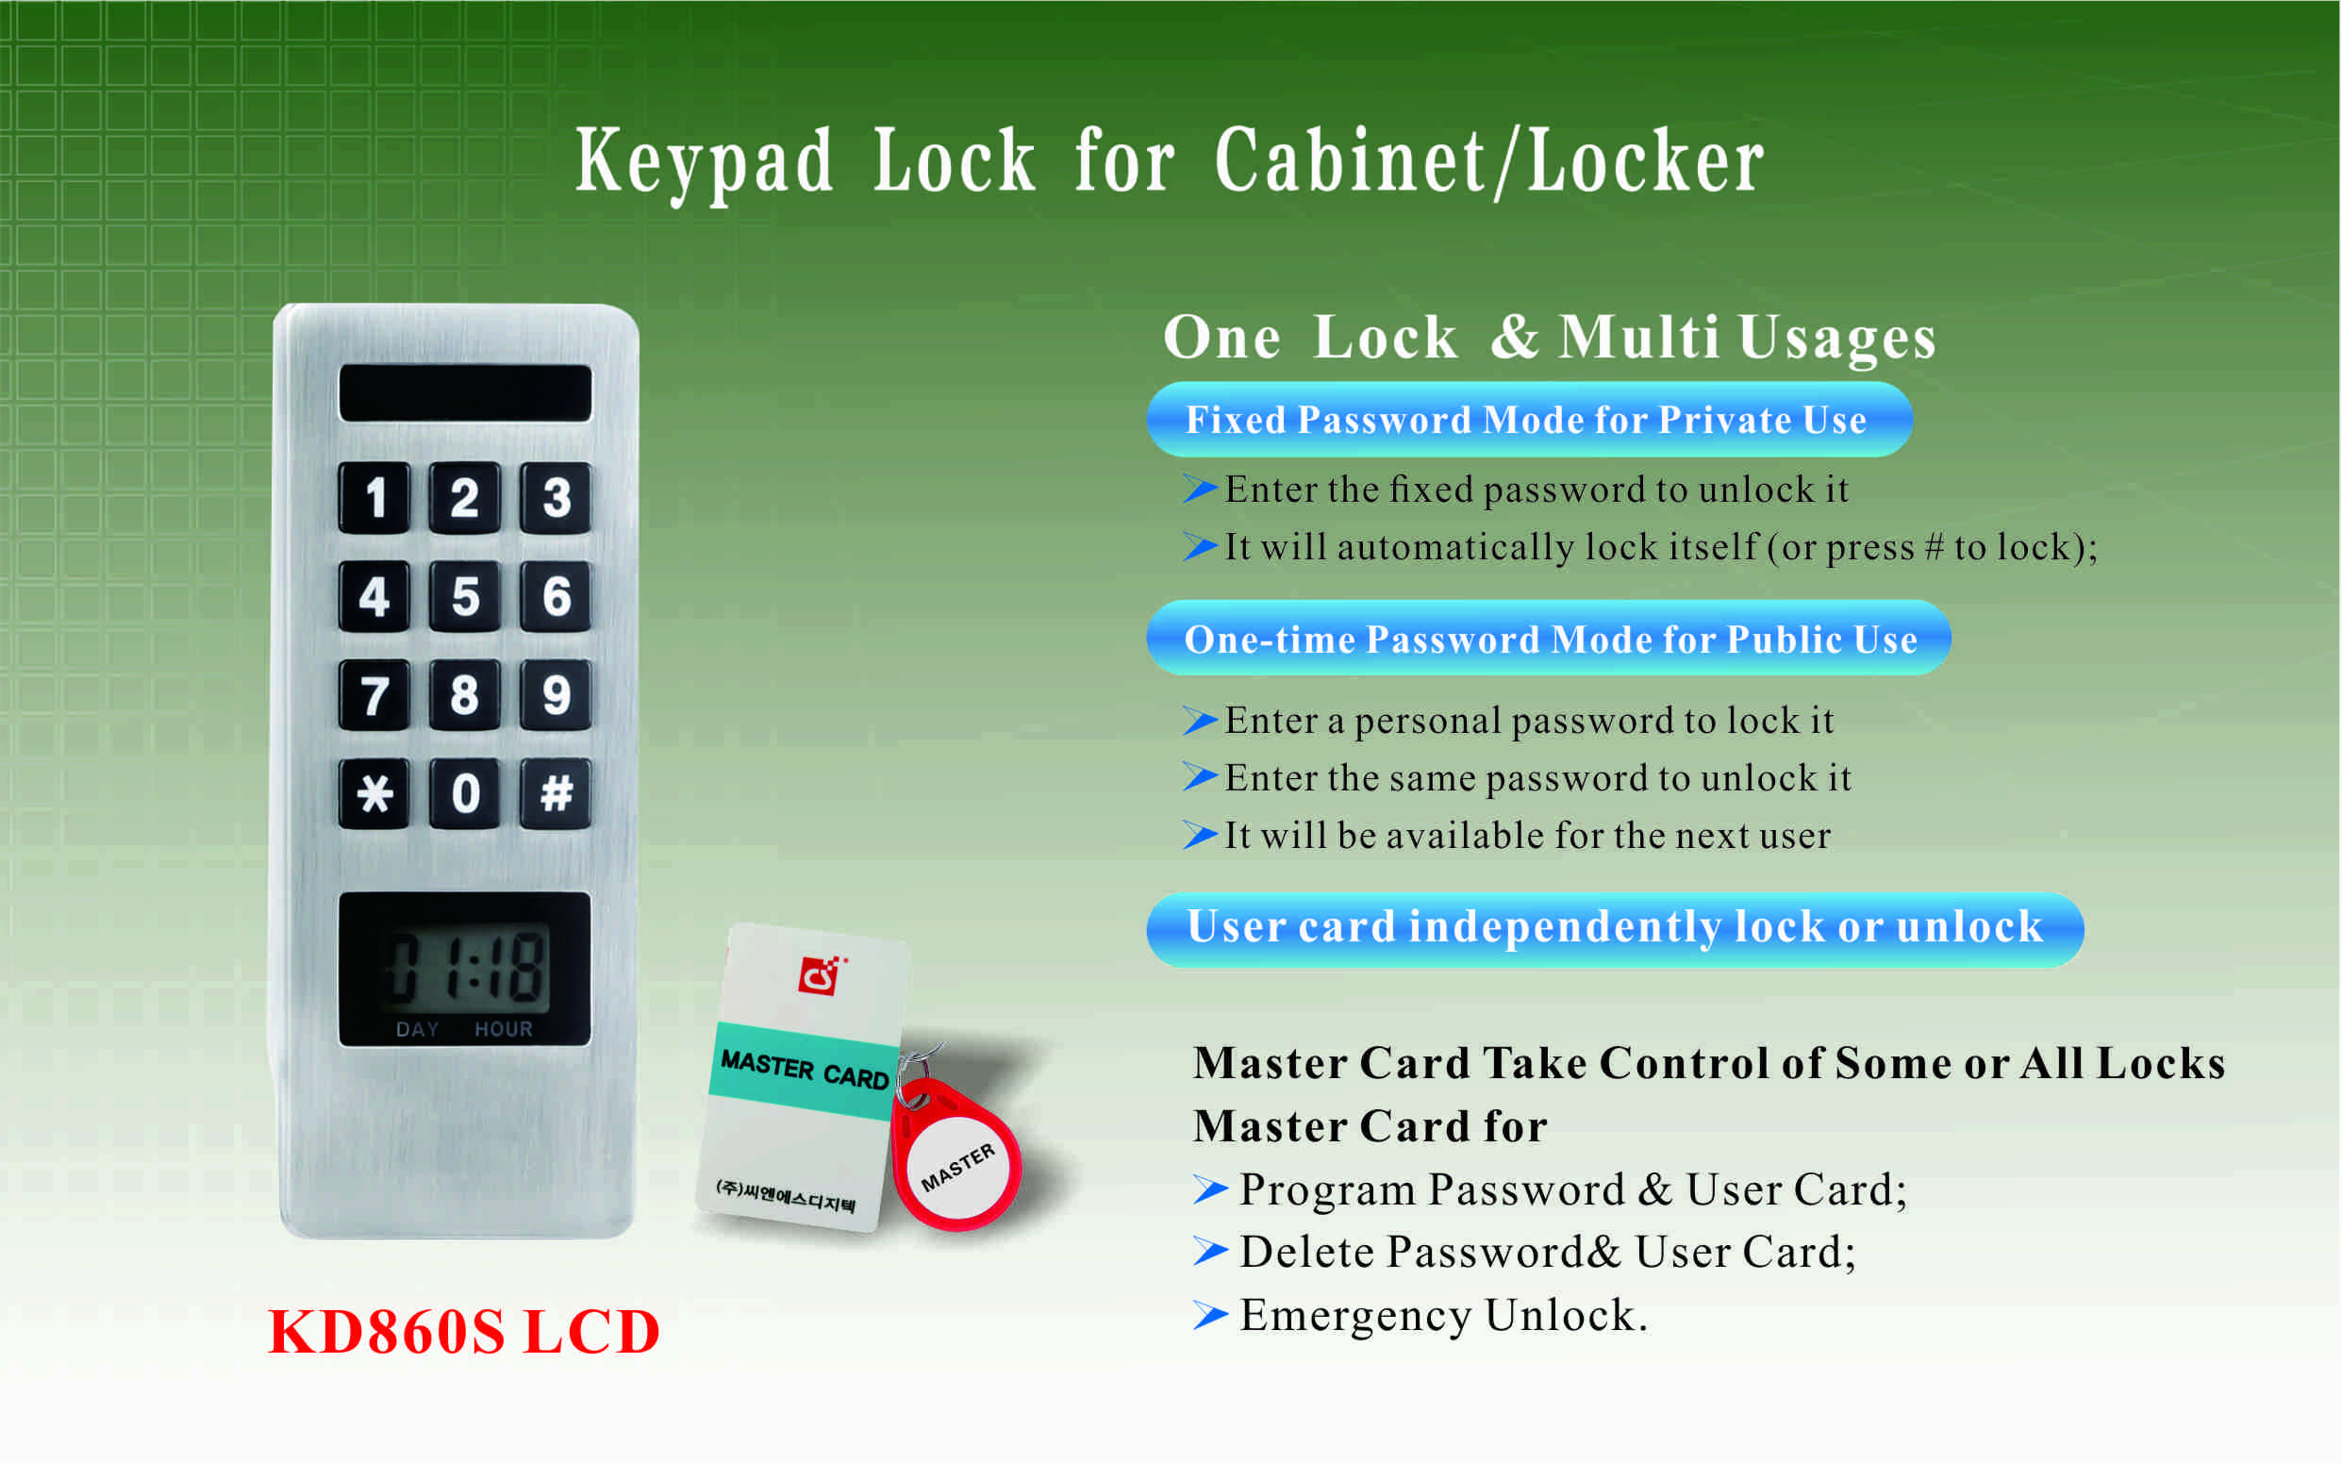
Features:
- Secure control by level management;
- Keypad with backlight for easy distinction;
- Indicator blinks while in locked status;
- Locking time will be shown on the screen;
- It will alarm when pre-set time reached;
- Wrong password or illegal card alarm;
- Low battery alarm;
- Anti-picked (prized) alarm;
- External power back up(USB port);
- Zinc alloy material.

Technical Parameters
Power supply | 3 x AA alkaline batteries
Battery life | 12～15 months
Static current | ≤20µA
Dynamic current | ≤200mA
Working temperature | -15 ～ +55℃
Working humidity | 20 ～ 95%RH
Alarm voltage | 3.7±0.2V
Door thickness | ≥ 13mm
Dimension
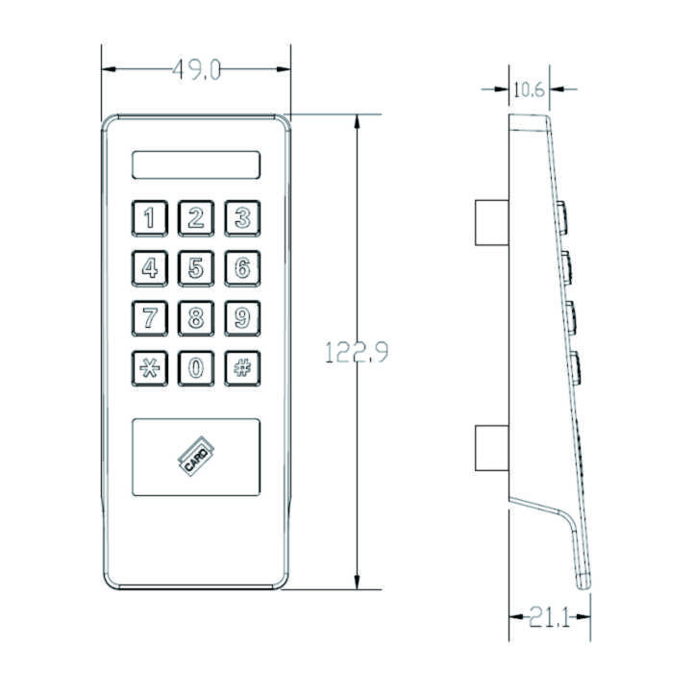

Latch mechanism: 300,000 life times (motor life times:450,000 times);
Tensile strength of the latch part against pulling force:1600N

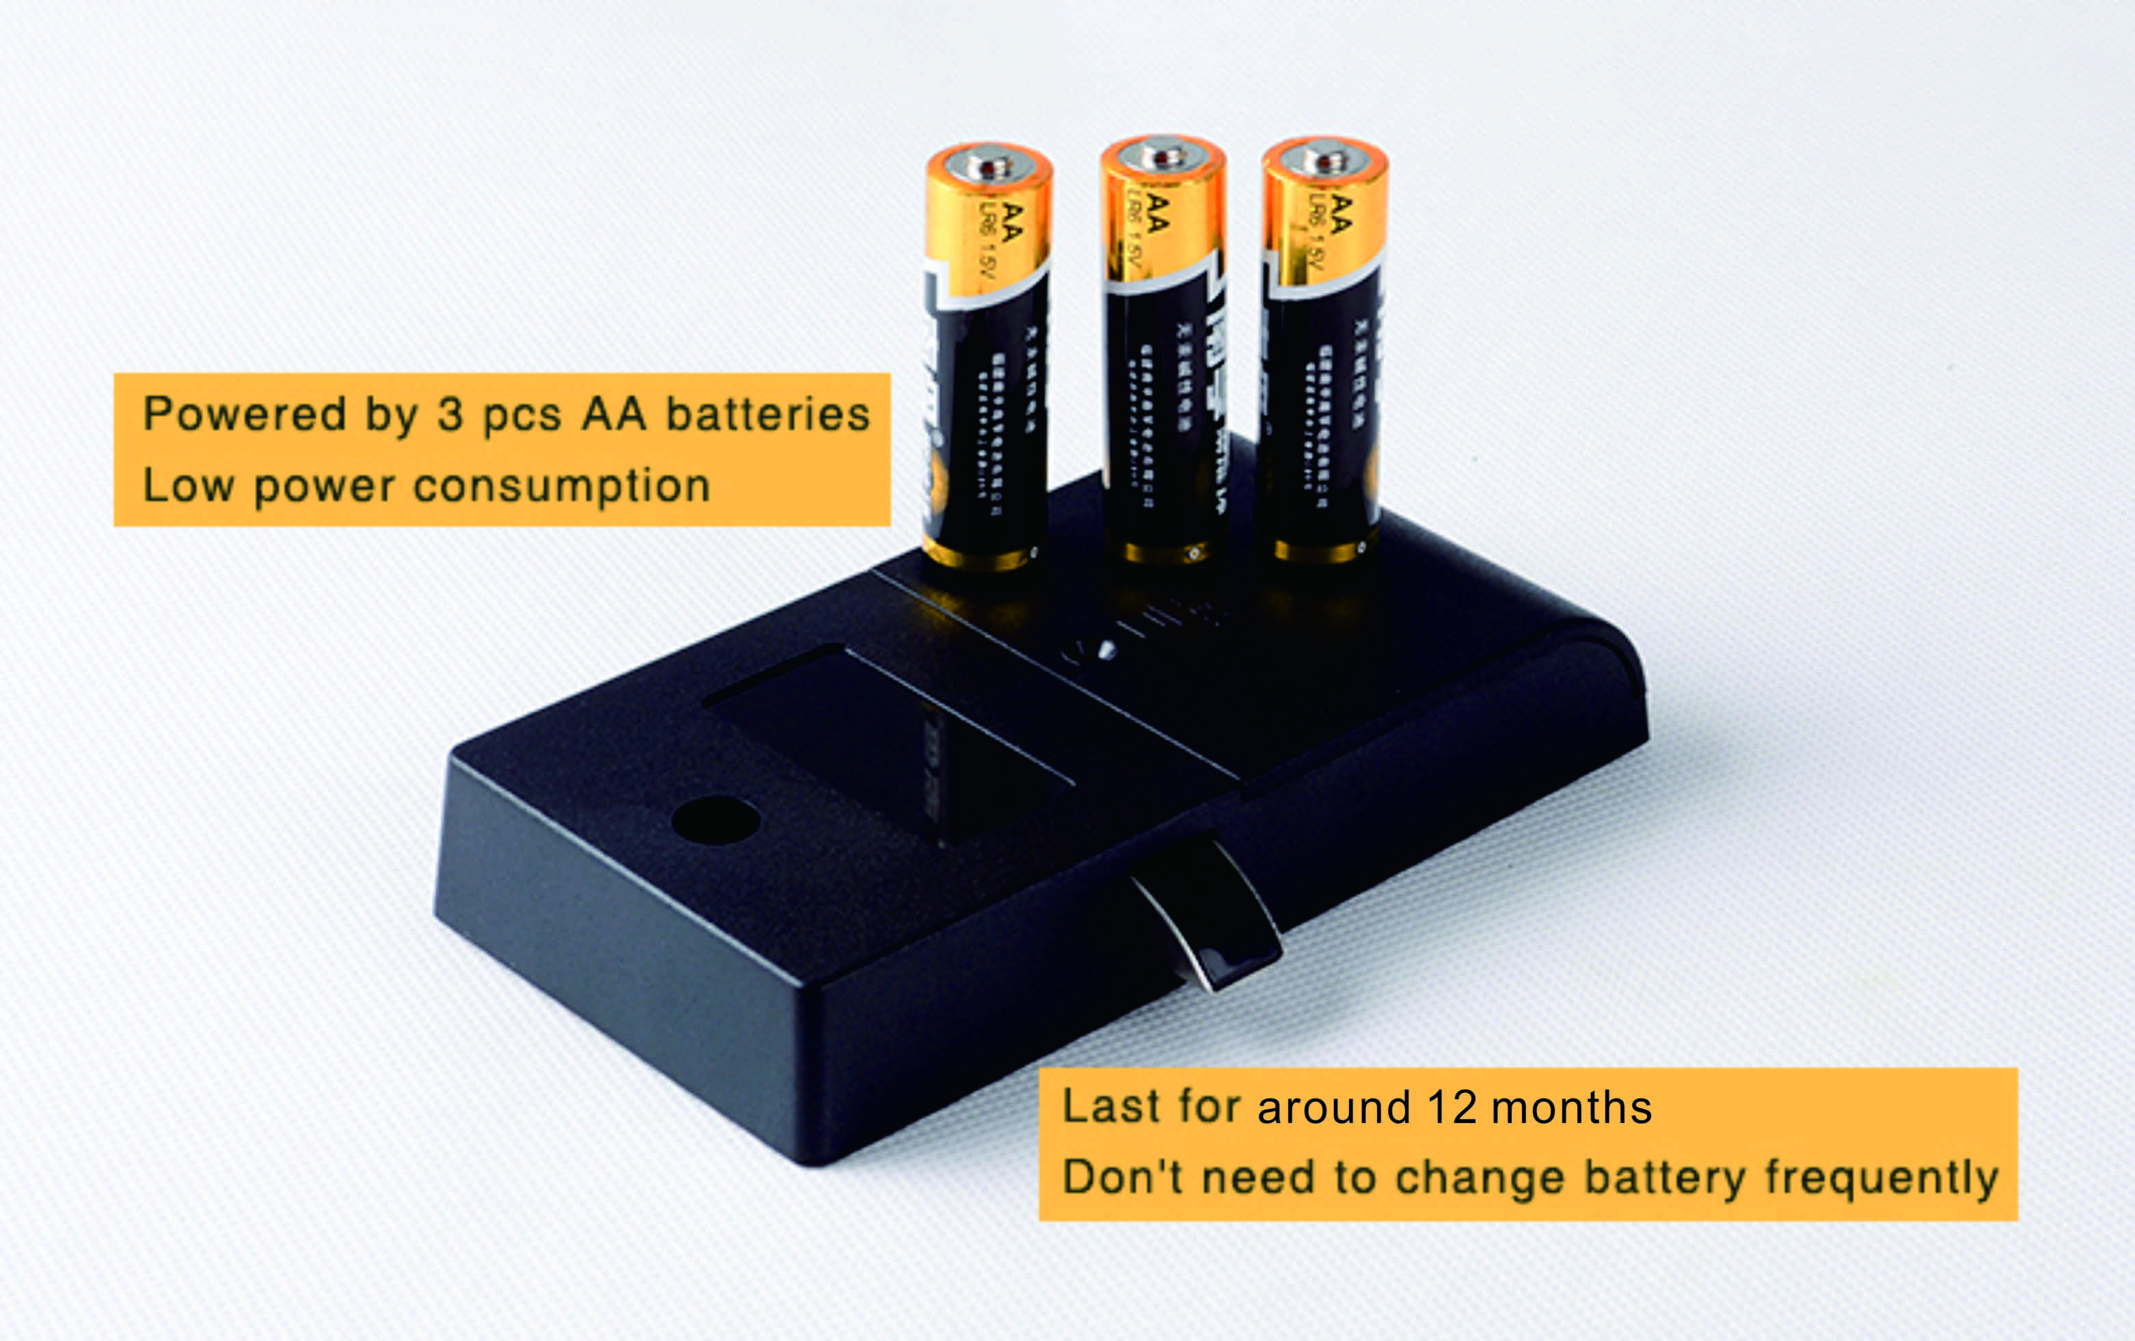

Emergency Unlocking
In case the batteries are exhausted and it is locked, use a USB
charger to unlock for emergency.
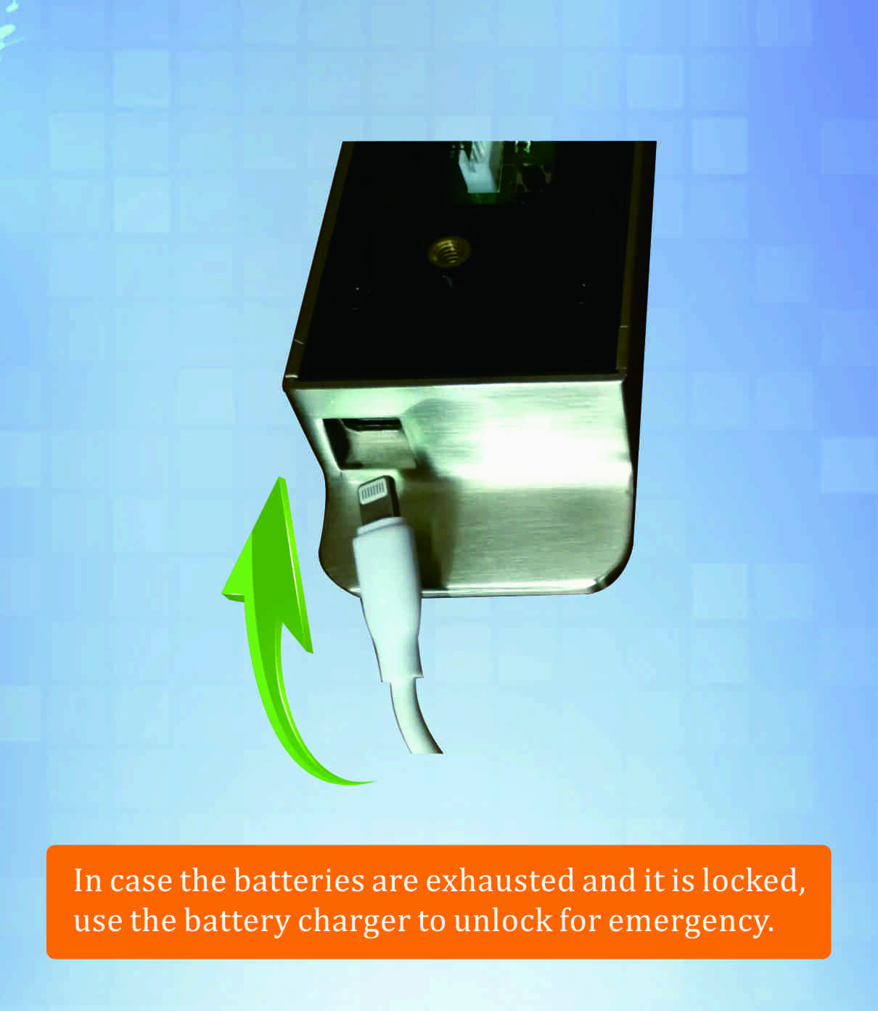

Package:
2pcs/inner box
Carton size: 430mm x 270mm x 220mm
40 pcs/ctn (12.30kg)

